**MODELING AND FRACTAL PARAMETRIZATION**

***Holofieieva M., Stanovskyi O., Tonkonogyi V.***

Design - by definition - is the creation of a description of an object that does not yet exist [1]. This implies the main problem of the design process - the inability to assess the "correctness" of the selected option of the object until the design is fully completed, the object is manufactured and tested. Thus, optimization in design comes down to solving many inverse problems: from object to project. The solution of the contradictions connected with this problem is sought, as a rule, on the way of creating models of the future object and testing the latter with the help of simulation. This problem is especially relevant when designing complex systems, which include interacting elements that jointly solve a certain common problem and have the following properties in combination: the absence of a single functioning algorithm in the form of some consistent mathematical description; "noisy" model, which complicates the design and observation, due not so much to the presence of random noise generators, but to a large number of secondary processes; non-stationarity, expressed in the drift of characteristics, changes in parameters, evolution in time; irreproducibility of experiments with it [1]. As a rule, all this makes it difficult to use in CAD systems such "standard" back calculation from the required properties of the system to the parameters of its design or manufacturing technology. In the process of such calculations, using of the so-called fractal dimension of individual elements of the designed systems can make a significant simplification of the applied models.

If we consider the concept of a fractal in relation to heterogeneous materials, then a certain universal chemically structured unit is embedded in it, which contains information about the structure and properties of the material under study [3]. Using this approach opens up new possibilities in system design.

The fractal type model is based on the definition of the self-similarity of an object [4]. At the same time, the main property of fractal objects is the independence of their properties from the scale, i.e. the results of studies of parameters at one of the dimensional levels are extended to the remaining scale levels. This principle of hierarchical organization is often found in nature and, of course, manifests itself in material structures, including heterogeneous materials.

There are various methods for determining the fractal dimension. In the general case, they come down to establishing a certain characteristic parameter, the change in the value of which at different scale levels is used to judge the fractal dimension. At the same time, for the effective application of such methods, it is necessary to take into account the specific properties of specific objects of study.

When designing a complex system, most often they resort to creating its version using a model. Next, the result of the "reverse" simulation of this option is calculated and the result of the calculation is compared with the requirement for the future object (the method of selection from the results of reverse calculation on the direct model - RCDM). In this article, the application of this approach in mechanical engineering is considered using two examples. In the first one, we are talking about designing the parameters of the technology for the process of manufacturing products from syntegran. The second example considers the application of the proposed method in the foundry industry.

Syntegran is a non-metallic heterogeneous material consisting of a polymer matrix based on epoxy resin, fillers in the form of crushed stone with a fraction of up to 10 mm, as well as fine mineral filler. According to the main physical and mechanical characteristics, syntegran is close to natural granite, while having a significant advantage over the latter - manufacturability. The manufacturing technology of syntegran products is the casting of a low-flowing mixture with subsequent vibrocompaction. The time of bulk polymerization is determined by the geometric characteristics of the manufactured parts. Basically, polymer concrete, which includes syntegran, is used to replace blocks of natural granite and cast iron in the manufacture of basic parts of technological equipment, plates of measuring machines, instruments and other equipment, the materials of which are subject to special requirements. This is due, first of all, to the fact that the materials under consideration have such properties as non-magnetism, corrosion resistance, low thermal conductivity, high dimensional and thermal stability, and vibration resistance. There is a possibility of directed regulation of the properties of the material under consideration (strength, stiffness, vibration damping characteristics, level of operating temperatures) by selecting the composition, changing the reinforcement schemes, the ratio of the components and the macrostructure of the material.

Figure 1 shows the dependence of the mechanical properties of syntegras on the content of the polymer binder δ.

200

150

100

50

Е, GPа σсomp σt, МPа λ

40

30

20

10

0 3 6 9 12 15 18 20 δ, %

0,035

0,030

0,025

0,025

Е

λ

σсomp

σt

Е

σcomp – compressive strength; σt – tensile strength; Е – dynamic modulus of elasticity; λ – damping factor.

Fig. 1 - Dependence of the syntegran properties on the content of the binder

Figure 2 shows a fragment of a frame made of syntegran with cast-iron mortgages

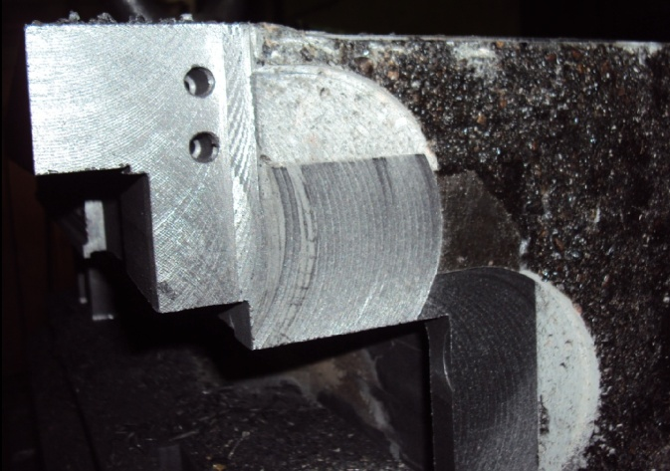

Fig. 2 - The fragment of the syntegranic frame of a metal-cutting machine with cast-iron mortgages

Along with the considered high performance characteristics of signtegrans, some of their shortcomings should be noted. The characteristics of heterogeneous materials are stochastic in nature. As a result, during the processing of their components, defects arise caused by random changes in the composition: the presence of shells, delamination of embedded parts, the mixture getting into cavities during casting, which are not intended for this by design, heterogeneity of composition and structure, and, consequently, physical and mechanical properties in the volume of the casting.

To analyze the properties of non-metallic heterogeneous materials, for example, in the non-destructive testing of products, a simplified structural model of such a material at the meso- and microlevels can be used (Figure 3).

In the materials under consideration, the structure is formed from elements of at least three hierarchical levels. H, A, and a are the characteristic linear dimensions of the volume of the material, heterogeneous volumes of the mesolevel and microlevel, respectively. In this case, H >> A >> a. It should be noted that the properties of the material as a whole, the ensemble, or individual elements of the mesolevel differ significantly from each other [16].

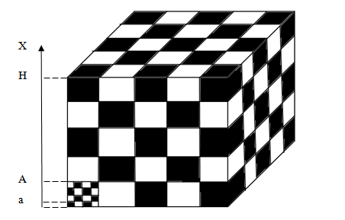

Fig. 3 - Structural model of a non-metallic heterogeneous material

When engineering the design of a part made of syntegran or its manufacturing technology, the task is as follows. Evaluate the design so that at this early stage the question can be answered whether the object will have the desired properties after manufacture. For example, if the object is the frame of a large metalworking machine, will it ensure that the specified requirements for vibration resistance are met? As you can see, the object model should allow us to calculate the vibration resistance parameters of the future frame. To do this, the model must be able to reproduce the movement and impacts inside the frame and at the same time evaluate the vibration parameters of its surface. If the latter do not meet the requirements, then the design parameters of this object can be changed in the model, after which the vibration resistance study is repeated.

As for the foundry, it should also be classified as extremely complex in terms of the possibility of measuring the parameters of ongoing processes. The latter are characterized by stochasticity, nonstationarity, high intensity, and multidimensionality. For example, the occurrence of air pockets in a hardening casting can be detected using infrared thermal imaging techniques due to the difference in surface temperatures in the defective and defect-free zones. In this situation, there is a need for a quick response in order to eliminate the identified artifact by external influence, for example, using vibration. However, temperature measurements using infrared thermometry, in the best case, will give some space-time display of the object - the temperature field, which is very difficult for mathematical description, and hence embedding in the control system. Of course, to solve design problems, these parameters must be not only metrologically understandable, but also strictly and, if possible, simply described mathematically. This possibility is provided by the proposed method “of express-selection from the results of reverse calculation on the direct model – RCDM”.

Figure 4 shows the procedure for developing a technology for obtaining new castings using the RCDM method.

drawing of the part

Agreement, remarks

Casting

Analysis results

Technology

technical control department

Design department

drawing, 3d model of the part

Agree-

ment

Mechanical processing shop

Melting results

CAD department

Foundry

Fig. 4 - Development of technology for obtaining new castings using the RCDM method

In the article, an express method for designing complex heterogeneous systems is considered, which includes the construction of a complex model of the primary state of the system being designed. it is possible to transform the design of the designed system and its manufacturing technology into models, as well as evaluate the change in state after each step of the transformation and choose the best parameters after comparison with the terms of reference for the designed object. The application of the method is considered on the example of designing parts from a non-metallic heterogeneous material - syntegran, as well as in foundry production. in order to optimize the design process, it is proposed to use the so-called fractal dimension of individual elements of the designed systems, which makes it possible to significantly simplify the applied models. further research is aimed at detailing the proposed method, as well as the study of the mathematical apparatus on which it is based.