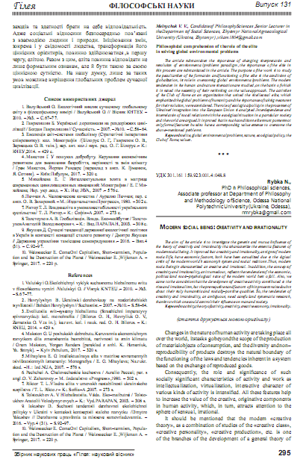
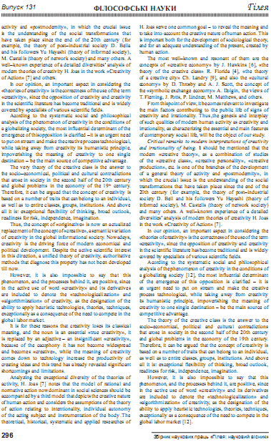

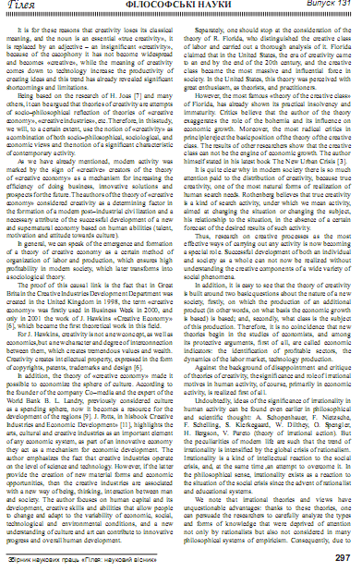

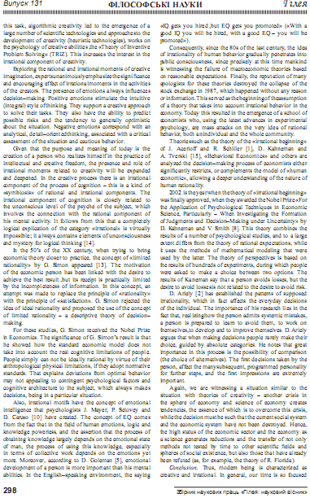

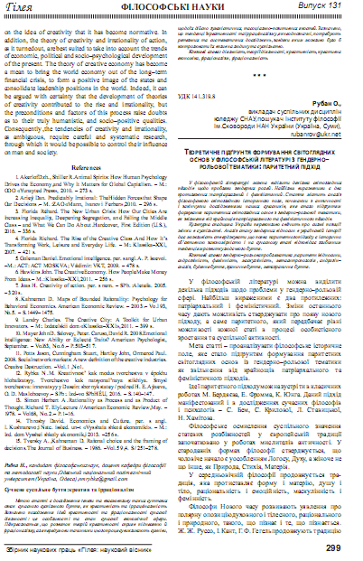

УДК 301.161 159.923:001.4:048.8
Rybka N.
PhD in Philosophical sciences, Associate professor
at Department of Philosophy and Methodology of Science,
Odessa National Polytechnic University (Ukraine, Odessa),
nmrybka@gmail.com

MODERN SOCIAL BEING: CREATIVITY AND IRRATIONALITY
The aim of the article is to investigate the genesis and mutual influence of the theory of creativity and irrationality that characterize the essential features of modern social being. It is proved that creativity and irrationality, as signs of modern social life, have economic factors, both have been actualized due to the logical crisis of the modern world’s economy’s system and social relations. Thus, modern social being is characterized as creative and irrational. In addition, the concept of creativity and irrationality, as it turned out, reflects the tendencies of the economic, political and socio-psychological state of the modern world best of all. Also, we came to the conclusion that the development of creative activity contributed to the rise and irrationalism, but the prerequisites and factors of this process raise doubts about their truly humanistic and socially-positive qualities. So, the tendencies of creativity and irrationality, as ambiguous, need careful and systematic research, thanks to which one could control their influence on man and society.
Key words: activity, theory of activity, creativity, creative economy, irrationality.
(стаття друкується мовою оригіналу)
INTRODUCTION
Changes in the nature of human activity are taking place all over the world, its tasks go beyond the scope of the production of material objects of consumption, and the diversity and non-reproducibility of products destroys the natural boundary of the functioning of the laws and tendencies inherent in a system based on the exchange of reproduced goods.
Consequently, the role and significance of such socially significant characteristics of activity and work as intellectualization, virtualization, interactive character of various kinds of activity is intensified. All these features help to increase the value of the creative, originative components in human activity, which, in turn, attracts attention to the sphere of sensual, irrational.
It should be mentioned that the modern «creative theory», as a combination of studies of the «creative class», «creative personality», «creative production», etc. is one of the branches of the development of a general theory of activity and «postmodernity», in which the crucial issue is the understanding of the social transformations that have taken place since the end of the 20th century (for example, the theory of post-industrial society D. Bella and his followers Yu Hayashi (theory of informed society), M. Castells (theory of network society) and many others. A well-known experience of a detailed diversities’ analysis of modern theories of creativity H. Joas in the work «Creativity of Action» [7] and others.
In our opinion, an important aspect in considering the «theories of creativity» is the correctness of the use of the term “creativity”, since the opposition of creativity and creativity in the scientific literature has become traditional and is widely covered by specialists of various scientific fields.
Acording to the systematic social and philosophical analysis of the phenomenon of creativity in the conditions of a globalizing society, the most influential determinant of the emergence of this opposition is clarified – it is an urgent need to put on stream and make the creative process technological, while taking away from creativity its humanistic principle, impoverishing the meaning of creativity to one single destination – be the main source of competitive advantage.
The very theory of the creative class is the answer to the socio-economical, political and cultural contradictions that arose in society in the second half of the 20th century and global problems in the economy of the 19th century. Therefore, it can be argued that the concept of creativity is based on a number of traits that can belong to an individual, as well as to entire classes, groups, institutions. And above all it is: exceptional flexibility of thinking, broad outlook, readiness for risk, independence, imagination.
Thus, the concept of «originative» is now an actualized replacement of the concept of «creative», a semantic variation of creativity in the global informational society. Nowadays, creativity is the driving force of modern economical and political development. Despite the active scientific interest in this direction, a unified theory of creativity, authoritative methods that diagnose this property has not been developed till now.
However, it is also impossible to say that this phenomenon, and the processes behind it, are positive, since in the active use of word «creativity» and its derivatives are included to denote the «technologicalization» and «algorithmization» of creativity, as the designation of the ability to apply heuristic technologies, theories, techniques, exceptionally as a consequence of the need to compete in the global labor market.
It is for these reasons that creativity loses its classical meaning, and the noun is an essential «true creativity», it is replaced by an adjective – an insignificant «creativity», because of the cacophony it has not become widespread and becomes «creative», while the meaning of creativity comes down to technology increase the productivity of creating ideas and this trend has already revealed significant shortcomings and limitations.
Analyzing the exceptional diversity of the theories of activity, H. Joas [7] notes that the model of rational and normative action now dominant in social sciences should be accompanied by a third model that depicts the creative nature of human action and considers the assumptions of the theory of action relating to intentionality, individual autonomy of the acting subject and instrumentation of the body. The theoretical, historical, systematic and applied researches of H. Joas serve one common goal – to reveal the meaning and to take into account the creative nature of human action. This is important both for the development of sociological theory, and for an adequate understanding of the present, created by human action.
The most well-known and resonant of them are the concepts of «creative economy» by J. Hаwkins [6], «the theory of the creative class» R. Florida [4], «the theory of a creative city» Ch. Landry [9], and also the «cultural economy» by D. Throsby and A.J. Scott, the concept of the «symbolic exchange economy» A. Dolgin, the views of T. Fleming, J. Potts, P. Lindner, M. Matthews, and others.
From this point of view, it becomes relevant to investigate the main factors contributing to the public life of signs of creativity and irrationality. Thus, the genesis and interplay of such qualities of modern human activity as creativity and irrationality, as characterizing the essential and main features of contemporary social life, will be the object of our study.

CRITICAL REMARKS TO MODERN INTERPRETATIONS OF CREATIVITY AND IRRATIONALITY OF BEING
It should be mentioned that the modern «creative theory», as a combination of studies of the «creative class», «creative personality», «creative production», etc. is one of the branches of the development of a general theory of activity and “postmodernity”, in which the crucial issue is the understanding of the social transformations that have taken place since the end of the 20th century (for example, the theory of post-industrial society D. Bell and his followers Yu Hayashi (theory of informed society), M. Castells (theory of network society) and many others. A well-known experience of a detailed diversities’ analysis of modern theories of creativity H. Joas in the work «Creativity of Action» [7]
In our opinion, an important aspect in considering the «theories of creativity» is the correctness of the use of the term «creativity», since the opposition of creativity and creativity in the scientific literature has become traditional and is widely covered by specialists of various scientific fields.
Acording to the systematic social and philosophical analysis of the phenomenon of creativity in the conditions of a globalizing society [12], the most influential determinant of the emergence of this opposition is clarified – it is an urgent need to put on stream and make the creative process technological, while taking away from creativity its humanistic principle, impoverishing the meaning of creativity to one single destination – be the main source of competitive advantage.
The theory of the creative class is the answer to the socio-economical, political and cultural contradictions that arose in society in the second half of the 20th century and global problems in the economy of the 19th century. Therefore, it can be argued that the concept of creativity is based on a number of traits that can belong to an individual, as well as to entire classes, groups, institutions. And above all it is: exceptional flexibility of thinking, broad outlook, readiness for risk, independence, imagination.
However, it is also impossible to say that this phenomenon, and the processes behind it, are positive, since in the active use of word «creativity» and its derivatives are included to denote the «technologicalization» and «algorithmization» of creativity, as the designation of the ability to apply heuristic technologies, theories, techniques, exceptionally as a consequence of the need to compete in the global labor market [12].
It is for these reasons that creativity loses its classical meaning, and the noun is an essential «true creativity», it is replaced by an adjective – an insignificant «creativity», because of the cacophony it has not become widespread and becomes «creative», while the meaning of creativity comes down to technology increase the productivity of creating ideas and this trend has already revealed significant shortcomings and limitations.
Being based on the research of H. Joas [7] and many others, it can be argued that theories of creativity are attempts of socio-philosophical reflection of theories of «creative economy», «creative industries», etc. Therefore, in this study, we will, to a certain extent, use the notion of «creativity» as a combination of both socio-philosophical, sociological, and economic views and the notion of a significant characteristic of contemporary activity.
As we have already mentioned, modern activity was marked by the sign of «creative» creators of the theory of «creative economy» as a mechanism for increasing the efficiency of doing business, innovative solutions and prospects for the future. The authors of the theory of «creative economy» considered creativity as a determining factor in the formation of a modern post-industrial civilization and a necessary attribute of the successful development of a new and supernatural economy based on human abilities (talent, motivation and attitude towards culture).
In general, we can speak of the emergence and formation of a theory of creative economy as a certain method of organization of labor and production, which ensures high profitability in modern society, which later transforms into a sociological theory.
The proof of this causal link is the fact that in Great Britain the Creative Industries Development Department was created in the United Kingdom in 1998, the term «creative economy» was firstly used in Business Week in 2000, and only in 2001 the work of J. Hawkins «Creative Economy» [6], which became the first theoretical work in this field.
For J. Hawkins, creativity is not a new concept, as well as economics, but a new character and degree of interconnection between them, which creates tremendous values and wealth. Creativity creates intellectual property, expressed in the form of copyrights, patents, trademarks and design [6].
In addition, the theory of «creative economy» made it possible to economize the sphere of culture. According to the founder of the company Co-media and the expert of the World Bank B. L. Landry, previously considered culture as a spending sphere, now it becomes a resource for the development of the regions [9]. J. Potts, in his book Creative Industries and Economic Development» [11], highlights the arts, cultural and creative industries as an important element of any economic system, as part of an innovative economy they act as a mechanism for economic development. The author emphasizes the fact that creative industries operate on the level of science and technology. However, if the latter provide the creation of new material forms and economic opportunities, then the creative industries are associated with a new way of being, thinking, interaction between man and society. The author focuses on human capital and its development, creative skills and abilities that allow people to change and adapt to the variability of economic, social, technological and environmental conditions, and a new understanding of culture and art can contribute to innovative progress and overall human development.
Separately, one should stop at the consideration of the theory of R. Florida, who distinguished the creative class of labor and carried out a thorough analysis of it. Florida claimed that in the United States, the era of creativity came to an end by the end of the 20th century, and the creative class became the most massive and influential force in society. In the United States, this theory was perceived with great enthusiasm, as theorists, and practitioners.
However, the most famous «theory of the creative class» of Florida, has already shown its practical insolvency and immaturity. Critics believe that the author of the theory exaggerates the role of the bohemia and its influence on economic growth. Moreover, the most radical critics in principle reject the basic position of the theory of the creative class. The results of other researchers show that the creative class can not be the engine of economic growth. The author himself stated in his latest book The New Urban Crisis [3].
It is quite clear why in modern society there is so much attention paid to the distribution of creativity, because true creativity, one of the most natural forms of realization of human search needs. Rothenberg believes that true creativity is a kind of search activity, under which we mean activity, aimed at changing the situation or changing the subject, his relationship to the situation, in the absence of a certain forecast of the desired results of such activity.
Thus, research on creative processes as the most effective ways of carrying out any activity is now becoming a special role. Successful development of both an individual and society as a whole can not now be realized without understanding the creative components of a wide variety of social phenomena.
In addition, it is easy to see that the theory of creativity is built around two basic questions about the nature of a new society, firstly, on which the production of an additional product (in other words, on what basis the economic growth is based) is based; and, secondly, what class is the subject of this production. Therefore, it is no coincidence that new theories begin in the studies of economists, and among its protective arguments, first of all, are called economic indicators: the identification of profitable sectors, the dynamics of the labor market, technology production.
Against the background of disappointment and critique of theories of creativity, the significance and role of irrational motives in human activity, of course, primarily in economic activity, is realized first of all.
Undoubtedly, ideas of the significance of irrationality in human activity can be found even earlier in philosophical and scientific thought: A. Schopenhauer, F. Nietzsche, F. Schelling, S. Kierkegaard, W. Dilthey, O. Spengler, H. Bergson, V. Pareto (theory of irrational action). But the peculiarities of modern life are such that the trend of irrationality is intensified by the global crisis of rationalism. Irrationality is a kind of intellectual reaction to the social crisis, and, at the same time, an attempt to overcome it. In the philosophical sense, irrationality exists as a reaction to the situation of the social crisis since the advent of rationalist and educational systems.
We note that irrational theories and views have unquestionable advantages: thanks to these theories, one can persuade the researchers to carefully analyze the types and forms of knowledge that were deprived of attention not only by rationalists but also not considered in many philosophical systems of empiricism. Consequently, due to this task, algorithmic creativity led to the emergence of a large number of scientific technologies and approaches to the development of creativity (heuristic technologies), works on the psychology of creative abilities, the «Theory of Inventive Problem Solving» (TRIZ). This increases the interest in the irrational component of creativity.
Exploring the rational and irrational moments of creative imagination, experts unanimously emphasize the significance and encouraging effect of irrational moments in the activities of the creators. The presence of emotions always influences decision-making. Positive emotions stimulate the intuitive (integral) style of thinking. They support a creative approach to solve their tasks. They also have the ability to predict possible risks and the tendency to generally optimistic about the situation. Negative emotions correspond with an analytical, detail-oriented thinking, associated with a critical assessment of the situation and cautious behavior.
Given that the purpose and meaning of today is the creation of a person who realizes himself in the practice of intellectual and creative freedom, the presence and role of irrational moments related to creativity will be expanded and deepened. In the creative process there is an irrational component of the process of cognition – this is a kind of «symbiosis» of rational and irrational components. The irrational component of cognition is closely related to the unconscious level of the psyche of the subject, which involves the connection with the rational component of his mental activity. It follows from this that a completely logical explication of the category «irrational» is virtually impossible; it always contains elements of unconsciousness and mystery for logical thinking [14].
In the 50's of the XX century, when trying to bring economic theory closer to practice, the concept of «limited rationality» by G. Simon appeared [13]. The motivation of the economic person has been linked with the desire to achieve the best result, but its receipt is practically limited by the incompleteness of information. In this concept, an attempt was made to replace the principle of «rationality» with the principle of «satisfaction». G. Simon rejected the idea of ideal rationality and proposed the use of the concept of limited rationality – a descriptive theory of decision-making.
For these studies, G. Simon received the Nobel Prize in Economics. The significance of G. Simon's result is that he showed how the standard economic model does not take into account the real cognitive limitations of people. People simply can not be ideally rational by virtue of their anthropological physical limitations, if they adopt normative standards. That explains deviations from optimal behavior may not appealing to contingent psychological factors and cognitive architecture to the subject, which always makes decisions, being in a particular situation.
Also, irrational motifs have the concept of emotional intelligence that psychologists J. Mayer, P. Selovey and D. Caruso [10] have created. The concept of EQ comes from the fact that in the field of human emotions, logic and knowledge powerless, and the assertion that the process of obtaining knowledge largely depends on the emotional state of man, the process of using this knowledge, especially in terms of collective work depends on the emotions yet more. Moreover, according to D. Goleman [5], emotional development of a person is more important than his mental abilities. In the English-speaking environment, the saying «IQ gets you hired, but EQ gets you promoted» («With a good IQ you will be hired, with a good EQ – you will be promoted»).
Consequently, since the 80s of the last century, the idea of irrationality of human behavior gradually penetrates into public consciousness, since precisely at this time mankind is witnessing the failure of macroeconomic theories based on reasonable expectations. Finally, the reputation of many apologists for these theories destroyed the collapse of the stock exchange in 1987, which happened without any reason or information. This served as the beginning of the assumption of a theory that takes into account irrational behavior in the economy. Today this resulted in the emergence of a school of economists who, using the latest advances in experimental psychology, are mass attacks on the very idea of rational behavior, both an individual and the whole community.
Theories such as the theory of the «irrational beginning» of J. Acerloff and R. Schiller [1], D. Kahneman and A. Tverski [15], «Behavioral Economics» and others are analyzed the decision-making process of economists either significantly restricts, or complements the model of «human economic», allowing a deeper understanding of the nature of human rationality.
2002 is the year when the theory of «irrational beginning» was finally approved, when they awarded the Nobel Prize «For the Application of Psychological Techniques in Economic Science, Particularly – When Investigating the Formation of Judgments and Decision-Making under Uncertainty» by D. Kahneman and V. Smith [8]. This theory combines the results of a number of psychological studies, and to a large extent differs from the theory of rational expectations, while it uses the methods of mathematical modeling that were used by the latter. The theory of perspectives is based on the results of hundreds of experiments, during which people were asked to make a choice between two options. The results of Kaneman say that a person avoids losses, but the desire to avoid losses is not related to the desire to avoid risk.
D. Ariely [2] has established the patterns of supposed irrationality, which in fact affects the everyday decisions of the individual. The importance of his research lies in the fact that, realizing how the person admits systemic mistakes, a person is prepared to learn to avoid them, to work on themselves, to develop and to improve themselves. D. Ariely argues that when making decisions people rarely make their choice, guided by absolute categories. He notes that great importance in this process is the possibility of comparison (the choice of alternatives). The first decisions taken by the person, affect the many subsequent, programmed personality for further steps, and the first impressions are extremely important.
Again, we are witnessing a situation similar to the situation with theories of creativity – another crisis in the sphere of economy and science of economy creates tendencies, the essence of which is to overcome this crisis, while the decision must be such that the current social system and the economic system have not been destroyed. Hence, the high status of the economic sector and the economy as a science generates reductions and the transfer of not only methods not tested by time to other scientific fields and spheres of social existence, but also those that have already been refuted (as, for example, the theory of R. Florida).
CONCLUSION
Thus, modern being is characterized as creative and irrational. In general, our time is so focused on the idea of creativity that it has become normative. In addition, the theory of creativity and irrationality of action, as it turned out, are best suited to take into account the trends of economic, political and socio-psychological development of the present. The theory of creative economy has become a mean to bring the world economy out of the long-term financial crisis, to form a positive image of the states and consolidate leadership positions in the world. Indeed, it can be argued with certainty that the development of theories of creativity contributed to the rise and irrationality, but the preconditions and factors of this process raise doubts as to their truly humanistic, and socio-positive qualities. Consequently, the tendencies of creativity and irrationality, as ambiguous, require careful and systematic research, through which it would be possible to control their influence on man and society.

References
- Akerlof Dzh., Shiller R. Animal Spirits: How Human Psychology Drives the Economy, and Why It Matters for Global Capitalism. M.: OOO «Yunayted Press», 2010. 273 s.
- Ariely, Dan. Predictably Irrational: The Hidden Forces that Shape Our Decisions. M.: ZAO «Mann, Ivanov i Ferber». 2010. 296 s.
- Florida, Richard. The New Urban Crisis: How Our Cities Are Increasing Inequality, Deepening Segregation, and Failing the Middle Class – and What We Can Do About . Hardcover, First Edition (U.S.). 2016. 336 s.
- Florida, Richard. The Rise of the Creative Class. And How It's Transforming Work, Leisure and Everyday Life. M.: Klassika-KhKhІ. 2007. 421 s.
- Goleman, Daniel. Еmotional intelligence. per. s angl. A.P. Isaevoi. – M.: ACT: ACT MOSKVA; Vladimir: VKT. 2009. 478 s.
- Hаwkins, John. The Creative Economy. How People Make Money From Ideas. M.: Klassika-ХХІ. 2011. 256 s.
- Joas H. Creativity of action. per. s nem. SPb.: Aleteiia. 2005. 320 s.
- Kahneman D. Maps of Bounded Rationality: Psychology for Behavioral Economics. American Economic Review, 2003. vol. 93, no.5, S. 1449-1475.
- Landry, Charles. The Creative City: A Toolkit for Urban Innovators. M.: Izdatelskii dom «Klassika-KhKhI», 2011. 399 s.
- Mayer, John D. Salovey, Peter. Caruso, David R. 2008. Emotional Intelligence: New Ability or Eclectic Traits? American Psychologist, September, Vol. 63, No. 6, p. 503-517.
- Potts Jason, Cunningham Stuart, Hartley John, Ormerod Paul. 2008. Social network markets: A new definition of the creative industries. Creative Destruction Vol 1, No 1.
- Rybka N.M. Kreatyvnostʹ kak modus tvorchestva v épokhu hlobalyzatsyy. Tvorchestvo kak natsyonalʹnaya stykhyya. Smysl tvorchestva: ynnovatsyy y Dasein: sbornyk statey / pod red H.E. Alyaeva, O.D. Masloboevoy. SPb.: Yzd-vo SPbHÉU, 2016. S. 140-147.
- Simon, Herbert A. Rationality as Process and as Product of Thought. Richard T. Ely Lecture // American Economic Review, May, 1978. v.68, no.2, p.1-16.
- Throsby, David. Economics and Culture. per. s angl. I. Kushnarevoi; Natc. issled. un t «Vysshaia shkola ekonomiki». M.: Izd. dom Vysshei shkoly ekonomiki. 2013. 256 s.
- Tversky A., Kahneman D. Rational choice and the framing of decisions. The Journal of Business. 1986. Vol. 59, 4. S/ 251-278.

Рибка Н., кандидат філософських наук, доцент кафедри філософії та методології науки, ОНПУ (Україна, Одеса), nmrybka@gmail.com
Сучасне суспільне буття: креатив та ірраціоналізм
Метою статті є дослідження ґенези та взаємовпливу таких суттєвих ознак сучасного суспільного буття, як креативність та ірраціональність. Визначено походження ідей креативності та ірраціональності сучасної діяльності: це особливості та стан сучасної економічної сфери. Підкреслюється, що розвиток теорій креативності сприяв піднесенню й ірраціоналізму, але передумови та чинники цього процесу викликають сумніви, щодо їх дійсно гуманістичних, та соціально-позитивних якостей. Зазначено, що тенденції креативності та ірраціоналізму, як неоднозначні, потребують ретельних та систематичних досліджень, завдяки яким можливо було б контролювати їх вплив на людину та суспільство.
Ключові слова: діяльність, теорії діяльності, креативність, креативна економіка, ірраціоналізм, ірраціональність.

