UDK 004.942 + 621.923

LASER TECHNIQUE TO CONTROL 3D PRINTING PROCESS QUALITY
Bogdan Verbilo¹, Dmitro Osoba².
Academician of the Ukraine Academy of Economic Cybernetics, Doctor of Science (Engineering), Professor of the department of Digital Technology in Engineering Vasily Larshin²

¹Odessa Military Academy, ²State University “Odessa Polytechnic”, Ukraine
ABSTRACT. A non-contact control method based on the use of laser measurement technology is currently promising to detect the deviant state of the object and the process in 3D printing. Online monitoring of object quality is essential for timely, reliable and fast fault detection.
Keywords: Additive manufacturing, complex-shaped parts, laser measuring, quality control.

ЛАЗЕРНА ТЕХНІКА КОНТРОЛЮ ЯКОСТІ ПРОЦЕСУ 3D ДРУКУ
¹Вербило Богдан Владиславович, ²Особа Дмитро Олександрович.
Академік Української академії економічної кібернетики, д-р техніч. наук, проф.
каф. Цифрових технологій в інжинірингу ²Ларшин Василь Петрович
¹Військова академія м.Одеса, ²Державний університет «Одеська політехніка», Україна
АНОТАЦІЯ. В даний час перспективним є безконтактний метод контролю, заснований на використанні лазерної вимірювальної техніки для виявлення відхилення стану об’єкта та процесу в 3D-друці. Онлайновий моніторинг якості об’єкта необхідний для своєчасного, надійного та швидкого виявлення несправностей.
Ключові слова: адитивне виробництво, складні деталі, лазерне вимірювання, контроль якості.
Introduction. Additive manufacturing (AM) has undeniable advantages over traditional technologies due to the absence of geometric constraints, the manufacture of complex shapes parts, the possibility of using different materials, etc. But nevertheless, in order to obtain a high-quality object, it is necessary to choose the correct printing parameters. A huge variety of defects occurs in 3D printing, which requires constant quality control of both the object being printed and the 3D printing process being performed. In this regard, the quality systems via state parameters and output parameters are to be worked online [1] based on laser measurement technique [2].
The work aims to research the error influences during laser measuring to detect the deviant state of the object and the 3D printing process and thereby reduce the error of laser measurement with its high performance.
The most part of the work. The concept of 3D printing has been imagined back in the 1970’s, but only in the last decade 3D printers have become widespread in various fields, namely biomedical purposes, mechanical engineering, military equipment, transport, aerospace, architecture, and design.
The quality of a product manufactured via the AM is about a part’s ability to perform the task for which it was designed, while maintaining structural integrity. Contributing factors are usually included in a part’s specifications and typically include geometry (the shape of the finished part and how it will fit with other parts), surface finish (the desired smoothness, roughness, or other functional surface treatment of the finished part), surface integrity, and material properties (a variety of attributes, including mechanical strength, stiffness, and fatigue life). For this reason, an equally important task (compared to the task of manufacturing an object) is the appropriate quality control, including control based on fast online measurements. There are two types of control: contact (tactile mechanical method) and non-contact (optical method) ones. Besides, there are some difficulties of non-contact laser measuring connected with the error influences. The sensor evaluates the diffuse part of the reflected laser light (Fig. 1).

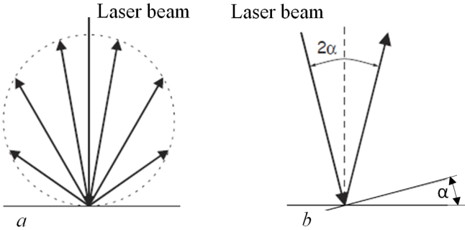
Fig. 1 – Reflection of the laser beam from the surface with diffuse (a) and direct mirror (b) cases [3]
It is difficult to find a minimum reflectance because even a small diffuse fraction can be evaluated from brightly reflecting surfaces. Commonly reflected beam is perceived by the so-called "complementary metal–oxide–semiconductor" (i.e., CMOS) camera. So this work is done by determining the intensity of the diffuse reflection the CMOS signal in real time and the subsequent compensation due to small light spot diameter. For example, for the ILD1420-10 laser model the light spot diameter is about from 45 x 40 µm to 140 x 160 µm [3]. Dark or shiny objects being measured may require longer exposure time which is dependent on the measuring rate and can only be increased by reducing the sensor's rate. There are several factors to make the measurement errors due to the error influences [3]. Some of them are given below.
1. Light from other sources. Thanks to the special integrated optical interference filters the optoNCDT 1420 sensors offer good performance in suppressing light from other sources. But this does not preclude the possibility of interference from other light sources when the objects being measured are shiny and when lower measuring rates are selected. That is why it is recommended to use the shields to screen the other light sources. This applies to measurement work performing in close proximity to welding equipment.
2. Mechanical vibrations. If the sensor is to be used for resolution in the µm to sub-µm range, special care is to be taken to ensure stable and vibration-free mounting of both sensor and target. This implies the inverse possibility of measuring micro-displacements caused by vibrations (the magnitude of vibrations), other things being equal.
3. Surface roughness. Laser-optical sensors detect the surface using very small laser spot. In contrast, a tactile, for example, using the Renishaw probe, detects a much larger area on the measurement object. In case of traversing measurements, surface roughness of 5 µm and more lead to an apparent distance change (Fig.2).

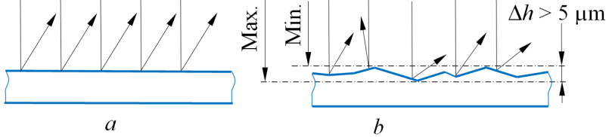
Fig. 2 – Surface roughness influence when ceramic reference surface (a) and the rough one (b) [3]
That is why suitable parameters for the averaging number may improve the comparability of optical and mechanical measurements. Recommendation for parameter choice may be the following: the average number should be selected in such a way that a surface area the size of which is comparable to those with mechanical measurements is averaged.
Conclusions. The use of the above recommendations makes it possible to increase by two or more times the speed of scanning a complex object with a laser beam during online monitoring and diagnostics of 3D printing, as well as to control surfaces with a free form, e.g., biomedical implant surfaces before and during their machining [4]. In the course of the performed analysis, it was found that the described laser technique can also be used to measure some parameters that were considered as interfering ones. This applies, for example, to measuring the amplitude of vibrations, all other things being equal. In this case, the changing position (oscillation magnitude) of the same section of the vibrating surface is measured and, consequently, the surface which is under observation has the same reflective characteristics during the measuring.

REFERENCES
- Larshin, V. P., Lishchenko, N. V., Babiychuk, O. B., Piteľ Ján (2021). “Virtual reality and real measurements”. Applied Aspects of Information Technology. Vol. 4, No. 1; 24–36. DOI: 10.15276/aait.01.2021.2.
- Larshin, V., Lishchenko, N. (2020). “Detecting systematic and random component of surface roughness signal”. Herald of Advanced Information Technology, Vol. 3, No. 2; 61-71. DOI: 10.15276/hait.03.2019.3.
- Operating instructions optoNCDT 1420. Available from: https://www.micro-epsilon.com/download/manuals/man--optoNCDT-1420--en.pdf. – [Accessed 11th May 2022].
- Larshin, V., Lishchenko, N. (2020). “Complex-shaped parts grinding technology information ensuring”. Applied Aspects of Information Technology. Vol. 3, No 4; 246-262. DOI: https://doi.org/10.15276/aait.04.2020.3.
- Oleksandr V. Komarov. (2020). “Reducing the search area of genetic algorithm using neural network autoencoder”. Herald of Advanced Information Technology. Vol.3 No.3: pp.113–124. DOI:10.15276/hait.03.2020.1.
- Anastasiia P. Dydyk, Olena K. Nosovets, Vitalii O. Babenko (2020). Setting up the genetic algorithm for the individualized treatment strategy searching. Scientific Journal Herald of Advanced Information Technology, Vol.3 No.3: pp.125–135. DOI:10.15276/hait.03.2020.2.
- Galina Yu. Shcherbakova, Viktor N. Krylov, Olha E. Plachinda. (2020). “Determination of characteristic points of electrocardiograms using multi-start optimization with a wavelet transform”. Herald of Advanced Information Technology, Vol.3 No.2: pp.23-33. DOI:10.15276/hait.02.2020.2.
- Yuriy V. Khoma, MiroslawSzmajda, MariuszPelc. (2020). “Development of scientific-methodological approaches of machine learning application in biosignals processing”. Herald of Advanced Information Technology, Vol.3 No.1: pp.383–394. DOI:10.15276/hait.01.2020.5.
- Denis S. Shibaev, Vladimir V. Vychuzhanin, Nikolay M. Rudnichenko, Natalia O. Shibaeva, Tatyana V. Otradskaya. (2019). “Data control in the diagnostics and forecasting the state of complex technical systems”. Herald of Advanced Information Technology, Vol.2 No.3: pp.183-196. DOI:10.15276/hait.03.2019.2.
- Olexandr N. Romanyuk, Sergey I. Vyatkin, Svetlana G. Antoshchuk, Pavlo I. Mykhaylov, Roman Yu. Chekhmestruk. (2019). “Blending functionally defined surfaces”. Applied Aspects of Information Technology. Vol.2 No.4: pp.271-282. DOI: 10.15276/aait.04.2019.2.

