UDK 004.9
DEVELOPING A FUNCTIONAL MODEL OF THE ELECTROCARDIOLOGICAL STUDY
Anna Filatova, Mohamad Fahs
DrSc, Full Prof. Anna Filatova
NTU “Kharkiv Polytechnic Institute”, Ukraine
ABSTRACT. The work presented functional model of the electrocardiological study in the form of a contextual diagram, its decomposition, and decomposition of the activities “To perform registration and analysis of electrocardiograms” and “To perform diagnostics”. Using the proposed functional model, the structural diagram of the cardiological decision support system is developed.
Keywords: Functional model; electrocardiological study; cardiological decision support system
РОЗРОБКА ФУНКЦІОНАЛЬНОЇ МОДЕЛІ ЕЛЕКТРОКАРДІОЛОГІЧНОГО ДОСЛІДЖЕННЯ
Філатова Анна Євгенівна, Фахс Мохамад
д.т.н., проф. Філатова Анна Євгенівна
НТУ «Харківський політехнічний інститут», Україна
АНОТАЦІЯ. У роботі представлено функціональну модель електрокардіологічного дослідження у вигляді контекстної діаграми, її декомпозицію та декомпозицію діяльностей «Проведення реєстрації та аналізу електрокардіограм» та «Проведення діагностики». За допомогою запропонованої функціональної моделі розроблено структурну схему кардіологічної системи підтримки прийняття рішень.
Ключoві слова: функціональна модель; електрокардіологічне дослідження; кардіологічна система підтримки прийняття рішень.
Introduction. With the advent of new methods of functional diagnostics in cardiology, such as the Holter monitoring of the electrocardiogram (ECG), the need has arisen for the automatic analysis of large amounts of information. Most of the signals (including ECG), obtained as a result of functional diagnostics of the heart and cardiovascular system, belong to the biomedical signal (BMS) with locally concentrated features (LCF) [1]. Therefore, the design of medical decision support systems (DSS) in cardiology is an urgent scientific and applied task. Most of the medical information systems operating in Ukrainian medical institutions are now morally and physically outdated. Mostly they have developed 10-15 years ago, no one has supported or improved them for a long time. These systems allow you to automate only the preparation of reporting forms [2, 3]. The use of foreign medical DSS is associated with such difficulties as the very high cost of software and the impossibility of upgrading the program code. Therefore, there is a need to create a modern Ukrainian medical DSS, which does not have the above disadvantages.
Purpose of the work. The aim of the study is to develop decision-support tools in the design of cardiological computer diagnostic systems based on the morphological analysis of BMS with LCF in order to improve the efficiency of the ECG study.
The main part of the work. Let us imagine a functional model of the ECG study using the methodology of functional modeling IDEF0. The context diagram represents the ECG study as a whole and shows the connection with the outside world. To build it, it is necessary to define inputs, outputs, controls and mechanisms. To perform an ECG study, there are first need to have patient data (name, gender, age, contact details, etc.), anamnesis data (medical history, comorbidities, etc.) and patient’s functional examination data (clinical blood test, blood pressure, etc.), as well as a referral to a study that indicates the type of an ECG study (for example, standard ECG recording, ECG with stress tests, Holter monitoring, etc.). All these data are the inputs to the context diagram (Fig. 1).
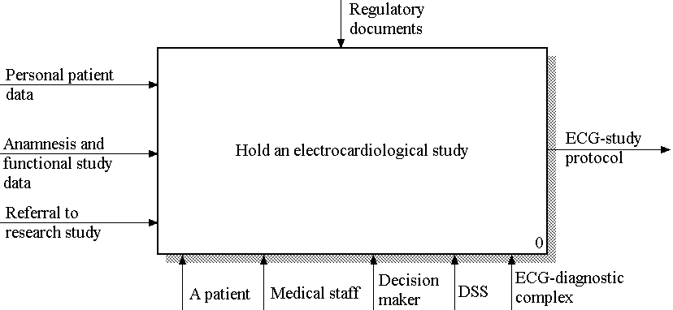

Fig. 1. Context diagram of the functional model of the ECG study
As a result of the ECG study, the patient receives a protocol in which the necessary information about the ECG study (for example, data on the ECG diagnostic complex with which the study was conducted, the type of the ECG- study, etc.), the result description the ECG study and diagnostic conclusion. Therefore, the ECG study protocol is the output of the context diagram (Fig. 1). Any study (including electrocardiographic) is carried out in accordance with the legislative framework, therefore the regulatory documents (study rules, standards for the formation of protocols, etc.) are the control of the context diagram (Fig. 1). Finally, the patient's ECG study is conducted by medical staff (nurse, laboratory technician, technician, etc.) using an ECG-diagnostic complex that allows recording the necessary ECG leads. A PC is connected to modern ECG-diagnostic complexes, where medical DSS are installed, the corresponding modules of which process and analyze the received ECG, as well as help the specialist doctor to develop diagnostic decisions. Therefore, the main mechanisms of the contextual diagram are the patient, the medical staff, the specialist doctor (that is, the decision maker), DSS, and the ECG-diagnostic complex (Fig. 1).
For the functional decomposition of the context diagram shown in Fig. 1, four main activities were identified: the activity 1 “To register a patient”; the activity 2 “To perform registration and analysis of ECG”; the activity 3 “To perform diagnostics”; the activity 4 “To form the ECG study protocol”. As for the context diagram, controls for all the activities are the regulatory documents.
As a result of the decomposition of the activity 2 “To perform registration and analysis of ECG”, the following functional blocks (FB) are allocated: the FB 21 “To perform registration of ECG”; the FB 22 “To perform ECG preprocessing”; the FB 23 “To perform morphological analysis of ECG”; the FB 24 “To form diagnostic signs”. As well as for the activity 2 as a whole, controls for all FB 21-24 are regulatory documents.
As a result of the decomposition of the activity 3 “To perform diagnostics”, the following FBs are identified: the FB 31 “To find previous studies”, the FB 32 “To analyze diagnostic signs”, the FB 33 “To estimate dynamics”, FB 34 “To estimate the effectiveness of treatment”, the FB 35 “To make a decision”. As well as for the activity 3 as a whole, the regulatory documents for all of the FB 31-35 are regulatory documents.
In the most general form, the proposed cardiological DSS can be divided into two logical parts: the automated workplace of the medical staff and the decision support system itself. Each part has its own control unit of modules and its own interface for communication between the respective modules, as well as for communication between the specified parts.
Conclusions. This work proposes the functional model of an ECG study using the IDEF0 functional modeling methodology and the structure of the cardiological DSS based on the developed functional model. The functional model of ECG study was developed taking into account the stages of biomedical signals processing. Decomposition of the activities “To perform registration and analysis of ECG” and “To perform diagnostics” allowed to highlight the most important functional blocks “To perform morphological analysis of ECG”, “To form diagnostic signs”, and “To make a decision” on which the quality and effectiveness of the ECG study as a whole depends, and also to allocate functional blocks, for the realization of which intellectual modules of the cardiological DSS are necessary. The proposed functional model of the ECG study allowed to develop a structural diagram of the cardiological DSS based on the morphological analysis of the BMS with LCF, and also to highlight the various modes of the DSS (automatic, semi-automatic, and manual).
Further research is aimed at developing an information model of the ECG study for the development of an informational structure of the cardiological DSS based on the morphological analysis of the BMS with LCF.

REFERENCES

- Filatova, A. E., Povoroznyuk, A. I. & Fahs, Mohamad .“Application of Probabilistic-Time Graphs for Evaluating the Effectiveness of the Electrocardiological Study Process”. Applied Aspects of Information Technology. Publ. Nauka i Tekhnika. Odessa: Ukraine. 2020; Vol. 3 No.1: 405–417. DOI: https://doi.org/10.15276/aait.01.2020.3
- Kachmar, V. O. (2010), “Medical information systems – the state of development in Ukraine”, Ukrainian Journal of Telemedicine and Medical Telematics, vol. 8 (1), 12–17.
- Doan, D. Ch., Kroschilin, A. W. & Kroschilina, C. W. (2015). “Obsor podchodow k probleme prinjatija reschenij w medizinckich invormazionnych cictemach w uclowijach neopredelennocti”, [Overview of approaches to the problem of decision-making in medical information systems in the face of uncertainty], Basic research, 12 (1), pp. 26-30 (in Russian).

