Communication Model of Open Government Data Gamification Based on Ukrainian Websites

Oleksandr Blazhko¹, Tetiana Luhova², Sergey Melnik², Viktoriia Ruvinska¹
¹System Software Department, Odessa National Polytechnic University, Ukraine
²Documentation and Information Activities Department, Odessa National Polytechnic University, Ukraine
blazhko@ieee.org, ta1678@yandex.ua, miroschnick@ukr.net, iolnlen@te.net.ua

Abstract — The article defines and characterizes the information-communicative model of gamification of the governmental open data web portals as well as defines the factors that contribute to the effective functioning of an open database in computer games of various types. The integration of Ukrainian governmental websites, containing open statistics data, into a public open data portal is described. The article provides the rules for selecting the data suitable for gamification and gives an example of the design of arcade-type games with open data sets.
Keywords — gamification, open datasets, electronic communication, computer games, communication barriers, data playability

Introduction
The modern world witnesses the rapid development of information processes on the global and regional scale, the information explosion and the accumulation in information systems of large arrays of open data, which can be used without restriction and integrated into any freely developed applications. All of this creates an urgent need for conceptual understanding and developing the mechanisms of the effective use of such data at the intersection of marketing and business interests, values of consumer society (popular culture), the ideals of democracy and virtualization technologies. Thus emerged a new area - gamification of open data or data games - games where gameplay and/or game content is based on real-world data external to the game, and where gameplay supports the exploration of and learning from this data [1].
Open Government Data (OGD) are primarily concerned not only with information, but also socio-communicative activity, closely connected to the latest people interaction intensifying technologies in today's society. This requires a more complex social, political and economical interaction of communication subjects using new methods of communication such as computer games. For this purpose, we must explore the phenomenon of computer games in relation to such human sciences as psychology, sociology, marketing, cultural studies, semiotics, philosophy, communication study and communicology, using integrative interdisciplinary approach.
At the beginning of 2015, after the Law on Public Information was changed, taking into account the concept of OGD, Ukraine joined the global process of structuring the public government data and their centralized deployment on the web portals in the form of OGD. This Law prescribes the governmental institutions to place the public data on http://data.gov.ua web portal in the structured text formats of CSV, XML, JSON instead of DOC(X), XLS(X), PDF which are deemed not structured enough. Yet, in the summerr of 2016, only 50% of OGD were structured. One of the consequences was that Ukraine held the 62th place among 92 countries in the Open Data Barometer rating in 2015 [2]. Thus there is a need for scientifically justifying the social necessity and usefulness of supporting and popularizing OGD websites for governmental services.

RELATED WORK
The issues of "open data" and "gamification" began to rise in business practice only recently. Despite this fact, science already accumulated considerable historiographical base.
The scientists analyze the problems of playability and data interaction [3, 4], develop algorithms for the automatic games content generation and the resource management principles of gamification [5, 6, 7, 8], justify the benefits of the use of electronic games in the learning process and the educational (competence) role of games with data [9], describe the types of games based on open data [1] and analyze the challenges of processes gamification [10, 11]. At the same time, the scope of open data gamification is constantly growing, now it includes studying, business, automobile industry, environment, government activities [12] etc. It should be noted that most studies focus on aspects of gamification in software engineering, learning theory, techniques of visualization and design. But the communicative features of this process appeared to be out of sight of scientists.
It is known that OGD are not public data in DOC(X), XLS(X) or PDF format, located on a web portal, but the data in structured text formats such as CSV, XML, JSON. The main reason for the low quality of OGD is that government officials fail to realize the importance of this topic and the citizens are unable to grasp its benefits [13]. If we consider OGD as a raw material for an information product with hidden marketing features, one of the ways of solving the problem would be the use of gamification for gaming practices and mechanisms in non-game context [14] in order to attract users to the solution of social problems.
In the field of Data Games there were created several mini games [1, 4], that use public data on the socio-economic status of certain territories:
- Open Data Monopoly - created on the basis of the game with the same name, but with the use of real data on the socio-economic condition of the city, taken from Wikipedia pages.
- Bar Chart Ball - a game in which the player controls a ball, the level for which is built from the bar chart. Each bar in the graph represents the value of an attribute. The ball can be rolled only to the right and OGD must be changed to go to a higher level .
- Open Data Civilization - map generator for the "Civilization" game, in which maps and data are taken from WikiMedia.org. Each map focuses on a specific aspect, such as the terrain, height and distribution of the resources like coal, oil etc.
At the same time, the authors of these games indicate the following unresolved issues. How will the game affect the various target groups of players? Which groups of players like the data games most? What can players learn while playing the game? Will the players in the game improve the values of public data?
In Ukraine, there are currently several examples of mini-games based on open data [8]. They were developed by the staff of the analytical Center of Journalism data agency "Texty" and are related to the electronic tax declarations of civil servants:
- http://texty.org.ua/d/static/decl_game/ - an arcade game based on collecting money in the form of bribes and avoiding danger in the form of electronic tax declarations.
- http://texty.org.ua/abt/ - a quest game about guessing the salaries of employees.
It was discovered that the first game, having a more complex design than the second game, was less popular among the data journalism website visitors.
All games with data can be divided into two groups containing statistical data or detailed data. For games with detailed data we offer scenarios with learning elements and explaining rules of positive/negative properties of data values, as well as their influence on society. Games with statistics do not include such rules.
Given these problems, as well as the presence of the previously mentioned open questions, we can conclude on the relevance of further research towards gamification of open data.
The purpose of our research is to determine the information-communicative model for gamification of state OGD, and to identify factors that contribute to the effective functioning of an open database in computer games of various types. On this basis, it is necessary to describe an example of the design of a computer game in the genre of arcade with sets of statistical data, including explanatory rules for positive/negative properties of statistical OGD.
To identify the potential of gamification regarding OGD and the specifics of its use on the example of computer games, it is necessary to consider the process of creating and transmitting an information product with hidden marketing features, which is intended for the operation of OGD. This product should be considered exclusively inside the system of social communication through the structural model of communication, which will allow specifying the main components of an open database functioning mechanism. Such analysis will reveal the conditions for quality and effective communication, structuring, regulation and promotion of the information product - computer game.

Communication Model of State Open Data Gamification
In communication science the term "communication" traditionally means the process of information transfer from one subject to another by means of different channels using different strategies and facilities. This process requires the presence of the participants, message, channel, noise and feedback that will indicate success or failure of communication. In view of the definition given above and the consolidation of the classic models of a communication act (D. Lasswell, D. Burleigh, Shannon - Weaver, M. de Fleury Osgood-Schramm), a process in which the implementation of the open data principle is possible, should be regarded as electronic communication (interaction), that includes the following interrelated components: the addresser (communicator, sender), the receiver (recipient, communicant), the message (in this case it is the OGD), the transmitter (encoder) and the transducer (decoder), the channel (computer or smartphone connected to the Internet), the code (sign information recording system on the media, linguistic or non-linguistic representation of information), a barrier (noise), feedback (interactivity), the effect or result.
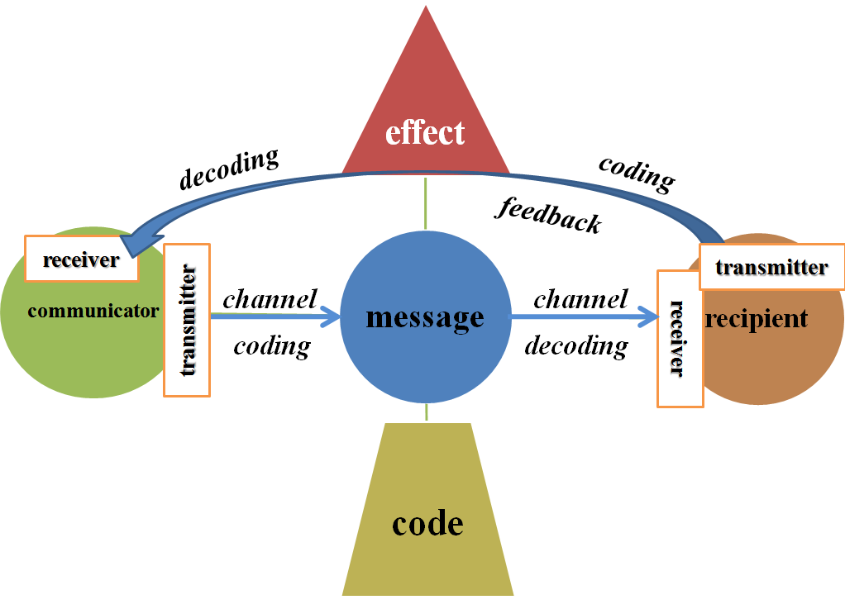
- The consolidated model of electronic communication
In this model, OGD participants are: the head of a state institution, an official, a clerk, a businessman and a citizen. In this case the sender will be a certain alliance of the institution head, the official, the clerk, the computer software developers, etc., because their goal is to create databases which would the used for the regulation of economic, political, social and cultural relations between the authorities and society, the manufacturer and the consumer, etc. The database is the information which is encoded in the form of statistics, special symbols, simplifying the understanding and perception of the users, in this case, citizens. Citizens, businessmen and other potential users of this information product, being recipients of such information, decode simplified statistical data in accordance with their level of education and knowledge. However, dry figures in a table often do not provide an overview of a socially significant aspect dynamics. Such presentation of information is not very effective to a user. Infographic visualization using different tools (diagrams, drawings, histograms, bar graphs, maps, etc.) can facilitate OGD perception. However, this form of information has some drawbacks: static images, low user involvement in the problems presented by OGD. Animation, interactivity, immersing the user into a virtual environment of OGD problematics are key gamification mechanisms. An exemplary model of electronic communication through gamification of open data portals is presented in Figure 2.
One should clearly define the performance criteria for each of the communication components in the situation of OGD gamification. For example, the performance criteria can be the degree of exerted influence, changes in the player’s attitude to the social problem presented in OGD, the achievement of the original goal. The indicator of feedback is its intensity, namely, number of players, query statistics, etc. The effectiveness of gamification is manifested in the popularity of the game, so feedback indicators correlate with indicators of gamification. The success or failure of the feedback is actually the regulation of economic, political, social and cultural relations between the authorities and society, between the producer and the consumer as well as the assistance of the citizens to the authorities in different matters of politics, economics, etc. In other words, the feedback is the result of actions directed by the sender to the recipient, the rate of effective interaction between the owners and users of OGD.
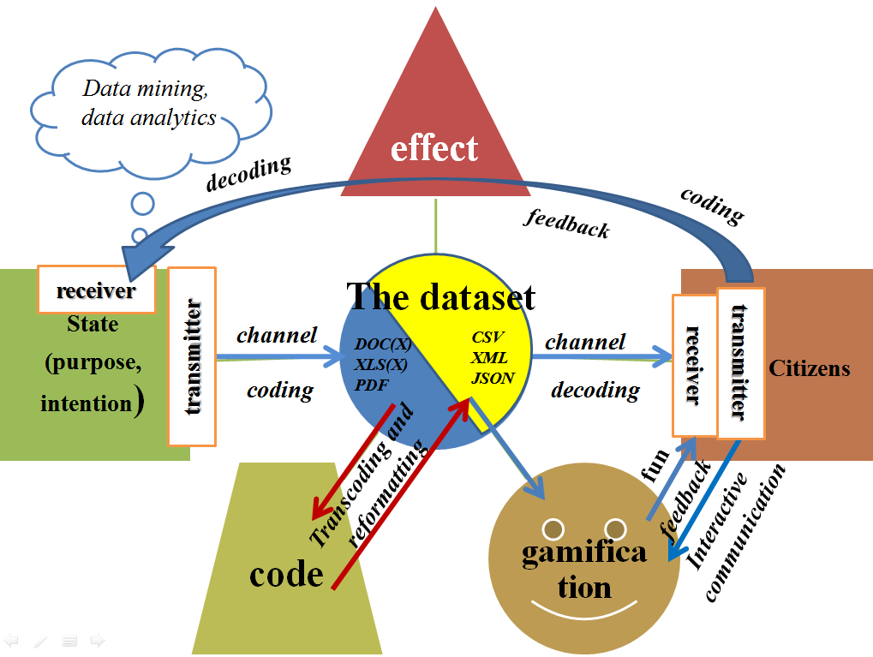
- Model of electronic communication through open data portals gamification
The following factors influence the effectiveness of OGD gamification: an adequately selected genre (action, simulators / managers, strategy, adventure, music, role-playing, logic, etc.), class (flash, arcade, 3D) and context (the story, the characters of the game) for generating data playability. The question is, what types of data can be represented in dynamic games (shooters, fighting games, stealth-action, etc.), planning games and simulators, plot-based (Action, Quest) and logic games.
The game genre must define the process of metaphorization during the transition from OGD entities to the game characters and items. For example, city OGD, as a rule, are the basis for socio-economic forecasting of the area development, so it is essential to use them in the "strategy" game genre. A good example is the game "Megapolis" of iLogos company, which is based on creating a virtual city with industry, water / energy supply and entertainment, based on a fictitious financial capital. Such games can use OGD with a budget line item of income / expenses of the city (XLS-files), OGD with the general plan of the city (graphical files) and other OGD with the city's infrastructure, providing the citizens with the ability to simulate the ways of the city development by means of the game.
The analysis of DOC-documents on the site of the Main Statistical Office in Odessa region (http://www.od.ukrstat.gov.ua) shows the main groups of themes for OGD-based games development. They are population and migration, labor market, prices, justice and crime, education, health, social protection, settlements and lodging, culture, economics and trade, science, technology and innovation, socio-economic development of the city and the region, income and living conditions. All of these topics are presented in the OGD in quantitative terms. For example, population growth (number of live births and deaths) for a certain period, the number of medical and educational institutions, consumer price indices for specific goods and services for certain months and years, the tempo and dynamics of increase / decrease of the nominal and real salary by years, by economic activities types, etc. The genre and the class of the game depends on the OGD scope and the coverage of the topics. A separate OGD section on the topic can be put to an arcade or a flash game in the catcher genre (for example, for a topic concerning population migration) or shooter genre (for a costs-related topic). Gamification of large OGD volume, especially on the intersection of several topics, makes it possible to create 3D games in the genre of planning (strategies, cases) or simulation (for example, "Store", "Recruiter", "Hospital", "Headmaster", etc.).
During the OGD game story creation it is important to maintain a dialogue between the axiological systems of the government and the citizens of various categories, based on the goals that were set during OGD gamification. For example, in the "shooter" genre there is a need of metaphorization for the game characters such as "monsters", "spacecraft" and survival tools such as "arms", "magic". This binary opposition of "good - evil" ("friend - foe") easily becomes the basis for the topic of justice and crime of city. However, it can not be applied to the subject of population and migration. The aim of the game should always to be linked to the achievement of positive results while considering the OGD semantics. Therefore the genre determining the process requires an analysis of keyword nouns of the OGD, which must not contradict the main action verbs of the genre. For example, if OGD contain the keyword "person", it is impossible to gamificate this OGD into the genre of "shooter" with the action-verb "kill". But for OGD with the keyword "price of production" it is possible, because the verb "kill" in relation to the price of products is used in the form of a metaphor.
A computer game has an obvious or hidden narrative, which is created through metaphorization - the concepts of one domain transfer their properties to the concepts from a different domain. We define metaphorization as the process of encoding, the mapping of symbols and signs from one sphere of knowledge and ideas to another. This process takes into account the conversion of natural language to computer-oriented language, as well as the channel of electronic communication and the context influencing its perception and decoding, etc. [15]. The context comprises physical, social, historical, psychological and cultural environment of the interaction between all participants of OGD process. For instance, technical equipment conditions, weather conditions, location of the equipment, such as the database server, form the physical context of communication. The links formed between the participants in the previous communication episodes form the historical context. Recipients convictions, their values, attitudes, social hierarchy, religion, the group roles and the time concept – all of these make the cultural context.
The collision between the axiologies of the communicator and the communicant, OGD and its user, generates communication barriers that can appear at all the stages of the communication process: transmission, encoding, decoding, reception and feedback. At the same time they are generated by anthropological factors such as the users computer literacy, their value systems, "cultural code" as a set of competencies and images associated with stereotypes in their minds, formed under the influence of modern culture in the process of socialization, education, media influence. All of this makes it possible to understand the semantics of the symbols referred to in the game.

IMPLEMENTATIONS
Data Games can only work with the data in structured text formats like CSV, XML, JSON, while public statistical data published at http://od.ukrstat.gov.ua are in DOC(X) or PDF. Therefore, to solve the problem of reading the data sets the following systems have been developed:
- “Odessa Public Open Data Portal” (http://data.ngorg.od.ua) based on free software DKAN.
- Software module “Data Transformer DOC2CSV” for automated table extraction from files in text-processor format, which has reduced the complexity of obtaining 143 OGD of different categories from 65 DOC-format documents [12].
Figure 3 shows the relationship of software modules for gamification of OGD with existing portals and websites.
The important selection criterion is the complexity of computer games development, which directly depends on the complexity of their design. Therefore, it is necessary to simplify the design of the game at the same time preserving its original goal, starting with the development of an arcade game. For that, we suggested displaying OGD as a histogram on the example of the Bar Chart Ball game [4]. The target audience of this game are as follows: students studying economic geography; students of humanities, as well as heads of public institutions.
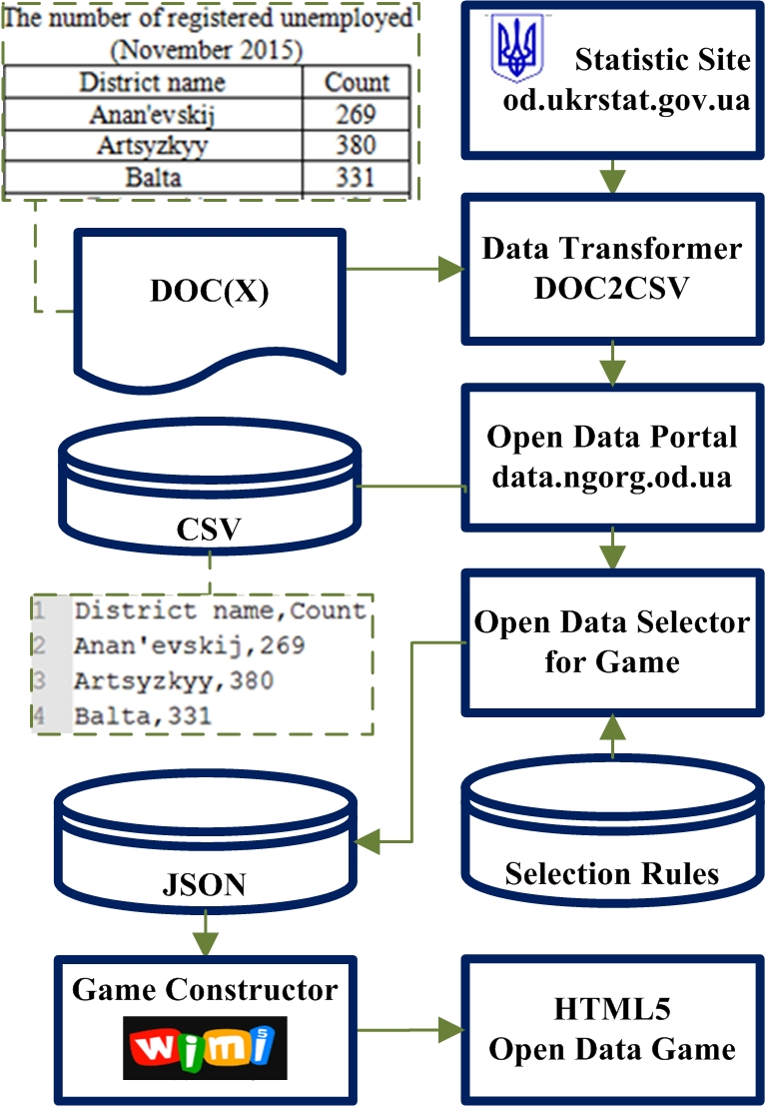
- The relationship of software modules for gamification of OGD with existing portals and websites
Design of a histogram game includes the following modified rules of the game "Bar Chart Ball":
- (1) The OGD is randomly selected and its histogram with columns is drawn. The columns values are the names of the regional districts taken from OGD table, their height is calculated from the OGD attribute value table corresponding to the region, as well as a picture describing the semantics of the OGD;
- (2) At the beginning of the game the ball is located on the leftmost column, and the game ends if the ball reaches the far right column;
- (3) The ball can start moving when the height of the right column is lower than that of the current column, otherwise its movement stops;
- (4) The user is presented with a list of OGD that should contain at least one OGD which provides the match between the goal of the game and the purpose of OGD;
- (5) If the list provided for user has no correct OGD, then a message is displayed on the deadlock and the ball is forced to the top column on the right side;
- (6) The columns of the districts may be arranged in the alphabetical order or in the order of the territorial proximity of the areas on the map according to the player's choice;
- (7) The player sees only a part of the columns of the districts on the screen, and the remaining columns of the districts will appear in groups on the new screen-stage, when the ball reaches the far right of the current scene of the game.
The main difference of the proposed rules from the rules of the game Bar Char Ball is:
- The 4th rule that prohibits the player to use the moral connotations of the OGD to achieve the goal of the game. It is necessary, for instance, to ensure that the player does not have the impression that high mortality rates in OGD contribute to the achievement of the goal of the game;
- The 5th rule, which considers the column as an insurmountable barrier to the movement of the ball. The column is indicated by an appropriate ideogram or sign-picker;
- The 6th rule, which considers the columns as a route model on the territorial map and invites the player to successfully pass through all districts.
The main difference between the proposed rules and the rules of the game "Bar Char Ball" is the fourth rule, which prohibits the player to use the moral connotations of OGD to achieve the goal of the game. For example, it is necessary to ensure that the player does not get the idea that high death rates in OGD help to achieve the goal of the game.
The software module “Open Data Selector for Game” selects OGD for the game based on its genre. The selection rules are stored in the “Selection Rules” database in the form of logical conditions set. For example, for an arcade game such as the histogram, the OGD with statistical data on the regional districts are selected, while for a shooter game the selected OGD should not contain keywords which are on the list of inappropriate words. Selected OGD are stored in a JSON database.
OGD gamification module is developed with the help of the game constructor WiMi5 which allows visual programming of the 2D web games and automatically generates HTML5, CSS3, Javascript code, stored in Chrome Web Store.
Figure 4 shows screenshot with an example of a game.
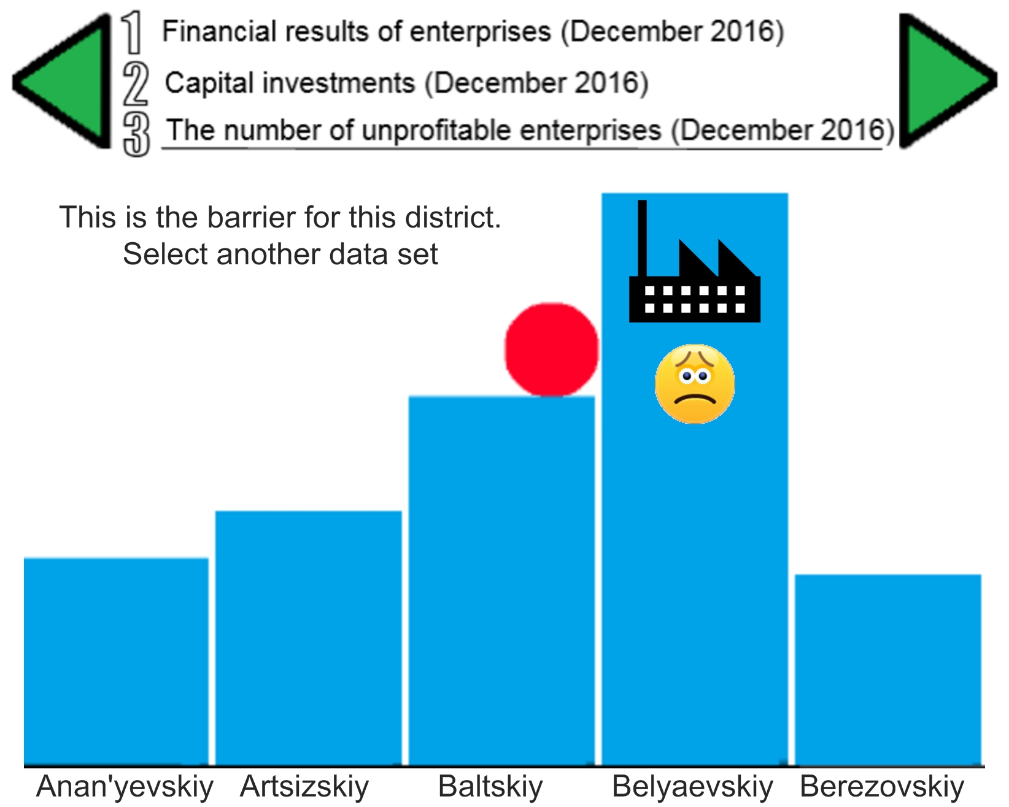
- Screenshot with an example of a game
OGD are manually selected from a JSON database and included into the software code of WiMi5. After the compilation in WiMi5, the game is published at the Chrome Web Store and its URL-address gets published in the OGD passports on the open data portal. That allows the visitor of the web portal to have access to the game while viewing the data of OGD.

CONCLUSIONS
Summing up, it should be noted that according to the Law of Ukraine on access to public information, government agencies are faced with the problem of providing at the request of society public information, connected to any activities of the state at different times. Such information should be the means of regulating economic, political, social and cultural relations between the authorities and society, between manufacturer and consumers, etc. This problem may be approached in a creative way and with outside-the-box thinking. One of such ways is the use of gamification for improving the relationships between government and citizens, aimed at attracting the attention of citizens to the socially problematic aspects of life, creating the government transparency and awareness of the results of governmental organizations activity, strengthening the loyalty of citizens and improving their quality of life.
Analysis of the information and communication component of OGD gamification through the structural communication model allows a more careful consideration of the OGD functioning mechanism as well as correctly choosing the genre and class of a computer game, destroying the communication barriers, creating the conditions for socially positive result and optimizing the communication between the authorities and the people.
For data games we suggest applying Applied Mathematics methods, those most suitable for each domain. In this case, at the request of the player, the computer calculates, outputs and explains optimal solutions. For example, Queue Theory can be applied in the field of services in order to assess the efficiency of enterprises both in terms of waiting times and customer service, as well as the optimal use of resources. In the area of ecology simulation, it is possible to predict the state of the environment depending on the various options of economic activity. For the industry and the economy, it is advisable to use the mathematical game theory, based on optimal strategies that lead to the creation of stable balance in particular, or the analysis of trade deals and negotiations for the formation of coalitions. The data obtained from mathematically processing the results of the game are the subject of feedback in the structure of communication "State - OGD - citizens", allowing optimizing the mechanism of state regulation of the social life.
The goal of the player in the developed game should always be connected to the achievement of positive results based on the OGD semantics. But there are OGD with ambiguity in the evaluation of the results. For example, in case of OGD on agricultural price statistics, price growth is a positive process for a farmer, but negative for a buyer. Therefore, in the future game you need to take into account the target group to which the player belongs. The group should be selected by the player or the program during the game.
At the end of 2015 Odessa National Polytechnic University participated in the launching of The European Commission project Erasmus+KA2 "GameHub: university-enterprise cooperation in the gaming industry in Ukraine" (№561728-EPP-1-2015-1-ES-EPPKA2-CBHE-JP). The main expected outcomes of the project are the following:
- GameHub structure and facilities at every Ukrainian partner university;
- newly created Game labs with learning modules, providing open and innovative teaching resources for new subjects that will modernize the Ukrainian engineering education;
- training provided to university teachers, students and unemployed (including ATO veterans) to enhance their skill and competency levels.
The methodology ideas as well as software and hardware solutions proposed in this paper will be used for the above mentioned project.
The proposed communicative model in the context of Ukrainian informational politics makes it possible to take a complex look at the process of gamificating open data and integrating it into the social communications system of the country, thus integrating it into the united global informational space.

Acknowledgment
This publication was created with the support of the European Commission Erasmus+KA2-project "GameHub: University-enterprises cooperation in game industry in Ukraine"(№ 561728-EPP-1-2015-1-ES-EPPKA2-CBHE-JP). The European Commission support for the production of this publication does not constitute an endorsement of the contents which reflect the views only of the authors, and the Commission cannot be held responsible for any use which may be made of the information contained therein.

References
- M. G. Friberger, J. Togelius, A. B. Cardona, M. Ermacora, A. Mousten, M. M. Jensen, V.-A. Tanase and U. Brøndsted, “Data Games”, in 4th Workshop on Procedural Content Generation, ACM, 2013, рр. 1-8.
- “ODB Global Report Third Edition” [Online]. Available: http://opendatabarometer.org/doc/3rdEdition/ODB-3rdEdition-GlobalReport.pdf
- C. Macklin, J. Wargaski, M. Edwards and K. Y. Li, “DATAPLAY: Mapping game mechanics to traditional data visualization”, in Proceedings of DiGRA, 2009.
- J.Togelius, M.G. Friberger, “Bar Chart Ball, a Data Game”, in Proc. 8th International Conference on Foundations of Digital Games (FDG 2013), 2013, pp. 451-452.
- G. A. B. Barros, “Data Games :Towards generating content using the real world”, in Proc. Doctoral Symposium of the 9th International and Interdisciplinary Conference on Modeling and Using Context (CONTEXT 2015), Larnaca, Cyprus, P. W. Eklund and R. Wegener, Eds, Vol.1537, 2015, pp. 15-22.
- J. Togelius, G. N. Yannakakis, K. O. Stanley and C. Browne, “Search-based procedural content generation” in Proc. EvoAppl., Germany, Berlin:Springer-Verlag, vol. 6024, 2010, pp. 147-161.
- M. G. Friberger, J. Togelius, “Generating game content from open data”, in Proc. International Conference on the Foundations of Digital Games, 2012, рр. 290-291.
- “Analytical Center. Data Journalism Agency TEXTY” [Online]. Available : http://texty.org.ua.
- M. Ney, V. Emin and J. Earp, “Paving the way to Game Based Learning: a question matrix for Teacher Reflection”, in Virtual Worlds for Serious Applications (VS-GAMES’12), Genova, October 2012, pp. 17-24.
- S. Diewald, A. Moller, L. Roalter, T. Stockinger and M. Kranz, “Gameful Design in the Automotive Domain: Review Outlook and Challenges”, in Proc. 5th International Conference on Automotive User Interfaces and Interactive Vehicular Applications ser. AutomotiveUI'13, 2013, pp. 262-265.
- D.D. Reese, “CyGaMEs Selene player log dataset: Gameplay assessment, flow dimensions and non-gameplay assessments”, British Journal of Educational Technology, Vol. 46, № 5, pp. 1005–1014, 2015.
- A. Kungurtsev, O. Blazhko, S. Kovalchuk and M.Skripkin, “Automating of creation of electronic documents warehouse on web-portals of open data”, Bulletin of NTU “KhPI”, Series: Mechanical-technological systems and complexes, Kharkov: NTU “KhPI”, vol.4 (1176), pp. 31–37, 2016.
- A. Vetrò, L. Canova, M. Torchiano, C. O. Minotas, R. Iemma and F. Morando, “Open data quality measurement framework: Definition and application to Open Government Data”, Government Information Quarterly, Vol. 33, Issue 2, pp. 325-337, 2016, doi: 10.1016/j.giq.2016.02.001.
- J. Hamari, J. Koivisto and H. Sarsa, “Does gamification work? - A literature review of empirical studies on gamification”, in Proc. 47th Hawaii Int. Conf. Syst. Sci., 2014, pp. 3025-3034.
- S. Möring, “Games and Metaphor – A Critical Analysis of the Metaphor Discourse in Game Studies”, Ph.D. dissertation, IT University, Copenhagen, 2013.

