**МІНІСТЕРСТВО ОСВІТИ І НАУКИ**

**ОДЕСЬКИЙ НАЦІОНАЛЬНИЙ ПОЛІТЕХНІЧНИЙ УНІВЕРСИТЕТ**

Конспект

лекцій із загального курсу фізики

розділ: «**Electricity and magnetism**»

Одеса ОНПУ 2019

**МІНІСТЕРСТВО ОСВІТИ І НАУКИ**

**ОДЕСЬКИЙ НАЦІОНАЛЬНИЙ ПОЛІТЕХНІЧНИЙ УНІВЕРСИТЕТ**

Конспект

лекцій із загального курсу фізики

розділ: **«Electricity and magnetism»**

для студентів усіх спеціальностей

Затверджено

на засіданні

Кафедри фізики ОНПУ

Протокол № від 2019

Одеса – ОНПУ - 2019

Конспект лекцій з дисципліни «Фізика», розділ «Electricity and magnetism» для студентів усіх спеціальностей денної форми навчання / Укл.: М.Є. Дюбченко, Н.М.Корнєва, Н.Н. Красницька – Одеса: ОНПУ, 2019.- 103 с.

Укладачі: М.Є. Дюбченко, к. т. н., Н.М. Корнєва, к. ф.-м .н., Н.Н. Красницька, к.філ.н.

Рецензент: **О.В. Маслов**, доктор техн. наук, проф..

Конспект лекцій містить основні відомості про електричне і магнітне поля. Розглядаються основні характеристики обох полів, утворених різноманітними фізичними об`єктами. На підставі класичної теорії електропровідності виведені закони Ома в диференціальній і інтегральній формах. ­Скорочено дані основи теорії Максвела для електромагнітного поля в інтегральній формі.

Учбовий матеріал супроводжується графічними матеріалами.

Table of contents

page

Part I. ELECTROSTATICS 6

Chapter 1. ELECTRIC FIELD IN VACUUM 6

§1. The law of conservation of electric charge 6

§2. Coulomb's Law 7

§3. Electric field 9

§4. The main characteristics of the electrostatic field - electric field strength and potential 9

§5. The relationship between the electric field strength and potential 12

§6. Flux of vector of the electric field strength 14

§7. Ostrogradski-Gauss theorem for an electrostatic field in a vacuum and its connection with Coulomb's law 15

§8. Application of the Ostrogradski-Gauss theorem to the calculation of fields 18

1) The field of an infinite uniformly charged plane 18

2) The field of two oppositely charged planes (Fig. 8.5) 20

3) Field of charged spherical surface 22

4) Field of a volume-charged ball 24

5) The field of infinite charged cylinder 26

Chapter 2. ELECTRIC FIELD IN DIELECTRICS 28

§1. Free and bound charges in dielectric. Types of dielectrics. 28

§2. Electronic and orientational polarization. Polarization vector 29

§3. The dielectric susceptibility of a substance and its temperature dependence 30

§4. Ostrogradski-Gauss theorem for the electric field in a dielectric. Electric displacement. Dielectric permeability of the medium 31

Chapter 3. CONDUCTORS IN ELECTRIC FIELD 34

§1. The field inside the conductor and near its surface. Charge distribution in conductor 34

§2. Electrical capacitance of solitary conductor 36

§3. Mutual capacity of two conductors. Capacitors. 37

§4. The energy of a charged solitary conductor and capacitor 39

§5. The energy of the electrostatic field. Bulk energy density. 40

Part II. CONSTANT ELECTRICAL CURRENT 42

§1. Constant electric current, its characteristics and conditions of existence 42

§2. Classical electronic theory of the electrical conductivity of metals and its experimental justification 44

1. Experience Riecke (1901) 46

2) Experiments of Stuart and Tolman (1916) 46

§3. The derivation of Ohm’s law in differential form from electronic representations 47

§4. Wiedemann-Franz law 48

§5. The generalized Ohm's law in integral form. Potential difference, electromotive force, voltage 49

§6. Joule-Lenz law 52

§7. The difficulties of the classical theory of the electrical conductivity of metals 54

§8. Electrons work function from metal. Thermionic emission 55

Part IІІ. ELECTROMAGNETISM 57

Chapter 1. MAGNETIC FIELD IN A VACUUM 57

§1. Magnetic field. Magnetic induction. Magnetic moment of the contour with current 57

§2. Ampere's law 60

§3. The magnetic field of the current. Biot-Savart-Laplace law and its application to the calculation of magnetic field. 62

a) The magnetic field of a rectilinear conductor with current 63

b) Magnetic field of circular current 65

§4. Vortex nature of a magnetic field. The law of total current for a magnetic field in vacuum and its application to the calculation of the magnetic field of a long solenoid 67

§5. The magnetic field of a moving charge 70

§6. Effect of a magnetic field on a moving charge. Lorenz force 72

§7. Motion of charged particles in a magnetic field. The principle of operation of cyclic charged particle accelerators. 73

§8. Hall effect. MHD - generator 76

§9. Magnetic flux. Ostrogradski-Gauss theorem. 78

§10. The work of moving in a magnetic field the conductor and the contour with a current 79

Chapter 2. ELECTROMAGNETIC INDUCTION 81

§1. Electromagnetic induction phenomenon 81

§2. The self-induction phenomenon. Inductance 83

§3. Current at closing and opening of the circuit containing inductance 84

§4. The phenomenon of mutual induction. Mutual inductance 87

§5. Magnetic field energy 88

Chapter 3. MAGNETIC FIELD IN SUBSTANCE 90

§1. Magnetic moments of electrons and atoms. Types of magnetics 90

§2. Micro and macro currents. Magnetization. Magnetic field strength 92

§3. Magnetic susceptibility and magnetic permeability of the substance. The law of total current for a magnetic field in a substance 93

§4. Diamagnets and paramagnets 94

§5. Ferromagnets. Magnetization curve. Magnetic hysteresis 95

§6. Spin nature of ferromagnetism. Domains. Curie point 97

Part IV. FUNDAMENTALS OF THE THEORY OF MAXWELL FOR ELECTROMAGNETIC FIELD 98

§1. Displacement current 98

§2. Maxwell's equations for the electromagnetic field in the integral form 100

**ELECTRICITY AND MAGNETISM**

# Part I. ELECTROSTATICS

## Chapter 1. ELECTRIC FIELD IN VACUUM

## §1. The law of conservation of electric charge

Electrostatics studies the interaction and properties of electrical charge systems that are stationary relative to the chosen inertial reference system.

Electric charge is a property of elementary particles that determines their electromagnetic interaction.

The entire set of electrical and magnetic phenomena is the manifestation of the existence, movement and interaction of electric charges. There are two types of electric charges - positive and negative. The charges of the same sign push off each other, and of different signs attract each other.

Electric charges are associated with material carriers. The smallest stable particle with a negative elementary charge is the electron



The elementary particles also include proton, neutron, positron, etc. The charge of the proton is positive and equal in magnitude to the electron charge. However, its rest mass is 1838 times the mass of an electron. A positron is a positively charged particle with a charge and mass equal to the charge and mass of an electron. The neutron is a neutral particle with a mass slightly exceeding the mass of the proton.

Atoms and molecules of any substance are built from these particles, therefore electric charges are part of all bodies. Since the charge of any body is formed by a set of elementary charges, it is an integral multiple of the elementary charge

$q=±\text{Ne}$ (1.1)

If a physical quantity can take only certain discrete values, then that means that it is quantized. The fact expressed by the formula (1.1) means that the electric charge is quantized. However, the elementary charge is so small that the change in the charge of macroscopic bodies can be considered continuous.

The magnitude of the charge, measured in different inertial systems, is the same, therefore it does not depend on whether this charge moves or is at rest.

One of the fundamental laws of nature is **electric charge conservation law**:

***The algebraic sum of the electric charges of bodies or particles that form an electrically isolated system does not change in any processes occurring in this system.***

New electrically charged particles can form in the system. For example, when the atoms of a substance are ionized, electrons and positively charged ions are formed. However, the algebraic sum of the charges of new particles is always zero and therefore the total charge of an isolated system will not change.

## §2. Coulomb's Law

The forces of interaction of fixed bodies or particles due to their electric charges are called electrostatic forces.

In 1785, Coulomb experimentally established a law that obeys the strength of the interaction of point charges.

Charged bodies, the size and shape of which can be neglected in this task, are called point charges.

Coulomb's law:

***the force of electrostatic interaction of two point charges in a vacuum is directly proportional to the product of these charges, inversely proportional to the square of the distance between the charges and directed along the line connecting them:***

$${\vec{F}}_{\text{12}}=k\frac{q_{1}q_{2}}{r^{2}}⋅\frac{{\vec{r}}_{\text{12}}}{r}$$

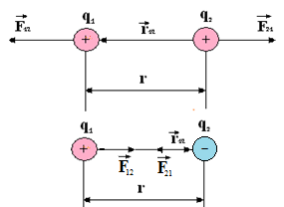

Fig. 2.1

- force acting on charge $q_{1}$ from charge $q_{2}$

***k*** – proportionality coefficient, depending on the choice of the system of units;

- radius-vector connecting charge $q_{2}$ with charge $q_{1}$.

In the SI system $k=1/4{\text{πε}}_{0}=9\text{.}{\text{10}}^{9}\frac{N⋅m^{2}}{{\text{C}}^{2}}$

The value  **= 8.85.10-12 F /m** is called the electric constant.

Accordingly, the Coulomb's law can be written as

$${\vec{F}}_{\text{12}}=-{\vec{F}}_{\text{21}}=\frac{1}{4{\text{πε}}_{0}}\frac{q_{1}q_{2}}{r^{2}}⋅\frac{{\vec{r}}_{\text{12}}}{r}$$

This form of the Coulomb's law is called rationalized.

In scalar form, the law has the form

$$F_{0}=\frac{1}{4{\text{πε}}_{0}}\frac{q_{1}q_{2}}{r^{2}}$$

If the charges are located in a homogeneous isotropic medium, then the Coulomb's law can be written as

$$F=\frac{1}{4{\text{πε}}_{0}}\frac{q_{1}q_{2}}{ε⋅r^{2}}$$

Here ε is the dielectric constant of the medium, which shows how many times the force of interaction of charges in the medium is less than the force of their interaction in vacuum:

$$ε=\frac{F_{0}}{F}$$

The forces acting on the charge are central. In the interaction of like charges F> 0, because $q_{1}q_{2}>0$, which corresponds to repulsion, and in the interaction of opposite charges $q_{1}q_{2}<0$ and F <0 - the attraction occurs.

Any charged body can be considered as a system of point charges. Therefore, the force with which one charged body acts on another is equal to the geometric sum of the forces applied to all the point charges of the second body from the point charges of the first body

$${\vec{F}}_{\text{12}}=\sum_{i=1}^{n}{\sum_{k=1}^{m}{{\vec{F}}_{\text{ik}}}}=\sum_{i,k=1}^{n_{1}m}{{\vec{F}}_{\text{ik}}}$$

## §3. Electric field

Coulomb interaction between fixed charges is carried out by means of an electrostatic field created by them. The electrostatic field is stationary, i.e. an electric field that does not change with time. In the general case, the electric field interacts between electric charges moving arbitrarily with respect to the inertial reference system.

An electric field manifests itself in the fact that an electric charge placed at some point of it is under the action of a force. The magnitude of the force acting on the charge can be judged from the "intensity" of the field. A characteristic feature of the electric field that distinguishes it from other physical fields is that it acts on an electric charge with a force that does not depend on the speed of the charge.

Modern physics asserts that the electric field really exists and in this sense, along with matter, is one of the kindes of matter. The field has energy, momentum and other physical properties.

## §4. The main characteristics of the electrostatic field - electric field strength and potential

The power characteristic of the electric field at a given point **is the vector of the electric field strength $\vec{E}$** , equal to the ratio of the force $\vec{F}$, acting from the field to a point trial charge placed at a given field point to the value of this charge $q_{0}$

 (4.1)

As a trial charge is usually taken a positive unit charge.

The strength of the electrostatic field, created by a point charge q in a vacuum can be found according to the Coulomb's law



or in scalar form

 (4.2)

- radius-vector, connecting the charge q with the point where the field strength is calculated.

At all points of the field, the vectors $\vec{E}$ are directed from the charge, if q > 0, and to it, if

q < 0, i.e. the direction of the vector $\vec{E}$ coincides with the direction of the force acting on the positive charge.

For the graphic image of the fields used the method of field lines. Field lines are called the lines, the tangents to which at each point coincide with the direction of the field strength vector. Field lines are considered directed as the field strength vector (examples on fig.4.1).

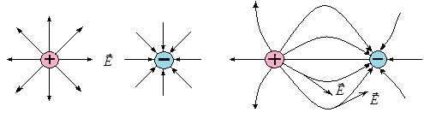

Fig. 4.1

Along with the vector $\vec{E}$, the vector of electric induction $\vec{D}$ is introduced, which

does not depend on the properties of the medium and is determined by:



Consider a field created by a fixed point charge ***q*** (fig.4.2). If under the action of the forces of the field, the charge $q_{0}$ has moved a distance $dl$, then the forces of the field has done the work

, (4.3)

where - angle between vectors $\vec{E}$ and $d\vec{l}$.

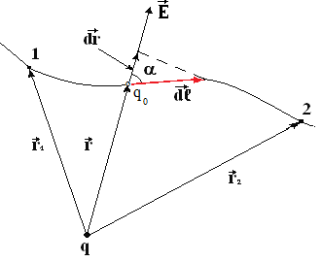

Fig. 4.2

The work of the Coulomb forces in the charge transfer from point 1 to point 2 is 

Since  represents the increment of the radius-vector module, then

 (4.4)

Consequently, the work done by the field forces to move the charge from one point to another does not depend on the shape and length of the move, but depends on the initial and final position of the moving charge. Therefore, the electrostatic field is potential.

The work of the potential field forces can be represented as a decrease in the potential energy of a charge in this field:

, (4.5)

where ${ E}_{p_{1}}$ and $E_{p_{2}}$- the values of the potential energy of the charge $q_{0}$ at points 1 and 2.

Comparison of formulas (4.4) and (4.5) leads to the following expression for the potential energy of a charge $q_{0}$ in a charge field ***q***

 (4.6)

From (4.6) it follows that the ratio of the potential energy of a charge $q_{0}$ to its value at each point of the field does not depend on $q_{0}$ and therefore can serve as an energy characteristic of the field.

**A scalar physical quantity that is numerically equal to the ratio of the potential energy of a charge placed at a given point of the field to the magnitude of that charge is called the potential of the electrostatic field.**

It serves as a measure of the potential energy at a given point of the field, in which conditionally the potential energy is zero.

 (4.7)

Substituting the value of potential energy (4.6) into formula (4.7), we obtain the following expression for the potential of a point charge:

 (4.8)

The work done by the forces of the electric field when the charge $q_{0}$ moves from one point of the field to another can be expressed in terms of the potential difference at these points:

 (4.9)

Thus, the work done on the charge by the field forces is equal to the product of the charge magnitude and the potential difference at the initial and final points.

If point 2 is located at infinity, where by condition the potential is zero, then the work of the field forces will be equal to

,

where ϕ - is the potential at the given point of the field.

It follows that

$φ=\frac{A_{∞}}{q_{0}}$.

At  

Therefore, ***the potential is numerically equal to the work done by the field forces over a unit positive charge when it is removed from a given point to infinity***.

The same amount of work must be done against the forces of the electric field in order to move a unit positive charge from infinity to a given point of the field.

**In the SI system, as a unit of the potential, called a volt, is taken the potential at such a point, to move to which from infinity a charge equal to 1 Coulomb, you need to do work in 1 joule**:



If a field is created by a system of point charges $q_{1},q_{2},\text{...}q_{n}$, then the potential of the field is equal to the algebraic sum of the potentials created by each of the charges separately:



## §5. The relationship between the electric field strength and potential

The potential of the electrostatic field is a continuous scalar function of the coordinates of the field points. In any real field, you can select a set of points for which $φ=\text{const}$. Such a locus of points of equal potential is called an equipotential surface (fig.5.1).

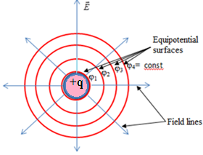

Fig.5.1

Field lines are always perpendicular to equipotential surfaces. Indeed, if the charge moves along an equipotential surface, then the work of moving it in a certain area 1-2:

$A_{\text{12}}=q_{0}\left(φ_{1}-φ_{2}\right)=0$ since $φ_{1}=φ_{2}$

On the other hand



This is only possible when

$$\text{cos}\left(\vec{E},^{Λ}d\vec{l}\right)=0$$

**Those. the angle between the vector $\vec{E}$ and the vector $d\vec{l}$, tangent to the equipotential surface, is $π/2$.**

Consider two infinitely close equipotential surfaces $φ$ and $φ+dφ$ (fig.5.2).

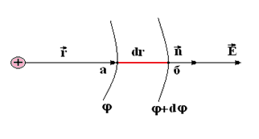

Fig. 5.2

The electric field strength vector is directed along the normal to the equipotential surface. When moving a positive charge from point "a" to point "b", performed work is



From here .

The value  characterizes the intensity of the potential change in the direction of the normal $\vec{n}$ and is called the potential gradient. The potential gradient is a vector quantity and is denoted by $\text{qrad}φ$:

$$\vec{E}=-\text{qrad}φ$$

The sign “-“ means, that the vector $\vec{E}$ and $\text{qrad}φ$ are directed in opposite directions. The vector $\vec{E}$ is directed towards decreasing the potential and, moreover, the fastest, since the rate of change of potential in the direction of the shortest distance between the equipotential surfaces is maximum (fig.5.3).

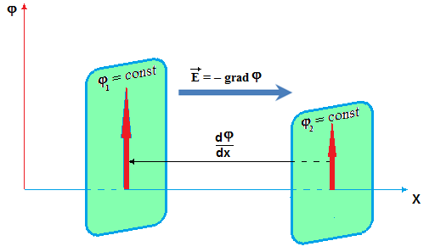

Fig.5.3

Since the potential is a scalar value and is easily measured experimentally, the field is usually characterized by setting the potential values at different points, and the connection between them is used to determine the field strength.

## §6. Flux of vector of the electric field strength

Field lines are useful not only because they clearly demonstrate the direction of the field, but also because they can be used to characterize the magnitude of the field in any region of space. For this, the density of the field lines should be numerically equal to the magnitude of the electric field strength.

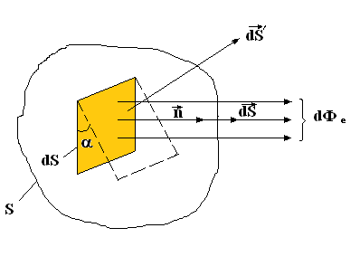

Fig. 6.1

Let choose on the surface ***S*** a small area ***dS***, perpendicular to the direction of the field $\vec{E}$. Let ${\text{d}\text{Ф}}_{е}$ be the number of force lines, crossing ***dS*** (fig.6.1). Then



or .

Let introduce a vector $d\vec{S}$, whose modulus is equal to the size of the area *dS*, and the direction coincides with the direction of the normal $\vec{n}$ to the area and therefore parallel $\vec{E}$:



Since the direction of the vector $\vec{n}$ is arbitrary, it is not a true vector, but a pseudovector.

Consider a small area $dS^{'}$, that is rotated relative to *dS* at an angle $α$ and through which the same number of field lines ${\text{d}\text{Ф}}_{е}$ passes. In this way

.

Let's take the scalar product of vectors $\vec{E}$ and $d{\vec{S}}^{'}$:

.

This shows that in the general case the number of field lines or the flux of the electric field strength:



Then the total flux $Ф_{е}$ of the electric field through the surface S is equal to the algebraic sum of the fluxes through all small portions of this surface:



## §7. Ostrogradski-Gauss theorem for an electrostatic field in a vacuum and its connection with Coulomb's law

Suppose that a closed surface covers two point charges $q_{1}$ and $q_{2}$ (fig.7.1).

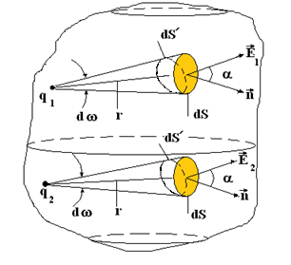

Fig. 7.1

Then the total number of lines (flux of electrical field strength) crossing this surface is

, (7.1)

where ${\vec{E}}_{1}$- is the field, created by the charge ;

- field, created by charge $q_{2}$.

Rewrite (7.1) in scalar form

, (7.2)

where  is the projection *dS* on the plane, which is perpendicular to the radius, connecting the point charge with the given field point.

In turn

$dS^{'}=r^{2}dω$, (7.3)

where $dω$- is the solid angle at which the area *dS* is visible from the point where the charge is located $q_{1 }$ or $q_{2}$;

$r$  - distance from the charge to the area *dS*.

Using the expressions for the field strengths, created by the charges $q_{1}$ and $q_{2}$ and the formula (7.3), by substituting them into (7.2), we get



The result obtained can be generalized to the case when inside a closed surface there are n point charges:



The result obtained is the *Ostrogradski-Gauss theorem*:

**The flux of the electrostatic field strength in vacuum through an arbitrary closed surface choosed in the field is proportional to the algebraic sum of the electric charges covered by this surface.**

The theorem is valid regardless of the presence of charges outside a closed surface. For example, consider a closed surface, inside which ***q = 0*** and the field is created only by external charges (fig.7.2)

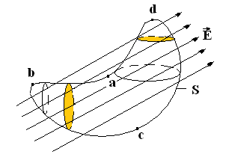

Fig. 7.2

The total flux penetrating the surface ***S*** can be written as the sum of the individual components, considering the lines leaving the surface to be positive and entering into it negative.

Then

,

which is consistent with the Gauss theorem.

The connection between the Ostrogradski-Gauss theorem and the Coulomb’s law lies in their mathematical equivalence. However, if we use the Coulomb's law to calculate the fields outside and inside charged bodies, we would have to carry out cumbersome calculations by dividing the body into point charges and calculating complex integrals. If Newton had known the Gauss theorem, then the proof that the earth's field behaves as if its entire mass is concentrated in the center of the earth would take only two lines and would not have to calculate a complex triple integral.

The use of the Ostrogradski-Gauss theorem is especially convenient in the case of fields that have a previously known symmetry.

## §8. Application of the Ostrogradski-Gauss theorem to the calculation of fields

If the charge is distributed along the thread or over the surface of a cylindrical body, then the value numerically equal to the ratio of the charge to the length of the cylinder element is called the linear charge density:

,

where $dl$- is the length of a physically infinitely small element of a cylinder;

$\text{dq}$– is the charge, displaced on this element.

If the charge is concentrated in a thin surface layer of the body, then the value, numerically equal to the ratio of charge to area, is called the surface density of charge:

.

### 1) The field of an infinite uniformly charged plane

Let the surface density of charge at all points of the plane be the same and equal σ. The charge will be considered positive. From the laws of symmetry it follows that the field is directed everywhere perpendicular to the plane and on both sides of the plane of the field are equal in magnitude.

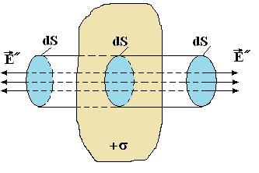

Fig. 8.1

Let us choose the integration surface in the form of a cylinder with generatrix, perpendicular to the plane and bases, symmetrically located relative to the plane (fig.8.1).

By virtue of symmetry

$${\vec{E}}^{'}={\vec{E}}^{''}=\vec{E}$$

The charge inside the integration surface is

$$q=σ⋅\text{dS}$$

According to the Gauss theorem, the flux of the vector of electric field strength through the side surface will be absent, since field lines do not cross it.

The flux through the end surfaces of the cylinder will be equal to

.

According to the Ostrogradski-Gauss theorem, the next condition must be fulfilled



From here

 (8.1)

This means that at any distance from the plane the field strength is the same in magnitude (fig.8.2)

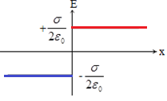

Fig.8.2

Find the potential difference between the points at the distance x1 and x2 from the plane (Fig. 8.3), using the relation

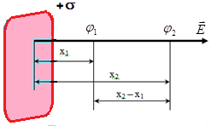 → 8.2)

Integrating $-\int_{φ_{1}}^{φ_{2}}{dφ}=\frac{σ}{2ε_{0}}\int_{x_{1}}^{x_{2}}{dx}$

will get $φ_{1}-φ_{2}=\frac{σ}{2ε_{0} }\left(x_{2}-x_{1}\right)$,

from which   
Fig.8.3 $φ= - \frac{σ}{2ε_{0} }\left|x\right|$  
.

The plot of the field potential versus the distance to the considered point is shown in Fig.8.4.

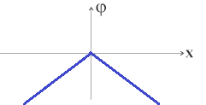

Fig.8.4

### 2) The field of two oppositely charged planes (Fig. 8.5)

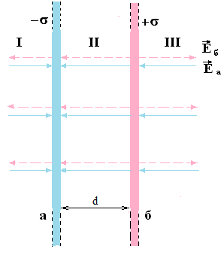

Fig. 8.5

The field strength created only by the plate "a" has a direction to this plate and is equal to

$$E_{a}=\frac{σ}{2ε_{0}}$$

The field strength created only by the plate "b" has a direction from the plate and is equal to

$$E_{в}=\frac{σ}{2ε_{0}}$$

Then in the area $Ι$: 

Then in the area $\text{ΙΙΙ}$: 

Then in the area $\text{ΙΙ}$: 

Thus, in a region external to the plates there is no field; it is concentrated between the plates and is equal:

 (8.2)

At all points in this area, the field strength is the same in magnitude and direction. Such a field is called homogeneous (fig.8.6).

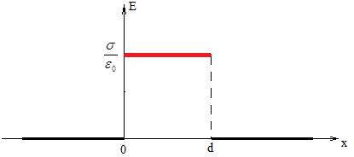

Fig.8.6

Let us find the variation of the potential with the distance between the planes and beyond them. Let ***d*** be the distance between the planes (fig. 8.7). Since the field strength outside the planes are zero, then

$$\frac{dφ}{dx}=0$$

$φ\left(0\right)$ = $φ_{1}$, ${φ\left(d\right)=φ_{2}}_{ }$

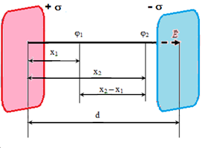

Fig/8.7

Repeating the actions according to the formula (8.2), we find

$$-\int_{φ_{1}}^{φ_{2}}{dφ=\frac{σ}{ε_{0}}\int_{x_{1}}^{x_{2}}{dx}}$$

$φ_{1}-φ_{2}=\frac{σd}{ε_{0} }=\frac{qd}{ε_{0}S}$ или $U=Ed$

Graphs of potential versus distance are shown in Figure 8.8.

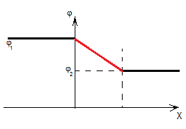

Fig.8.8

### 3) Field of charged spherical surface

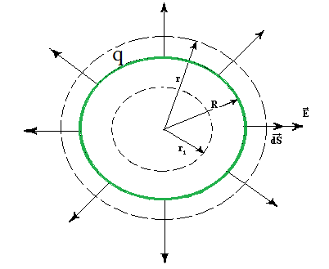

Fig. 8.9

Due to symmetry, the electric field $\vec{Е}$ lines should diverge radially from the center (fig.8.9). As the integration surface, we choose a sphere of radius r ˃ R.

At any point of this sphere $\vec{E}d\vec{S}=\text{EdS}$ and therefore



Using the Gauss theorem, we get



From here

 (8.3)

The result obtained is the same as in the case when the entire charge is concentrated at the point r = 0. For the field inside the sphere with $r_{1}<r$

, i.e. 

Thus, inside a spherical surface charged with a constant surface density $σ$, the field is absent, and outside its field is identical with the field of a point charge of the same magnitude placed in the center of the sphere.

The graph of ***E*** versus ***r*** is shown in Fig.8.10.

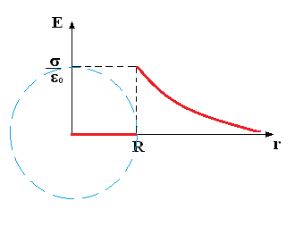

Fig. 8.10

The potential difference outside the sphere (Fig. 8.11) is determined by the relation:

$$φ_{1}-φ_{2}=\int_{r_{1}}^{r_{2}}{\frac{qdr}{4πε_{0}r^{2}}=\frac{q}{4πε_{0}}\left(\frac{1}{r_{1}}-\frac{1}{r_{2}}\right)}$$

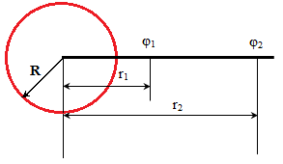

Fig.8.11

Since there is no field inside the sphere, the potential inside the sphere is the same at all points and is equal to the potential on the surface of the sphere.

$φ\left(R\right)$ = $\frac{q}{4πε_{0}R}$

The potential of a uniformly charged sphere is distributed as follows (Fig. 8.12)

If ***r1* = *r*** and ***r2* → ,** then the potential outside the sphere is

$φ$ = $\frac{q}{4πε_{0}r}$

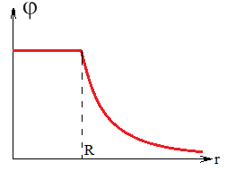

Fig.8.12

### 4) Field of a volume-charged ball

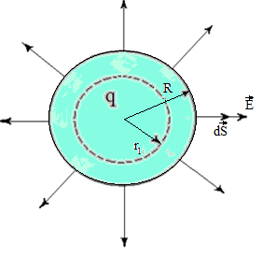

Fig. 8.13

Since a uniformly charged ball (fig.8.13) can be represented as a sequence of concentric spherical layers, the formula for the field outside the ball is valid as in the case of a surface-charged sphere.

To determine the field inside the ball, we choose as the Gaussian surface a sphere with radius r < R (here R is the radius of the ball). This sphere limits the volume



which corresponds to the volume of the ball as



Hence the charge inside the imaginary sphere



where ***q -*** is the charge of the ball.

Applying the Gauss theorem, we obtain

 or

, from where

 (8.4)

Thus, inside the ball, the field strength grows linearly with the distance from the center of the ball, and outside the ball, the field strength decreases according to the same law as for a point charge.

The graph of *E* versus *r* is shown in Figure 8.14.

Here $ρ=\frac{q}{V}=\frac{3q}{4πR^{3}}$– **is the bulk charge density.**

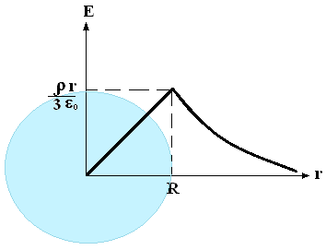

Fig.8.14

Calculate the potential on the surface of the ball.

$$φ=\frac{q}{4πε_{0}R}=\frac{4πρR^{3}}{12πε_{0}R}=\frac{ρR^{2}}{3ε_{0}}$$

Inside the ball, the potential difference is determined by the formula:

$-dφ=Edr=\frac{ρrdr}{3ε_{0}}$

or after integration

$$φ_{1}-φ_{2}=\frac{ρ}{6ε_{0}}\left(r_{2}^{2}-r_{1}^{2}\right)$$

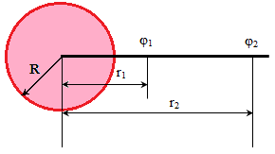

Fig.8.15

Find the potential difference between the center of the ball and its surface:

$$φ\left(0\right)-φ\left(R\right)=\frac{ρR^{2}}{{6ε}_{0}}$$

$$φ\left(0\right)=φ\left(R\right)+\frac{ρR^{2}}{6ε_{0}}=\frac{ρR^{2}}{3ε_{0}}+\frac{ρR^{2}}{6ε_{0}}=\frac{ρR^{2}}{2ε_{0}}$$

Thus (Fig.8.15 and 8.16),

at r $<$ R $φ_{1}-φ_{2}=\frac{ρ}{6ε_{0}}(r_{2}^{2}-r_{1}^{2})$

at r = R $φ_{1}-φ_{2}=0$

at r $>$ R $φ_{1}-φ_{2}=\frac{q}{4πε_{0}}(\frac{1}{r_{1}}-\frac{1}{r_{2}})$,

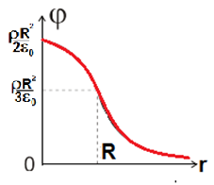

Fig.8.16

### 5) The field of infinite charged cylinder

Let the cylinder with radius R have a charge distributed along a cylindrical surface with a surface density $σ$.It follows from symmetry considerations that the field strength at any point is directed along a radial straight line perpendicular to the axis of the cylinder. As a Gaussian surface, choose a cylinder of radius ***r*** and height ***h*** (fig.8.17).

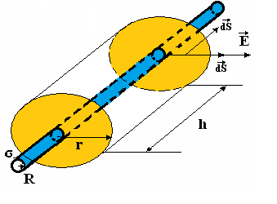

Fig.8.17

Vectors $\vec{E}$ and $d\vec{S}$ are perpendicular to the end surfaces of the cylinder and parallel to each other on the side surface.

Therefore at the ends $\vec{E}d\vec{S}=0$, and on the side surface

.

Equating this expression to the magnitude of the charge contained inside a cylindrical surface, we obtain

 or  (8.5)

If r < R, then the closed surface contains no charges, so that ***E*** = 0 (fig.8.18)

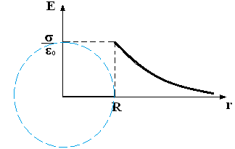

Fig.8.18

As can be seen from the last formula, **the field strength of an infinite charged cylinder is inversely proportional to the distance to the considered point**.

The potential difference between the points r1 and r2 is equal to (fig.8.19):

$$φ_{1}-φ_{2}=\frac{τ}{2πε_{0}}\int_{r_{1}}^{r_{2}}{\frac{dr}{r}}=\frac{τ}{2πε_{0}}ln\frac{r_{2}}{r_{1}}$$

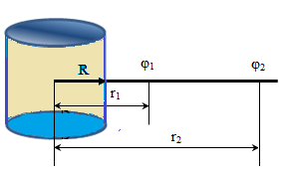

Fig.8.19

On the surface of the cylinder (at $r_{1}=r_{2}$) $φ=0$ (fig.8.20)

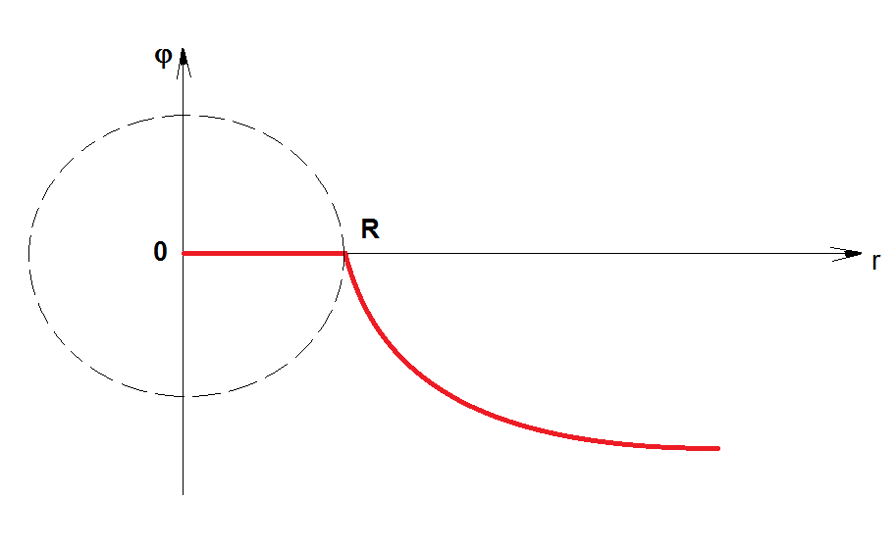

Fig.8.20

**The common conclusion for all examples:**

***The field strength in vacuum changes abruptly when passing through a charged surface, while the potential is a continuous function of the coordinates.***

## Chapter 2. ELECTRIC FIELD IN DIELECTRICS

## §1. Free and bound charges in dielectric. Types of dielectrics.

All substances, depending on the nature of their influence on the electric field created in them, are divided into conductors, semiconductors and dielectrics.

**Substances that do not conduct electrical current are called dielectrics.**

All dielectric molecules are electrically neutral, since the total charge of electrons and atomic nuclei that make up the molecule is zero.

The charges that make up the molecules of a dielectric are called bound, and the charges that are not part of its molecules are called free (conduction electrons in metals, holes in semiconductors, ions)

Despite the electrical neutrality, the molecules have electrical properties. In the first approximation, the molecule can be considered as an electric dipole.

An electric dipole is a system of two equal in absolute value electric charges opposite in sign, the distance between which is small compared to the distance to the field point in question.

The main characteristic of a dipole is its electrical moment, determined by the expression



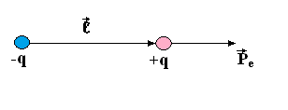

Fig.1.1

**The vector  is directed along the dipole axis from negative to positive charge (fig.1.1).**

For a dipole molecule, its positive charge is equal to the total charge of atomic nuclei and is placed at the center of gravity of the positive charges; the negative charge is equal to the total charge of the electrons and is placed in the center of gravity of the negative charges.

There are non-polar and polar dielectrics.

**A dielectric is called non-polar if in the absence of an external electric field the "centers of gravity" of the positive and negative charges coincide**. Such, for example, are molecules $H_{2},N_{2},O_{2}$, etc. Such molecules do not have their own dipole moment. However, under the action of an external electric field, the charges in a non-polar molecule are displaced relative to each other: positive in the direction of the field, negative in relation to the field, as a result of which the molecule acquires an induced dipole moment, the value of which is proportional to the field strength:

 (1.1)

where $α$ is the polarizability of the molecule, depending only on the volume of the molecule $\left[α\right]=1m^{3}$.

Vectors  and  always coincide in direction.

**A dielectric is called polar if the "centers of gravity" of the positive and negative charges do not coincide in the absence of an external electric field**.

The action of an external electric field on a polar molecule is reduced mainly to the tendency to rotate the molecule so that its dipole moment is established in the direction of the field. In this case, the external field practically does not affect the magnitude of the dipole moment of the molecule.

## §2. Electronic and orientational polarization. Polarization vector

In the absence of an external electric field, the total dipole moment of both types of dielectrics is zero, since for a non-polar dielectric, the dipole moments of each molecule are zero, and for a polar dielectric, the dipole moments of molecules are randomly oriented due to the thermal motion of the molecules.

Under the action of an external field, the dielectric is polarized (fig.2.1).

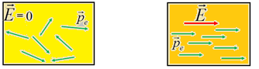

Fig.2.1

This means that the resulting dipole moment of the dielectric becomes non-zero. Depending on the structure of the molecules (atoms) of the dielectric, two types of polarization are distinguished:

***a) Electronic polarization of non-polar dielectric.***

In the molecules of these dielectrics, induced dipole moments arise, directed along the field, and the thermal motion of the molecules does not affect the electron polarization.

***b) Orientational polarization of polar dielectric.***

The external field tends to orient the dipole moments of polar molecules in the direction of the field. This is hampered by the chaotic thermal motion of molecules. As a result, the joint action of the field and thermal motion arises a preferential orientation of the dipole moments of the molecules along the field, increasing with increasing electric field strength and decreasing temperature.

A quantitative measure of dielectric polarization is the polarization vector . Polarization is the ratio of the electric dipole moment of a small dielectric volume to the value of this volume.

,

where- is the electric dipole moment of the i -th molecule;

n - is the total number of molecules in the volume $\text{Δ}\text{V}$.

## §3. The dielectric susceptibility of a substance and its temperature dependence

The polarization of a non-polar dielectric in an electric field is



(this follows from the fact that the vectors of all molecules have the same direction along $\vec{E}$),

wherе $n_{0}$- the number of molecules per unit volume;

${\vec{p}}_{e}$         - induced dipole moment of one molecule.

Using (1.1), we get

, (3.1)

where $χ=n_{0}α$ is the dielectric susceptibility of a substance or the polarizability of a unit volume.

If the polar dielectric is in an electric field, then its polarization (in weak fields)



moreover, the dielectric susceptibilityof a polar dielectric is calculated by the Debye-Langevin formula:



The effect of temperature on the nature of changes in the dielectric susceptibility for both types of dielectrics is different (fig.3.1).

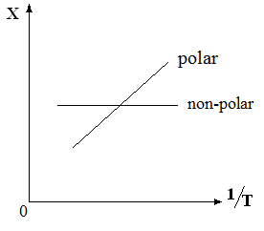

Fig.3.1

## §4. Ostrogradski-Gauss theorem for the electric field in a dielectric. Electric displacement. Dielectric permeability of the medium

In an external electric field, as a result of the polarization of the dielectric in its thin layers, bounding surfaces produce uncompensated bound charges with surface density , called surface polarization charges (fig.4.1).

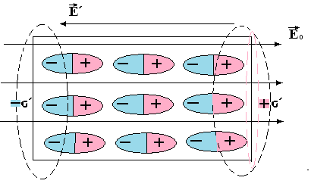

Fig.4.1

As a result, the electric field in the medium is created both by the free charges of the external field and by the associated charges of the dielectric.

According to the principle of superposition of fields, the field strength in a medium is equal to the geometric sum of the of the fields strengths of free and related charges:

 (4.1)

Accordingly, the Ostrogradski-Gauss theorem for an electrostatic field in vacuum can be extended to an electrostatic field in a medium, if by a common charge we mean the algebraic sum of all free and related charges covered by a closed Gaussian surface ***S***:

 (4.2)

Let's try to find the sum of the associated charges. According to this select a cylinder in the dielectric with the area of the base ***dS*** and generatrix, parallel to the vector  (fig.4.2).

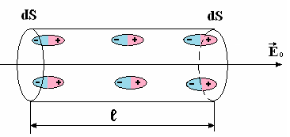

Fig.4.2

On each of the bases of the cylinder is a polarized charge . Considering the cylinder as a dipole, we find its electric moment by the formula:

 (4.3)

On the other hand, from the definition of polarization it follows that

 (4.4)

Equating (4.3) and (4.4), we get

.

Hence the sum of polarized charges on the surface of the dielectric is equal to

.

Since the total charge of the entire dielectric region must be zero, the sum of the bound charges is numerically equal and opposite in sign to the sum of polarized charges:



Formula (4.2) we write now in the following form:



Combining both integrals on the left, we get

 (4.5)

Vector quantity, denoted by

$\vec{D}=ε_{0}\vec{E}+{\vec{Р}}_{е}$ (4.6)

is сalled **electrical displacement**.

Then the Ostrogradski-Gauss theorem for the electrostatic field in the medium will be

 (4.7)

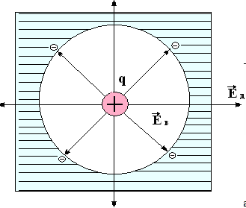 According to this theorem, the flux of the vector of electric displacement of an electrostatic field through an arbitrary closed surface is proportional to the algebraic sum of free charges covered by this surface.

Substituting formula (3.1) into (4.6), we obtain

 (4.8)

Dimensionless value

$$ε=\left(1+χ\right)$$

is called the **relative dielectric constant.**

Thus, the relation (4.8) can be written as

$\vec{D}={\text{εε}}_{0}\vec{E}$

For vacuum $χ=0$ and $ε=1$, therefore Fig.4.3

$$\vec{D}{\text{=}\text{ε}}_{0}\vec{E}$$

***The vector $\vec{D}$, unlike the vector $\vec{E}$, does not depend on the properties of the medium***.

For example, for a point charge placed in the center of a spherical cavity inside an infinite dielectric (fig.4.3), we have

 - in vacuum

 - in dielectric

Negative charges are concentrated at the boundary between the cavity and the dielectric and the field strength decreases in $ε$ times ($\text{ε}\text{>}1$), hence the density of field lines decreases. Such an abrupt change in the strength vector creates a number of inconveniences in the calculation of the field.

The electric displacement vector is expressed both in the cavity and in the dielectric by the same formula



The overall picture of the field is simpler than for the field $\vec{E}$. The lines of the vector $\vec{D}$ will go continuously (fig.4.4).

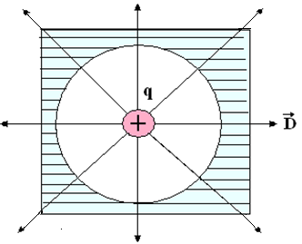

Fig.4.4

From the juxtaposition of the figures, the main difference between the fields $\vec{E}$ and $\vec{D}$ are the next. The lines of the vector $\vec{E}$ begin and end on any, both free and bound charges, so their density at the boundary of the dielectric changes abruptly. The lines of the vector $\vec{D}$ begin and end only on free charges, and their density at the boundary of the dielectric remains unchanged.

## Chapter 3. CONDUCTORS IN ELECTRIC FIELD

## §1. The field inside the conductor and near its surface. Charge distribution in conductor

In conductors, unlike dielectrics, electric charges can move freely under the action of a field. If the conductors are liquids or gases, then they move both positive and negative ions, and electrons. In metals, conductivity is due only to electrons.

**1.** Under the action of an external field in a conductor, the redistribution of charges occurs in such a way that an own electric field with a intensity opposite to that of the external field  is formed in the volume of the conductor.

The displacement of free charges will occur until the force no longer act on the charges. This moment is reached when the strength of the resulting field in the conductor becomes zero, i.e.

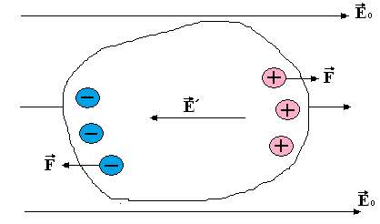

Fig.1.1

.

**2.** Equality to zero of the field strength inside the conductor, means that the entire conductor volume is equipotential. Indeed, at any point inside the conductor

 that is  or

**3.** At all points on the surface of the conductor $\vec{E}={\vec{E}}_{n}$ and ${\vec{E}}_{τ}=0$, because otherwise, under the action of the component , the charges would move along the conductor, which contradicts their stati equilibrium. Therefore, on the surface of the conductor, the vector $\vec{E}$ is directed along the normal to it.

**4.** Since , then the conductor surface is also equipotential.

**5.** Near the surface of a charged conductor, induction $\vec{D}$ and field strength $\vec{E}$ are proportional to the surface density of the charge (fig.1.2).

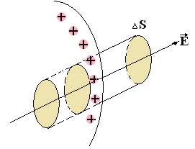

Fig.1.2

We apply the Ostrogradski-Gauss theorem to an elementary cylinder with a base $\text{Δ}\text{S}$, whose axis is oriented along the vector .

Since there is no field inside the conductor, the vector $\vec{D}$ will cross only the outer base of the cylinder, therefore



or  and .

**6.** In a charged conductor, uncompensated charges are located only on the surface of the conductor.

Since there is no field inside the conductor, the flux of vector  through any Gaussian surface inside the conductor is zero. Then, according to the Ostrogradski-Gauss theorem



those the sum of the charges inside the surface is zero.

This property is used for electrostatic protection of electrical devices and wires from external electric fields.

The distribution of charges on the outer surface of the conductors depends only on their shape: the surface charge density increases with increasing curvature of the surface.

## §2. Electrical capacitance of solitary conductor

**A conductor removed from other bodies so far that the influence of their fields can be neglected is called a solitary conductor**.

If to the solitary conductor consistently add charges , then after their redistribution over the volume of the conductor, it acquires potentials . The ratio remains constant and is called electric capacity:

 (2.1)

The capacitance of a solitary conductor is numerically equal to the charge that the conductor needs to communicate to change its potential by one. It depends on the shape and size of the conductor and on the dielectric properties of the environment.

In the SI system, a **Farad is taken as a unit of capacity — the capacity of such a conductor, when communicating a charge in 1C, its potential changes to 1V:**

.

In practice, also use multiple units:

; .

We determine the electrical capacitance of a solitary spherical conductor. Its potential can be found by integrating expression (8.3) in ***r*** from ***R*** to  :

 (2.2)

Substituting (2.2) into (2.1), we obtain



For example, for the Earth, assuming $\text{ε}\text{=}1$ we get

.

## §3. Mutual capacity of two conductors. Capacitors.

If there are other conductors near the conductor, then its electrical capacity increases. This is due to the fact that induced charges (of opposite sign) appear on neighboring conductors, which weaken the field created by the charge q on the first conductor and, consequently, reduce its potential and increase electrical capacity.

In the case of two closely spaced conductors charged with equal in magnitude but opposite charges in sign, there will be a potential difference between them. Then the value



called the mutual electrical capacity of the two conductors. It is numerically equal to the charge that must be transferred from one conductor to another to change the potential difference between them by one.

The mutual electrical capacity of two conductors depends on their shape, size and mutual arrangement, as well as on the dielectric constant of the medium. If one of the conductors is removed to infinity, then the potential difference between them will increase, and their mutual capacitance will decrease, tending to the value of the electric capacity of a solitary conductor.

A system of 2 conductors arranged relative to each other in such a way that the field created by them is concentrated in a limited region of space is called a capacitor. The conductors themselves in this case are called plates.

Depending on the shape of the plates capacitors are divided into flat, spherical and cylindrical.

A flat capacitor consists of two parallel metal plates each of area ***S*** and located at a close distance ***d*** from each other. Taking into account the dielectric properties of the medium in the gap, the field strength between the plates

 and .

On the other hand, using the relation between ***E*** and , we have



Hence, for the capacitance of a flat capacitor, we get the formula

.

**The capacitance of a flat capacitor depends on the area of the plates and on the distance between them, as well as on the dielectric constant of the dielectric**.

In addition to the capacitance, each capacitor is characterized by a limiting voltage , that can be applied to the capacitor plates without fear of its breakdown, i.e. the occurrence of a spark between the plates.

To prevent breakdown usually resorted to the serial connection of capacitors. If a potential difference  is applied to the ends of the battery of capacitors, then the edge plates will be charged with opposite charges ***±q***.

Due to electrostatic induction on all the intermediate plates will also induce charges $±q$.

In this case, the full potential difference is distributed between the capacitors according to their capacitances (fig.3.1).



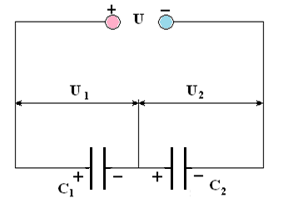

Fig.3.1

**Capacity with parallel and series connection of capacitors**

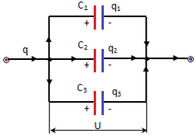a) parallel connection (Fig.3.2)

Fig.3.2

 

   







b) serial connection (Fig.3.3)

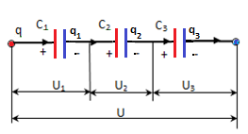

Fig.3.3



According to the law of conservation of charge



   







## §4. The energy of a charged solitary conductor and capacitor

In order to bring to the conductor some charge ***dq***, it is necessary to expend some work, because each subsequent portion of the bringed charge feels a repulsive effect from the charges presented here before.

When the charge ***dq*** is transfered from infinity () to the conductor (), the work is performed

.

When ***dq*** is transferred from the conductor to infinity, the electrostatic field forces do the same work. Consequently, as the conductor charge increases by ***dq*** the potential energy increases, that is

.

The total energy of a charged conductor can be found by integrating, i.e.



Applying the relation, we can get the following expressions

 (4.1)

Applying the relationship , you can get the following expressions

; . (4.2)

For a charged capacitor, the potential difference is equal . Therefore, the ratio for the total energy of its electrostatic field is:

 ;  ; . (4.3)

They are valid for any form of capacitor plates.

## §5. The energy of the electrostatic field. Bulk energy density.

The energy of a charged capacitor can be expressed in terms of the quantities characterizing the electric field in the gap between the plates.

Capacity of a flat capacitor is equal to

.

By substituting this expression into formula (4.3) we get



Since the product ***Sd*** represents the volume, occupied by the field, and the quotient $U/d$ is equal to the field strength in the gap, then

 (5.1)

This expression relates the energy of a capacitor to the field strength, while the formula  relates it to the charge on the plates. The question arises: what is the carrier of energy - charges or field?

Constant fields and the charges causing them cannot exist separately from each other. However, time-varying fields can exist independently of the charges that excited them and propagate in space in the form of electromagnetic waves. Experience shows that electromagnetic waves transfer energy, therefore the field is the carrier of energy.

**The volumetric energy density of an electrostatic field is a physical quantity that is numerically equal to the ratio of the field energy contained in the volume to this volume.**



From (5.1) it follows that

 (5.2)

Given the relationship , formula (5.2) can be represented as

.

In an isotropic dielectric, the directions of the vectors $\vec{E}$ and $\vec{D}$ coincide, therefore



Knowing the energy density at each point of the field, one can find the field energy contained in any volume ***V*** by calculating the integral



# Part II. CONSTANT ELECTRICAL CURRENT

## §1. Constant electric current, its characteristics and conditions of existence

**Electric current this is any orderly movement of electric charges.**

***The direction of the electric current coincides with the direction of the orderly movement of positive charges.***

The electric current arising in conducting media as a result of the orderly movement of free charges is called conduction current. For example, the current in metals and semiconductors associated with the movement of free electrons, the current in electrolytes, due to the movement of ions of opposite signs.

The orderly movement of electric charges can be accomplished in another way — by moving a charged body (conductor or dielectric) in space. This current is called convection current. For example, the motion of the Earth, having a negative excess charge, in the orbit.

When ordered charges move in a conductor, their equilibrium distribution is disturbed, i.e. the conductor surface is no longer equipotential and the electric force lines of are not perpendicular to it (${\vec{Е}}_{τ}=0$). Consequently, an electric field must exist inside the conductor and the current will continue until all points of the conductor become equipotential.

Thus, for the appearance and existence of an electric current in a conductor, ***two conditions are necessary:***

1) **the presence in this medium of charge carriers** - charged particles that could move freely;

2) **the existence in the environment of an external electric field**, the energy of which would be spent on an orderly movement of charges. To maintain the current, the electric field energy must be continuously replenished, i.e. a source of electrical energy is needed in which the conversion of any kind of energy into energy of the electric field is carried out. Such a device is called a source of electromotive force or current source.

The quantitative characteristic of the current is the current strength.

**The current strength is a scalar physical quantity equal to the ratio of the charge dq transferred through the conductor cross-section during the time dt to this time interval**:



If the current is created by carriers of both signs, then



**Electric current is called constant if the current strength and its direction do not change over time.**

In SI $\left[I\right]=1A$- ampere, $\left[q\right]=1\text{C}$- charge, passing through the cross section of the conductor for 1***s*** at a constant current of 1***A***.

In order for the current to be constant it is necessary that in no part of the conductor the charges accumulate and decrease. Therefore, the DC (direct current) circuit must be closed.

Electric current can be distributed unevenly over the surface through which it flows. Therefore used a vector quantity called **current density $\vec{j}$** . **This vector is numerically equal to the ratio of the force of the current $dI$ through a small element of the surface, normal to the direction of movement of the charges, to the value of the area $dS$ of this element (fig1.1)**:



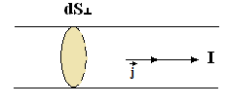

Fig.1.1

The direction of the vector $\vec{j}$ coincides with the direction of current $I$.

In SI



Knowing the current density vector $\vec{j}$ at each point in space, you can find the strength of current $I$ through any surface $S$:



**That is the current through a certain surface is equal to the flux of the current density vector through this surface.**

For direct current, the current density is the same over the entire cross section S, therefore

.

It follows that in a DC circuit, consisting of conductors of variable cross-sectional area (fig.1.2), the current density in various sections is inversely proportional to the areas of these sections:

${j_{1}}/{j_{2}}{{\text{=S}}_{2}}/{S_{1}}$.

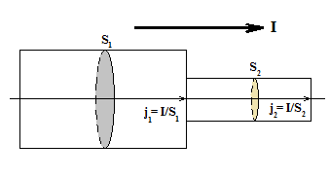

Fig.1.2

## §2. Classical electronic theory of the electrical conductivity of metals and its experimental justification

The electronic theory of electrical conductivity was created in 1900 by Paul Drude (1863-1906), and improved by Heinrich Lorenz (1853-1928).

From the point of view of the theory, the high electrical conductivity of metals is due to the fact that there are a large number of current carriers in metals - conduction electrons formed from the valence electrons of atoms.

Conduction electrons are treated as:

**1)** Electron gas having the properties of a monatomic ideal gas. As it moves, conduction electrons collide with ions of the metal crystal lattice. It is believed that the average electron free path $\bar{λ}$ in order of magnitude should be equal to the period of the metal lattice, i.e.

$$\bar{λ}≈d_{\text{lat}}≈{\text{10}}^{-\text{10}}m$$

**2)** Applying to the electron gas the results obtained in the kinetic theory of gases, one can find the average velocity of thermal motion of electrons as



where m = 9,1.10-31 kg - electron mass.

For room temperature ($\text{T=}{\text{300}}^{0}K$), the calculation using this formula leads to the following result



**3)** Under the action of an external field in a conductor, an ordered motion of electrons with an average speed occurs. The magnitude of this speed can be estimated on the basis of the following considerations.

Consider a section of conductor of length , located between two sections ***dS*** (fig.2.1).

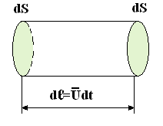

Fig.2.1

If there are $n_{0}$ electrons in a unit volume, then in the selected cylindrical volume their number is



These electrons carry charge

,

which creates current

.

Density of this current

 (2.1)

It was experimentally established that, for example, for insulated copper wire with a cross section $1{mm}^{2}$, the allowable current density



Since for a monovalent metal, the number of electrons per unit volume is equal to the number of atoms in the same volume, i.e.

$$n_{0}≈{\text{10}}^{\text{29}}m^{-3},$$

then the average velocity of the ordered motion of electrons



Consequently, , this is due to frequent collisions of electrons with ions of the crystal lattice.

**4)** Despite of the small value of , the current in the circuit is set almost instantly.

When the circuit is closed, an electric field arises in it, which propagates with speed  . Thus, after a time , where ***L*** is the length of the chain, an ordered movement of electrons will begin in it. For example, with ***L*** - 1000m , i.e. electric current occurs throughout the circuit almost simultaneously with the closure of the circuit.

The electronic theory of the electrical conductivity of metals has been substantiated by a series of experiments.

### 1. Experience Riecke (1901)

Through the circuit, consisting of two copper and one aluminum cylinder with carefully polished ends, a current was passed throughout the year (fig.2.2). A charge equal to  was missed at the same time

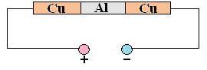

Fig.2.2

In a subsequent study of the cylinders under a microscope and through weighing, no changes were detected. This indicated that charge transfer is not carried out by atoms and ions, which are different for different substances, but by electrons.

To identify these charge carriers with electrons, it was necessary to determine the sign and the numerical value of the specific charge of the carriers.

### 2) Experiments of Stuart and Tolman (1916)

The metal rod was set in motion with speed , hence current carriers also move at this speed. Then the rod was sharply braked on the conductive wall and closed the galvanometer circuit (fig.2.3).

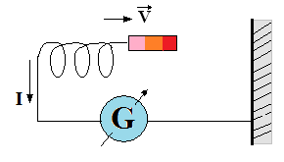

Fig.2.3

Charge carriers that are not connected with the lattice continue to move by inertia and a short-term current arises in the galvanometer circuit. The sign of charge determined by the direction of the current, as well as the value of the specific charge, turned out to be close to the corresponding values ​​for electrons.

A similar experiment was carried out with a coil revolving around an axis (fig.2.4).

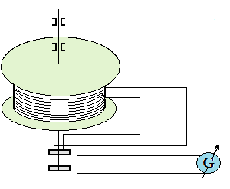

Fig.2.4

When braking at one end of the coil, free current carriers collected and created a variable potential difference.

## §3. The derivation of Ohm’s law in differential form from electronic representations

Suppose that all electrons pass between two successive collisions with ions of the crystal lattice the same paths, equal to the length of the free path. In this case, we will assume that the energy acquired by the electron is completely transferred to the ion and the velocity becomes zero.

In the presence of an electric field a force, acting on each electron.

$$F=eE$$

Then the electron motion equation has the form

$ma=eE$ (3.1)

By the end of the run (before the collision), the speed of the ordered movement reaches on average value

, (3.2)

where $\bar{τ}$ is the average time between two successive collisions of an electron with lattice ions.

As a result of the collision with the ion, the electron completely loses its speed, therefore the average speed of the ordered motion is equal to:

 (3.3)

The resulting electron velocity is equal to the sum of the average velocity of their thermal motion $\bar{V}$ and the average velocity $\bar{U}$ of the ordered motion



but then , so 

Therefore, the average electron mean free time is

$\bar{τ}=\frac{\bar{λ}}{\bar{V}}$ (3.4)

Substituting the value $\overline{τ}$ in the formula (3.3), we get

 (3.5)

Substituting (3.5) into formula (1.1), we obtain

 (3.6)

The value  is called **conductivity**, and its inverse  is called the **conductor resistivity**. Consequently

 **- Ohm’s law in differential form**

Since vectors and $\vec{j}$ have the same direction, Ohm’s law in vector form will take the form



**The conduction current density is proportional to the electric field strength in the conductor and coincides with it in direction.**

If the electrons had not collided with the lattice ions, then the free path length and, consequently, the conductivity would be infinitely large. Thus, according to classical concepts, the electrical resistance of metals is due to the collisions of free electrons with ions.

## §4. Wiedemann-Franz law

In 1853, Wiedemann and Franz experimentally established that for all metals at the same temperature the ratio of the thermal conductivity coefficient K to coefficient of conductivity  is the same and is proportional to temperature.

Considering electrons as a monatomic gas, we write the expression for the thermal conductivity coefficient from the kinetic theory of gases:

 (4.1)

From formulas (4.1) and (3.6) it follows that

 (4.2)

Given that the average kinetic energy of thermal motion of electrons



where - is the mean square velocity of electrons and assuming that , when substituted in (4.2), we get

.

At T =  for, the value of J. Ω is obtained (which agrees well with the experimental data).

## §5. The generalized Ohm's law in integral form. Potential difference, electromotive force, voltage

In the conductor there is an electrostatic field created by electrons and positive ions - the field of Coulomb forces. The Coulomb interaction between charges always leads to an equilibrium charge distribution in which the electric field in the conductor disappears due to the connection of opposite charges and the entire conductor becomes equipotential. Consequently, an electrostatic field cannot be the cause of the orderly movement of electrons, i.e. cannot create a constant electric current.

In order to maintain a constant current in the circuit, it is necessary to have in addition to the Coulomb forces other non-electrostatic forces causing the separation of the charges and their ordered movement. Such forces are called extraneous forces and they are created by sources of electrical energy.

Consequently, at any point inside the section of the conductor containing the source, the strength of the resulting field will be

 (5.1)

where - is the field strength of the Coulomb forces,

 - field strength of external forces.

Substituting this expression in Ohm’s law for current density, we obtain

 (5.2)

Let us pass from differential to integral relations. Consider a closed circuit, in section 1 - 2 of which a third-party current source is turned on (fig.5.1).

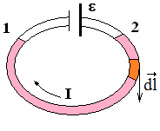

Fig.5.1

Let's make scalar multiplying both sides of equality (5.2) by a vector numerically equal to the element of the conductor length and directed along the tangent to the conductor in the same direction as the current density vector:



Given that the scalar product of coinciding in the direction of the vectors and  is equal to the product of their modules, as well as the ratio, we get

.

Integrating along the conductor length from section **1** to section **2**, we get

 (5.3)

Let us clarify the physical meaning of all the terms in formula (5.3).

1. The integral  depends on the material, size and shape of the conductor and is called its resistance . For homogeneous linear conductor  and



where - the length of the conductor between sections 1 and 2.

2. The integral  is numerically equal to the work performed by the Coulomb forces when moving a unit positive charge from point **1** to point **2**. In electrostatics, it was shown that

where and are the potentials at points **1** and **2** of the conductor.



where  and - potentials at points 1 and 2 of the conductor.

3. The integral  is numerically equal to the work done by external forces when moving a single positive charge from point 1 to point 2. This work is performed by the energy of the current source and is called the electromotive force of the source, i.e.



The value numerically equal to the work performed by the total field of Coulomb and external forces, when a unit positive charge is moved along the chain, is called a voltage drop or simply the voltage in a given section of chain ().

Then the formula (5.3) takes the form



This formula expresses Ohm’s law in integral form for an arbitrary section of a circuit.

The voltage in the circuit is equal to the sum of the potential difference and the electromotive force.

In this form, Ohm's law is applicable both to passive sections of the circuit and to active sections containing sources of EMF.

Consider special cases:

1. An unbranched chain is closed (fig.5.2).

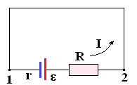

Fig.5.2

  





2. The chain part is homogeneous (fig.5.3), that is

 ; 





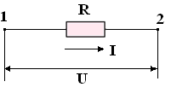

Fig.5.3

3. The chain contains several sources of EMF (fig.5.4).

**The rule of signs**: ***If inside the source current flows from the cathode to the anode, then the EMF considered positive.***

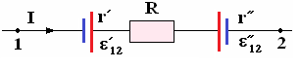

Fig.5.4

Then





## §6. Joule-Lenz law

With the passage of electric current I through a part of the circuit that does not contain emf, for some period of time t will pass a charge q = It. At the same time, the forces of the electric field will perform work on the charge ***q*** transfer from a high potential point to a lower point potential:

$A=\left(φ_{1}-φ_{2}\right)q=UIt$ (6.1)

If no chemical transformations take place in the conductor, then the work of the current is spent on increasing the internal energy of the conductor, as a result of which the conductor heats up. According to the law of conservation of energy, the amount of heat released is equal to the perfect work:

$Q=A=UIt$ (6.2)

The relation (6.2) is called **the Joule-Lenz law**.

In accordance with Ohm’s law ( $U=IR$ или $I=U/R$), formula (6.2) can be expressed as

$Q=I^{2}Rt$ (6.3)

or

$Q=\frac{U^{2}}{R}t$ (6.4)

If two conductors are connected in series with different resistances, then the same current ***I*** will flow through them. Then, according to (6.3), a greater amount of heat will be emitted in a conductor with greater resistance (Fig. 6.1a).

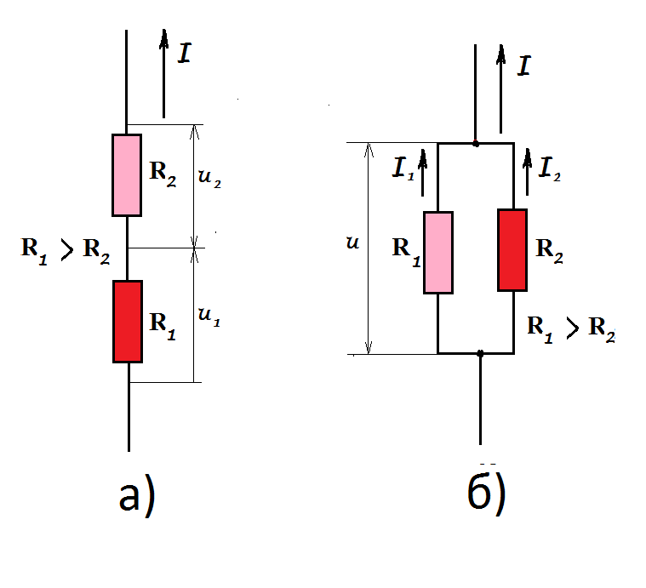

Fig.6.1

If the conductors are connected in parallel, their terminals will have the same voltage ***U***. Therefore, in accordance with (6.4), a greater amount of heat will be emitted in a conductor with less resistance (Fig. 6.1b).

To move from the integral form of recording the Joule-Lenz law to the differential form, which allows to determine the amount of heat released in different places of the conductor, select the elementary volume of the conductor in the form of a cylinder of length ***dl*** and area of the base ***dS*** (Fig. 6.2)

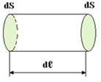

Fig.6.2

For him, the formula (6.1) is written

$dQ=RI^{2}dt$. (6.5)

Considering, that $R=\frac{ρ}{dS}dl$ and ***I = jS***, by substituting in (6.5), we get

$dQ=\frac{ρdl}{dS}{\left(jdS\right)}^{2}dt=ρj^{2}dVdt$ (6.6)

Dividing (6.6) by ***dV*** and ***dt***, we finally get the Joule-Lenz law in differential form

$Q_{уд}=ρj^{2}$.

Here, $Q_{уд}=\frac{dQ}{dVdt}$ is called **the specific thermal power of the current**.

## §7. The difficulties of the classical theory of the electrical conductivity of metals

It was experimentally established that for most metals at temperatures close to room temperature, the resistivity varies in proportion to the absolute temperature:



According to classical ideas, the resistance of metals should increase as the square root of temperature. Indeed, because

 and ,

then  and .

The second difficulty of the classical theory is that the electron gas must have a molar heat capacity equal to . In addition, the heat capacity of the crystal lattice according to the law of Dulong and Petit is equal to

***С=3R***

Therefore, according to the electronic theory, the heat capacity of monovalent metals should be

.

However, experience shows that the heat capacity of metals, as well as the heat capacity of solid dielectrics, in accordance with the law of Dulong and Petit is close to C = 3 R.

An explanation of these inconsistencies could only be given by the quantum theory of metals.

The advantage of the classical theory is that it was able to explain the Ohm and Joule-Lenz laws, and also provided a qualitative explanation of the Wiedemann-Franz law.

## §8. Electrons work function from metal. Thermionic emission

The conduction electrons in the metal are in indiscriminate thermal motion. The most rapidly moving electrons with a sufficiently large kinetic energy, can escape from the metal into the surrounding space. At the same time they do a work against:

1) the forces of attraction from the side of excess positive charge that occurs in the metal as a result of their departure;

2) repulsive forces from previously ejected electrons that form an electronic "cloud" near the surface of the conductor (fig.8.1).

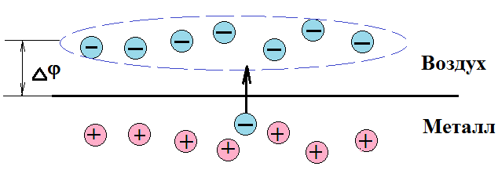

Fig.8.1

As a result, a kind of capacitor with a potential differenceis formed between the positively charged surface of the conductor and the negatively charged cloud.

The work that needs to be done to remove an electron from a metal into a vacuum is called the **work function**. She is equal to



The potential difference  is usually called the **contact potential difference** between the metal and the environment. It depends on the electron work function of the metal, which in turn depends on the chemical nature of the metal and the state of its surface (pollution, humidity, etc.).

Work function of electrons is measured in electron-volts (eV).

1 eV - is the energy that an electron acquires by passing a potential difference of 1V.



Thus, in a metal, an electron is in a potential well with depth . To leave the surface of a metal, an electron must have kinetic energy that satisfies the following condition:

 - ***exit condition***

**Emission of electrons by metal is called electron emission.**

At normal temperatures, the number of electrons with enough energy to eject is small. There are a number of ways to communicate extra energy to electrons:

**1.** The impact of a strong accelerating external electric field - field emission or cold emission.

**2.** Irradiation of metals with visible and ultraviolet light - photoelectron emission.

**3.** Bombing of a metal by electrons or ions - secondary electron emission.

**4.** Conductor heating - thermionic emission.

The phenomenon of thermionic emission is the basis of the operation of electron tubes. As an example, consider the operation of a diode, which is a glass vacuum tank containing two electrodes - the cathode and the anode (fig.8.2). The cathode, which is the source of electrons, is heated with a special battery. When the cathode filament is heated, an electron cloud appears that carries a negative charge.

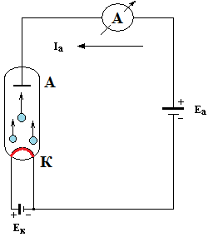

Fig.8.2

To create an electric field between the cathode and the anode between them is included anode battery. As a result of the movement of electrons from the cathode to the anode, an electric current arises in the circuit.

The dependence of the anode current recorded by the ammeter on the anode voltage is called the volt-ampere characteristic of the lamp (fig.8.3).

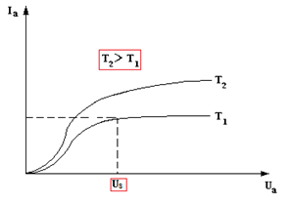

Fig.8.3

When the growth of the anode current stops, i.e. he reaches saturation. Its value is greater, the higher the temperature of the cathode, because the number of electrons in the cloud increases. The saturation current is due to the fact that all electrons ejected from the cathode reach the surface of the anode.

# Part IІІ. ELECTROMAGNETISM

## Chapter 1. MAGNETIC FIELD IN A VACUUM

## §1. Magnetic field. Magnetic induction. Magnetic moment of the contour with current

It was found that there is a field around moving charges, current-carrying conductors and permanent magnets, which is detected by force action. This field, as well as the electric field, has certain physical properties, for example, energy, the property of inertia and is one of the types of matter. It was called magnetic.

This name comes from the fact that, as Oersted discovered in 1820, the field around a conductor with current has an orienting effect on a magnetic needle.

The force of the magnetic field is manifested only in relation to moving charges, conductors with current and permanent magnets.

In contrast to the electric field, the magnetic field (constant) does not act on nonmoving electric charges.

From the experiment of Oersted it follows, that the magnetic field is directional and must be characterized by a vector quantity. This value is the magnetic induction vector.

Similar to the fact that the electric field strength is numerically equal to the ratio of the electrostatic force to the charge, the magnetic field induction can be defined as the ratio of the magnetic force to the value of *qV*. In this way

;  (1.1)

where V is the velocity of the charge.

In SI

$$\left[В\right]=\frac{1N}{1A⋅s⋅1m/s}=\frac{N}{A⋅m}=1\text{Т}$$

In addition, vector $\vec{B}$ can be introduced else in two independent ways.

If we rely on the force effect of a magnetic field on a small element $dl$ of a conductor with current ***I***, then the magnetic induction is numerically equal to the ratio of the force acting on a small element of a conductor with a current perpendicularly oriented to the direction of the field to the product of the current by the length of this element.

In this way

 (1.2)

The third method is based on the force action of the magnetic field on a small contour with current (fig.1.1).

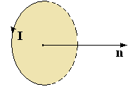

Fig.1.1

Just as a trial charge was used to study the electric field, a trial current circulating in a small closed flat circuit is used for the magnetic field. The orientation of the contour in space is characterized by the direction of the normal, which is considered positive if, from its end, the current in the contour is seen counterclockwise.

When introducing a trial contour into a magnetic field, the latter has an orientation effect on it, setting its positive normal in the direction of the field.

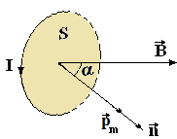

Fig.1.2

If the contour is rotated so that the directions of the normal and the field do not coincide, then a rotational moment arises, tending to rotate the contour to an equilibrium position (fig.1.2). The magnitude of this moment is proportional to the current strength in the circuit, the area of ​​the contour and the sine of the angle between the direction of the field and the positive normal:



When , then .

If different contours are placed in a given magnetic field, the magnitude will also be different, but the ratio



will be the same and can be taken as the basis for determining the magnetic induction vector $\vec{B}$. **It is numerically equal to the ratio of the rotational moment acting on a small contour with a current in a magnetic field to the magnetic moment of the contour with such its orientation in the field when this ratio reaches the maximum value**

 (1.3)

**A vector quantity, equal to the product of the current on the area of the contour is called magnetic moment of the contour** with a current



or in scalar form



The vector is directed so that from its end the current in the contour is visible counterclockwise (fig.1.3).

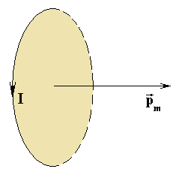

Fig.1.3

If the contour with current has an arbitrary shape, then



Expression (1.3) in the vector form has the form

.

It follows that the rotational moment is maximum if the contour is so oriented in the field that its magnetic moment is perpendicular to $\vec{B}$.

Thus, magnetic induction characterizes the force effect of a magnetic field both on the charge, and on the current element and on the circuit with current. Therefore, it is an analogy of the electric field strength $\vec{Е}$, which characterizes the action of a electric field on a charge. Similarly to the electric field, a field of a vector $\vec{В}$ is depicted graphically using magnetic field lines. These are the such lines, the tangents to which at each point coincide with the direction of the vector $\vec{В}$ at these points.

The direction of the magnetic induction lines of the current is determined by the rule of the right screw**: if the screw is screwed in the direction of the current in the conductor, then direction of its rotation will indicate the direction of the magnetic induction lines**.

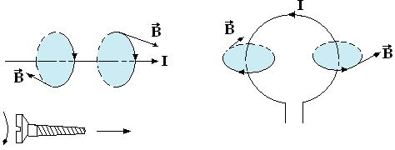

Fig.1.4

The magnetic field strength lines, unlike the electric field strength lines, have neither a beginning nor an end. This is equivalent to the statement that there are no magnetic charges. Consequently, the magnetic field is vortex, self-enclosed, i.e. not having a source and drain.

Along with magnetic induction , another phisical value is introduced to describe the magnetic field - the magnetic field strength , which does not depend on the properties of the medium and is related to $\vec{В}$ by the ratio

,

where $μ_{0}$- is the magnetic constant: ;

- relative magnetic permeability of the medium.

For a magnetic field, as for an electric one, the superposition principle holds true: ***the field generated by several moving charges (currents) is equal to the vector sum of the fields generated by each charge (current) separately:***



## §2. Ampere's law

If we place a conductor with a current in a magnetic field, then it will be affected by a force that, as it was discovered, is directly proportional to the strength of current **I** in the conductor, its length $l$, magnetic induction in the field $B$ and $\text{sin}α$ ($α$- the angle between the direction of current and vector $\vec{В}$), e.с.

 (2.1)

This formula is valid for the case of a straight conductor and a uniform field (the field in which the vector $\vec{В}$ is constant) and is called **Ampere's law**.

In the general case, when the conductor has an arbitrary shape and the field is not uniform, the expression (2.1) has the form

 (2.2)

where *dF* is the force, acting on the conductor element in length $dl$.

Amper`s law can be written in vector form as follows



The direction of the force, acting on the conductor element, can be determined by the rule of the left hand (fig.2.1).

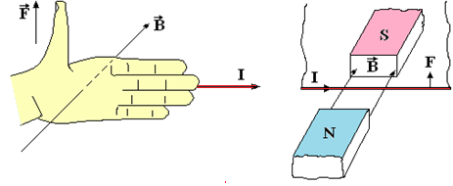

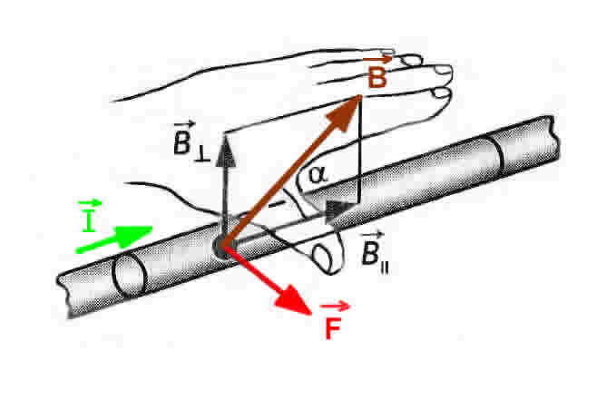

Fig.2.1

***If the palm of the left hand is positioned so that the magnetic induction lines enter it, and the four outstretched fingers coincide with the direction of the current in the conductor, then the left thumb indicates the direction of the force acting on the conductor from the field.***

This rule is convenient when an element with a current is perpendicular to the direction of the magnetic field.

Therefore, it is better to use the universal rule of the right screw, which allows to determine the direction of any vector that is the result of vector multiplication of two other vectors (fig.2.2).

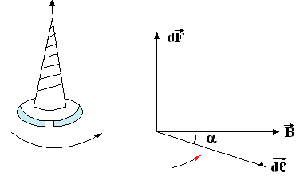

Fig.2.2

**If the screw is rotated in the direction of the shortest rotation from $d\vec{l}$ to $\vec{B}$, then the direction of its movement coincides with the direction of the force $d\vec{F}$.**

**A characteristic feature of the Ampere force is that it is always directed perpendicularly to the magnetic field lines**.

## §3. The magnetic field of the current. Biot-Savart-Laplace law and its application to the calculation of magnetic field.

The magnetic field of direct currents was studied by Biot (French physicist -1820) and Savart, and the final formulation of the law they found belongs to Laplace. This law determines the induction of a magnetic field created by a constant electric current.

Let current ***I*** flow along a curved conductor (fig.3.1).

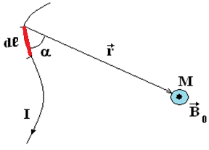

Fig.3.1

For selected element of the conductor length $dl$ the law states that **the induction of a magnetic field, created in a vacuum by a small conductor element with a current at a certain point is proportional to the length of the element, the current strength, the sine of the angle between the direction of the current and the radius-vector of the point and is inversely proportional to the square of the distance**

, 3.1)

where k - coefficient of proportionality, depending on the choice of the system of units.

In Si



The law of Bio-Savart-Laplace in vector form has the form

 (3.2)

If the conductor with current is in any medium, then

 (3.3)

This form of writing the law is called rationalized.

The last two expressions imply the physical meaning of the relative magnetic permeability of the medium µ . It shows how many times the magnetic induction of a field in a given medium differs from magnetic induction in a vacuum, i.e.



*Let us consider two examples of the application of the law of Biot-Savart-Laplace to clarify the magnetic fields of linear conductors with current.*

### a) The magnetic field of a rectilinear conductor with current

Let us assume that a current $I$ flows through a straight-line infinitely long conductor of very small cross section. According to the law of Biot-Savart-Laplace, the magnetic induction vector $d\vec{B}$ of the field created at point A by an element of a conductor with current $I$ is numerically equal to:

,

where $α$- is the angle between $(d{\vec{l}}^{Λ}\vec{r})$.

Since the vectors and $\vec{r}$ for all sections of the straight conductor lie in the same plane (the plane of the drawing), at point A all the vectors  from the individual sections of the conductor are directed along one straight line perpendicular to the plane of the drawing (fig.3.2).

Therefore, the vector $\vec{B}$ of the resulting field is also directed perpendicular to the plane

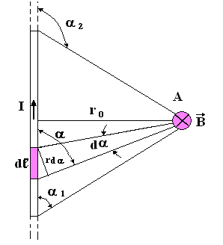

Fig.3.2

of drawing and according to the principle of superposition is numerically equal to the algebraic sum of the modules of the vectors $d\vec{B}$

 (3.4)

Perform trigonometric transformations. From the figure it is clear that

 

From here



Substituting in (3.4) the expression found, we obtain



If the conductor is infinitely long, then $α_{1}=0$, $α_{2}=π$.

Then the magnetic induction at any point in the field of such a conductor is equal to:



**Induction at each point of the magnetic field of an infinitely long conductor with a current is inversely proportional to the shortest distance from this point to the conductor.**

It should be remembered that, in accordance with the derivation of expression (3.4), it is valid at distances $r_{0}$ that are large compared with the diameter of the wire.

### b) Magnetic field of circular current

Find the induction of the magnetic field in the center of a circular coil of radius R over which current $I$ flows (fig.3.3). According to the Biot-Savart-Laplace law, the magnetic induction of the field created by the element $dl$ at point 0 is equal to

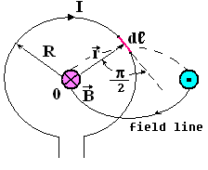

Fig.3.3

.

Since , then  and ,

consequently



Induction of the resulting field at the point 0 is equal to:



The direction of the vector $\vec{B}$ is determined by the rule of the right screw.

We determine the magnetic induction at an arbitrary point M on the axis of the coil (fig.3.4).

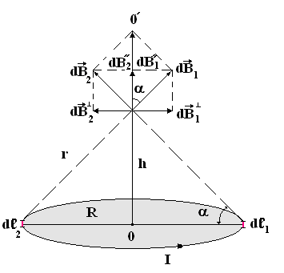

Fig.3.4

As can be seen from the figure , therefore $d\vec{B}$ numerically equal to

.

Consider the induction vectors of magnetic fields created at the point ***M*** by two equal in length but diametrically opposite elements ${dl}_{1}$ and ${dl}_{2}$. We decompose each of these vectors into two components: perpendicular to the axis $00^{'}$ and directed along the axis $00^{'}$. Components of vectors and  do not contribute to the resultant field. Therefore, making the substitution

 and 

and integrating over the whole contour, we get

.

Considering that the magnetic moment of the current loop



will get



or taking into account that vectors ${\vec{p}}_{m}$ and $\vec{B}$ have the same direction, in vector form



## §4. Vortex nature of a magnetic field. The law of total current for a magnetic field in vacuum and its application to the calculation of the magnetic field of a long solenoid

In an electrostatic field, the work of moving the charge does not depend on the shape of the path, but is determined only by the potential difference at the end and starting points of the path, i.e.



When moving around a closed loop



Consequently

$$\oint_{L}{\vec{E}d\vec{l}=0}$$

Those, the circulation of the electrostatic field strength vector $\vec{Е}$ along any closed loop ***L*** is zero. **Such fields are called potential or irrotational**. As previously stated, the magnetic field is non-potential or vortex. For a magnetic field, the circulation of the vector of magnetic field strength along any closed circuit covering the current is non-zero, i.e.

$$\oint_{L}{\vec{B}d\vec{l}≠0}$$

It is easiest to calculate this integral in the case of a direct current field.

Let the closed loop lies in a plane perpendicular to the current (fig.4.1).

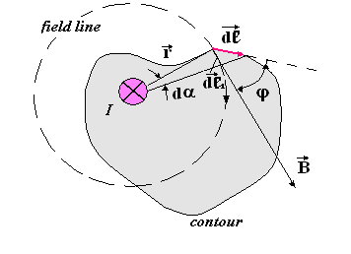

Fig.4.1

Magnetic force lines of a rectilinear current are circles with a center on the axis of the conductor. The vector $\vec{E}$ is directed tangentially to the circle and, therefore, perpendicular to the radius-vector $\vec{r}$.

Consider the contour section $d\vec{l}$. The vector $\vec{B}$ makes with a section $d\vec{l}$ angle $α$. In this way



where ${dl}_{1}$ is the length of the vector $d\vec{l}$ projection on the vector $\vec{B}$ direction. On the other hand

$${dl}_{1}=r⋅dα$$

Therefore, taking into account the expression for the induction of the magnetic field of a direct conductor in a vacuum, we obtain



Circulation over the entire contour L will be obtained by integrating over from 0 to $2π$

.

This theorem is a direct consequence of the law of Biot-Savart-Laplace and is called the **Law of Total Current**:

If the magnetic field is created by a system of currents $I_{1},I_{2},\text{...}I_{N}$, then the magnetic field induction vector will be equal to the geometric sum of the fields created by each current separately.

In this case, the law of total current can be written in the form:

$$\oint_{L}{\vec{B}d\vec{l}=μ_{0}}\sum_{i=1}^{N}{I_{i}}$$

and reads like this:

**The circulation of the magnetic field induction vector in a vacuum along a closed contour is proportional to the algebraic sum of the currents covered by this contour.**

It should be borne in mind that current is considered a positive, the direction of which is connected with the direction of the detour along the contour by the rule of the right screw.

For example, for the system of currents shown in the picture (fig.4.2)

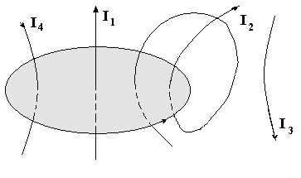

Fig.4.2

Thus, the potential cannot be ascribed to the magnetic field, which would have been unambiguously connected with the field induction, as in an electric field . In a vortex magnetic field, after each round-trip along the contour covering the current and returning to the initial point, the potential would be incremented by $I$.

As an example, using the law of total current, will find the magnetic field of a long solenoid.

The solenoid is a set of turns of wire, evenly wound on a common cylindrical frame. If the length of a solenoid ***L*** is many times greater than the diameter ***d*** of its turns, then the solenoid is considered infinitely long ($L≫d)$.

Inside the solenoid, the vector $\vec{B}$ is parallel to its axis according to the rule of the right screw. The magnetic field lines of the solenoid look something like this (fig.4.3).

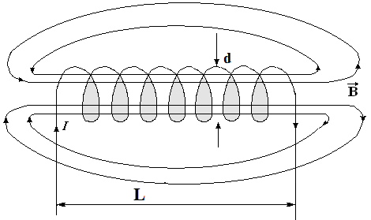

Fig.4.3

If the solenoid is infinitely long, then outside its magnetic induction  is zero.

Take a rectangular contour 12341 (fig.4.4).

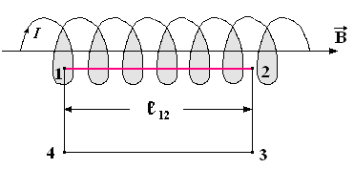

Fig.4.4

The circulation of the vector $\vec{B}$ along this contour can be represented



The second and fourth integrals are equal to zero, since the vector is perpendicular to the contour sections over which the integrals are taken. The third integral can be neglected, since The field outside the solenoid is small. Then



Let n be the number of turns of the solenoid per unit length. Then the length $l_{\text{12}}$ contains ${nl}_{\text{12}}$ turns and in accordance with the law of total current we have

${Bl}_{\text{12}}=μ_{0}{nl}_{\text{12}}I$

or .

If the solenoid is of finite length, then the resulting formula is valid for points in the middle part of the solenoid, and at its edges the magnetic induction has half the value, i.e.

$$B=\frac{1}{2}μ_{0}\text{nI}$$

## §5. The magnetic field of a moving charge

Every moving charge creates a magnetic field around itself.

According to the law of Biot-Savart-Laplace, the magnetic field induction of a conductor element $dl$ with current $I$ is equal to

 (5.1)

This field is the geometric sum of the fields created by each of the moving charges (fig.5.1).

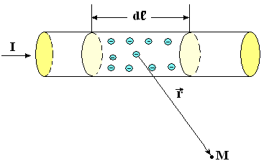

Fig.5.1

If $r\text{>>}dl$, we can assume that the radius-vector $\vec{r}$ is the same for all charges, i.e. each of the charges creates at the point M the same field ${\vec{B}}_{q}$, then

 (5.2)

where N is the total number of charges moving in the element $dl$.

On the other hand

 (5.3)

From (5.1), (5.2), and (5.3) we find the induction of the magnetic field created by the moving charge

 (5.4)

or in vector form

 (5.5)

The direction of the vector ${\vec{B}}_{q}$ is perpendicular to the plane passing through the vectors $\vec{V}$ and $\vec{r}$, and is oriented according to the right screw rule, if q > 0, and in the opposite direction, if

q < 0 (fig.5.2).

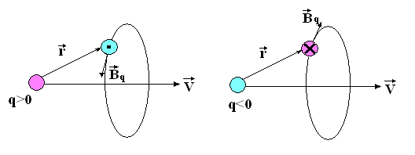

Fig.5.2

From formula (5.4) it follows that at all points of the straight line that coincides with the direction of the velocity vector $\vec{V}$, magnetic induction $B_{q}=0$, since $\text{sin}α=0$. Therefore, the **magnetic field of a moving charge is not spherically symmetric**.

The magnetic induction lines are circles whose centers are located on a straight line along which the charge moves.

**The magnetic field of a moving charge is variable**, since even when the radius-vector $\vec{r}$ changes in magnitude and direction. With the same value of the distance r, the value $B_{q}$ is maximal at the points of the plane drawn through a moving particle perpendicular to its speed $V(α=π/2$).

## §6. Effect of a magnetic field on a moving charge. Lorenz force

According to Ampere's law, element $dl$ of a conductor with current $I$, which is in a magnetic field, is acted upon by the force

 (6.1)

The force experienced by an element of current is the resultant of all forces acting on individual charges moving in this element. Consequently

$d\vec{F}=N{\vec{F}}_{Λ}$ (6.2)

where ***N*** is the number of moving charges in the current element.

Since , then from expressions (6.1) and (6.2) we have

.

Hence, the force acting on a single charge ***q***, moving with speed $\vec{V}$ in a magnetic field $\vec{B}$, will be equal to



and is called the **Lorentz force**.

The direction of force is determined by the rule of the right screw if q > 0. If q < 0, then the direction of the force is reversed (fig.5.3).

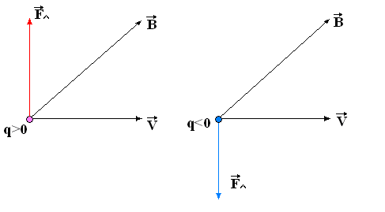

Fig.5.3

The modulus of the Lorentz force is equal to

,

where $α$ is the angle between the vectors $\vec{V}$ and $\vec{B}$.

**The direction of Lorentz force is always perpendicular to the direction of movement of the particles**. Consequently, the particle moves with a constant in value, but changing in the direction velocity in a plane perpendicular to the vector of magnetic induction. Consequently, **it does not do work and does not change the kinetic energy of the particle.** This is true for a constant magnetic field.

In the general case, a moving charge, in addition to a magnetic field with induction $\vec{B}$, can also be affected by an electric field with intensity $\vec{E}$. Then the resulting force applied to the charge is

$$\vec{F}=q\vec{E}+q(\vec{V}×\vec{B})$$

and is called the **generalized Lorentz force**.

## §7. Motion of charged particles in a magnetic field. The principle of operation of cyclic charged particle accelerators.

The obtained expression for the Lorentz force makes it possible to establish the laws of motion of charged particles in a magnetic field, underlying the design of charged particle accelerators - cyclotrons, magnetohydrodynamic generators - MHD generators, electron-beam devices, etc.

Let the magnetic field be homogeneous and, moreover, an electric field does not affect the particles.

Let us examine the simplest examples.

**1) The charged particle moves along the magnetic field lines,** i.e.  and (fig.7.1).

Consequently



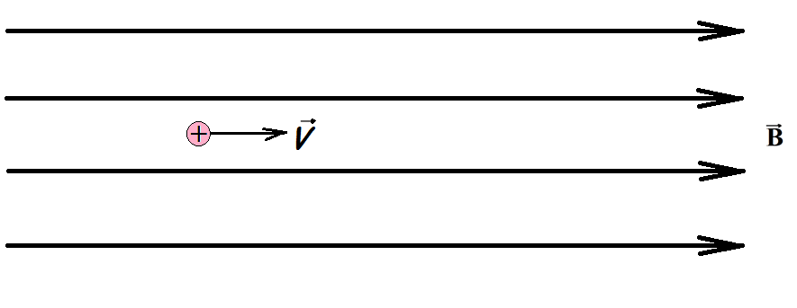

Fig.7.1

The magnetic field does not act on the particle. It will move evenly and straight.

**2) A charged particle moves perpendicular to the magnetic induction lines,** i.e. and

.

Then the Lorentz force is numerically equal



The direction of force is always perpendicular to the direction of movement of the particles. Consequently, the particle moves with a constant in value, but changing in the direction velocity in a plane perpendicular to the vector of magnetic induction (fig.7.2).

In this case, the Lorentz force is a centripetal force, creating a centripetal acceleration



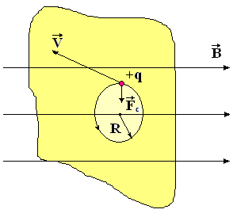

Fig.7.2

Thus the particle moves in a circle. Centripetal acceleration is expressed in the following way through the speed and radius of the trajectory

.

Equating both expressions for and solving with respect to ***R***, we have



Since ***B*** = const and ***V*** = const, the radius of curvature of the trajectory is constant, i.e. the particle moves in a circle whose radius is directly proportional to the speed of the particle and inversely proportional to the product of its specific charge  and field induction .

The circumference is



and the period of revolution of the particle in the field -

 (7.1)

and does not depend on the speed of the particle and, therefore, on its kinetic energy. This property is used in accelerators of charged particles intended to produce particles (electrons, protons, atomic nuclei, ions) with high kinetic energy. One such device is a cyclotron.

The basic principle of operation of the cyclotron is to accelerate the charged particles by the electric field, keeping them in orbit by the magnetic field.

The main components of the cyclotron are an evacuated cylindrical cavity cut along the diameter and forming two dees (D-shaped cavities), an electromagnet whose field is perpendicular to the plane of the dees and a high voltage generator creating a potential difference between the dees. Charged particles are created by the source ***S***, located near the center of the dees (fig.7.3).

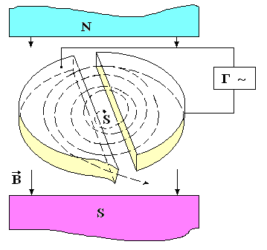

Fig.7.3

From source S, particles are injected into the left dee and move under the action of the Lorentz force, making an arc of small radius. With the passage of the gap between the dees the particle is accelerated by the electric field and their energy increases by an amount , therefore in the right dee they move along an arc of a larger radius corresponding to a higher speed. The next time the accelerating gap is reached, the high voltage generator switches the polarity of the voltage on the dees and the particles again increase energy in an electric field and, as a result, describe a spiral with an increasing radius. Once near the outer wall of one of the dees, the particles enter the output device, which consists of two plates, to which high voltage is applied. Since the period of the turnover in the dees does not depend on the speed of the particles and remains constant, the polarity of the voltage on the dees changes with the same frequency, which ensures the synchronous movement of all the particles. The synchronicity condition is violated when the velocity of a particle becomes comparable with the speed of light in a vacuum, since this increases the mass of the particle () and the period in accordance with (7.1) increases.

Cyclotrons are mainly used in the acceleration of heavy particles, for example, protons to energies of the order of 200 MeV.

**3) A charged particle moves at an arbitrary acute angle to the field induction vector.**

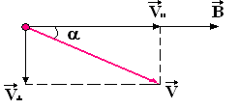

Fig.7.4

We decompose the velocity vector into two components: parallel to the vector and perpendicular to it . The speed in a magnetic field does not change (fig.7.4). The Lorentz force changes the direction only of the velocity  in the plane perpendicular to the vector, therefore the particle will move in this plane along a circle of radius



In addition, the particle moves progressively at a constant speed. Therefore, the trajectory of motion of a charged particle is a helix, whose axis coincides with the line of induction of the magnetic field (fig.7.5).

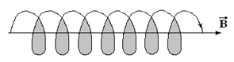

Fig.7.5

## §8. Hall effect. MHD - generator

The Hall effect is the occurrence of a transverse electric field in a conductor or semiconductor with a current when placed in a magnetic field. The phenomenon was discovered in 1880 by the American scientist E. Hall.

Let the conductor in the form of a flat tape, through which current flows, is located perpendicular to the magnetic induction lines (fig.8.1).

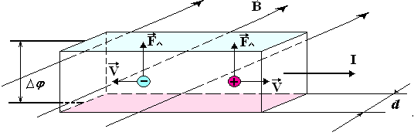

Fig.8.1

At the indicated direction of the current, the Lorentz force acting on the electrons, is directed upwards. Therefore, the upper surface of the conductor will be charged negatively, and the lower - positively. With a positive carriers sign, the direction of the Lorentz force remains the same, and the signs of charges on the slices change. The deviation of current carriers in the transverse direction occurs until the effect of the resulting transverse electric field balances the Lorentz force.

If the carrier concentration of both charges is the same, then the potential difference also occurs, because in general, the drift velocity of these carriers is different.

Provided that , the Hall potential difference is

,

where d - is the thickness of the conductor in the direction of the field;

R -is the Hall constant, the sign of which depends on the sign of charge carriers.

Consequently, the measurement of the Hall constant allows us to determine the nature of the conductivity (electrons or holes), as well as the carrier concentration and the average length of their free path.

Using miniature Hall sensors, you can measure any value that affects the Hall potential difference - the current through the sensor, the induction of an external magnetic field, the orientation of the sensor relative to this field. The Hall effect is also used when converting current, modulating electrical oscillations, recording sound, amplifying direct and alternating currents, etc.

The idea of a magnetohydrodynamic generator, abbreviated as MHD - generator, is to replace in the generator a conductor moving in a magnetic field with a stream of hot gases (hence, conductive) generated during the combustion of fuel. If such a stream of ionized gas (plasma) is directed through a pipe placed in a magnetic field, then ions of different signs will be deflected in different directions (fig.8.2). Therefore, on the electrodes introduced into the pipe, an EMF will appear.

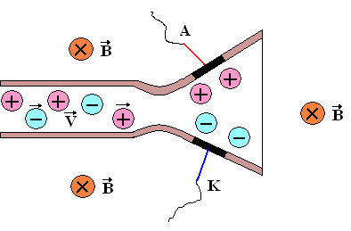

Fig.8.2

When the electrodes are shorted to an external load, electric current flows in it. In order to increase the electrical conductivity of a gas, an alkaline metal vapor is introduced into it, which has a low ionization energy.

## §9. Magnetic flux. Ostrogradski-Gauss theorem.

The concept of flux of magnetic induction vector is introduced by analogy with the flux of the vector strength of the electrostatic field.

The vector flux through the area ***dS*** is numerically equal to the number of magnetic field lines penetrating this area (fig.8.1).

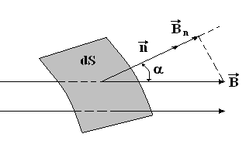

Fig.8.1

where - is the angle between the vector  and the unit normal vector  to the ***dS*** area:

 - projection of the vector  on the direction of the normal .

Magnetic flux through an arbitrary surface S:



In vector form:



If the field is homogeneous and the surface ***S*** is flat and perpendicular to the field, then

***B*** = const and

.

Magnetic induction lines do not have a beginning and an end, and are closed. Therefore, the number of lines entering the surface is equal to the number of lines leaving the surface (fig.9.2), i.e. the Ostrogradski-Gauss theorem is true:

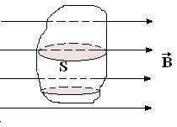

Fig.9.2

***magnetic flux through an arbitrary closed surface is zero:***



This result is a mathematical expression of the fact that in nature there are no magnetic charges on which magnetic field lines would begin or end.

In the SI system, the unit of magnetic flux is called a weber.

.

## §10. The work of moving in a magnetic field the conductor and the contour with a current

Ampere's force acts on a conductor with a current in a magnetic field.



under the action of which the conductor moves a distance ***dx*** (fig.10.1).

Hence Ampere's forces do the work:

.

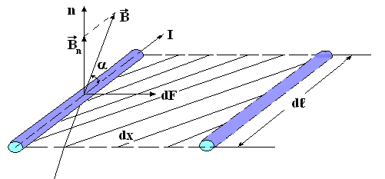

Fig.10.1

Since  represents the surface area described by the element conductor and, we get



Assuming the current strength is constant and integrating this expression we get

.

**The work done by the Ampere forces when moving a conductor in which the current is constant is equal to the product of the current by the amount of magnetic flux through the surface described by the conductor as it moves**.

If a frame with a current is in a magnetic field, then an expression for the work on its movement can be obtained by algebraically summing the work done by the magnetic field on moving each of the four sides (fig.10.2):



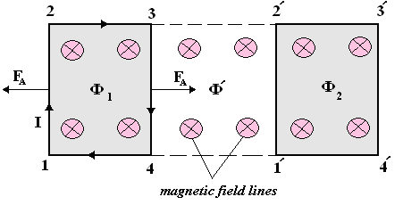

Fig.10.2

, because the respective sides do not cross the magnetic flux.

Conductor 1.2 crosses the stream , but moves against the field forces, therefore

.

Conductor 3.4 crosses the stream and therefore



Complete work



**Thus, the work done by magnetic forces above the contour is equal to the product of the current to the increment of the magnetic flux through the conductor**.

In this case, the work is done not at the expense of the energy of an external magnetic field, but at the expense of a source that maintains a constant current in the circuit.

## Chapter 2. ELECTROMAGNETIC INDUCTION

## §1. Electromagnetic induction phenomenon

The phenomenon, which is the occurrence of an electric current in a closed conductive circuit when the flux of magnetic induction changes through the surface bounded by this circuit, is called electromagnetic induction, and the resulting current is called induction current.

Since the creation of a current in the circuit requires the presence of EMF, the phenomenon of electromagnetic induction suggests that when the magnetic flux changes in the circuit, an induced EMF occurs.

**Electromagnetic induction law:**

***EMF of electromagnetic induction in the circuit is proportional and opposite in sign to the rate of change of the magnetic flux through the surface bounded by the circuit, i.e.***



The conclusion of this law is easier to do based on the law of conservation of energy.

Suppose there is a contour with a moving side (Fig. 1). In the presence of a battery with EMF current  flows in it. The current source in time  will do the work, which according to the law of Joule-Lenz transverce into heat, that is

.

Let's place the circuit in a uniform magnetic field with induction . Under the action of the Ampere force, the moving side of the frame will move a distance . Moreover, as a result of electromagnetic induction, the current in the circuit will change and become equal ***I***. Ampere's force will do the job



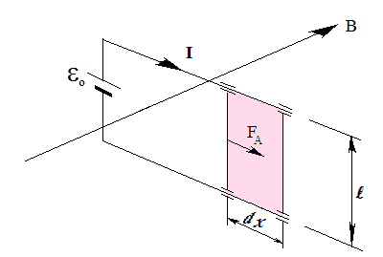

Fig.1.1

This work is carried out at the expense of the current source (magnetic induction does not change), that is,



After the conversion, we get



The resulting ratio can be considered as an expression of Ohm's law for the circuit, in which, besides the source EMF, induction EMF acts, i.e.



The expression for the EMF of induction does not depend on the method of changing magnetic flux. It may be done by movement of the contour, its deformation or by changing of it's place in the field.

The minus sign in the right part of the law of electromagnetic induction corresponds to the Lenz rule: for any change in the magnetic flux through the surface bounded by a circuit, an induction current arises in it, the magnetic field of which opposes the change in the magnetic flux that caused the induction current.

This law is explained below picture (Fig.1.2)

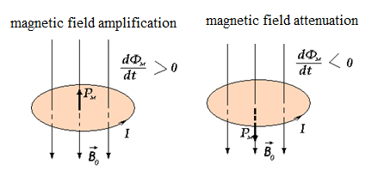

Fig.1.2

## §2. The self-induction phenomenon. Inductance

Around every conductor with current there is a magnetic field, the induction of which according to the law of Bio-Savart-Laplace is proportional to the current

***B ~ I***

The intrinsic magnetic field of the circuit creates a magnetic flux through the surface bounded by the contour.



So, the magnetic flux is also proportional to the strength of the current:

 (2.1)

**The coefficient of proportionality between the strength of the current and its own magnetic flux is called the inductance of the circuit**.

***The inductance of the circuit depends only on the geometric shape of the circuit, its size and the magnetic permeability of the medium.***

When the current in the circuit changes, the magnetic flux will also change, and this leads to the appearance of an EMF in the circuit.

**The phenomenon of EMF induction in an electric circuit due to a change electric current in it is called the phenomenon of self-induction, and the induced EMF is called self-induced EMF**.

According to the law of electromagnetic induction and the formula (2.1) we have



If the magnetic properties of the medium do not change and the contour is not deformed, then ***L*** = const and

 (2.2)

The minus sign in formula (2.2) shows that the presence of inductance leads to a deceleration of the change in current in the circuit.

Indeed, if $\frac{dI}{dt}>0$ (the current increases), then $ε_{c}<0$ and it is directed against the current caused by external sources.

If $\frac{dI}{dt}<0$ (the current decreases), then $ε_{c}>0$ the current reduction “slows down”.

Thus, with the growth and with the decrease of the current, the EMF of self-induction counteracts, in accordance with the Lenz rule, a change in the current in the circuit. As the inertia element of the circuit in relation to the change in the current in it is the inductance of the circuit.

The unit inductance is **Henry - is the inductance of such a conductor, in which when a current changes by *1A* for *1s*, self-induced EMF in *1B* is excited**.

## §3. Current at closing and opening of the circuit containing inductance

The current additionally arising due to self-induction, according to the Lenz rule, is always directed so as to counteract the change in the current in the circuit. Therefore, the establishment of the current when the circuit is closed and the current decreases when the circuit containing the inductance is opened, occurs not instantaneously, but gradually.

1. Consider a circuit consisting of inductance ***L***, sources of EMF, resistance ***R*** and key ***K,*** connected in series (Fig.3.1)

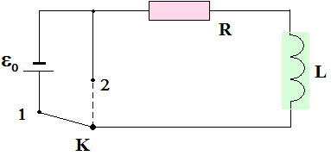

Fig.3.1

A constant current flows in the circuit

.

Let the EMF be turned off at the moment of time ***t*** = 0 (the key ***K*** is in position 2). The current will begin to decrease, and the EMF of self-induction, which arises in this case according to the Lenz rule, will be directed along the current.

So, by Ohm's Law



or

 (3.1)

Separating variables and integrating, we have



From here



or finally

 (3.2)

Thus, the current in the circuit does not instantly drop to zero, but decreases exponentially.

The rate of decrease is determined by the value

, (3.3)

which is called **the time constant**.

After substituting (3.3) into (3.2) we get



From the formula it is clear that there is a time during which the current strength decreases by a factor of "e". Obviously, the greater the inductance ***L*** and the lower the resistance ***R***, the slower the current in the circuit drops (Fig.3.2).

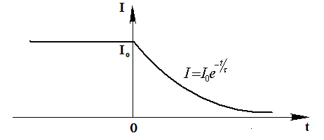

Fig.3.2

If you simply break the circuit with a large inductance, the resulting induced voltage creates a spark at the point of rupture. This shortens the service life of the switch. To avoid this, a diode is included in the circuit (Fig.3.3).

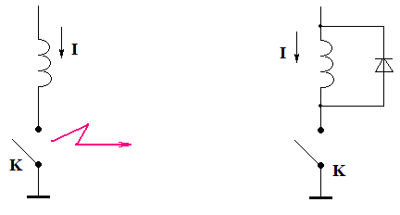

Fig.3.3

1. Let the EMF turn on at time ***t = 0*** (the key ***K*** is transferred from position 1 to position 2).

Until the current reaches a steady-state value, a self-induced EMF will act in the circuit besides.

So according to Ohm's law



or



The solution of the inhomogeneous differential equation is equal to the sum of the general solution of the homogeneous equation (3.1) and the particular solution of the inhomogeneous equation. One particular solution is



So, the general solution of equation (3.3) will be



At the initial moment, the current strength is ***I*** = 0, therefore



From here



The current in the circuit gradually increases from zero to the value corresponding to the DC value (fig.3.4).

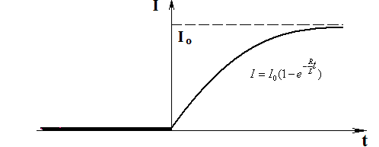

Fig.3.4

## §4. The phenomenon of mutual induction. Mutual inductance

**Mutual induction is the phenomenon of induced EMF in one electric circuit when the electric current changes in another circuit or when the relative position of these two circuits changes.** This EMF is called the electromotive force of mutual induction.

Take two contours, located close to each other (fig.4.1).

If a current of force flows in circuit 1, it creates a magnetic flux through circuit 2



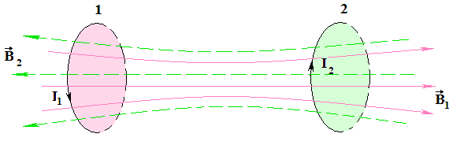

Fig.4.1

When changing the current in circuit 2, induced EMF

.

Similarly, when a current flows in circuit 2, a flux coupled to circuit 1 occurs

$$Ф_{1}=L_{12}I_{2}$$

With changes in current in circuit 1 is induced EMF



The coefficients of proportionality and are called mutual inductances of the circuits. In the absence of ferromagnetic, these coefficients are always equal to each other:

=

***Their value depends on the shape, size and relative position of the contours, as well as on the magnetic permeability of the environment***.

In the case of a ferromagnetic medium, they are generally not equal to each other and depend moreover on the strength of the currents in both circuits and on the nature of their change.

The principle of operation of transformers is based on the phenomenon of mutual induction .

## §5. Magnetic field energy

Consider the circuit shown in the figure (Fig.5.1)

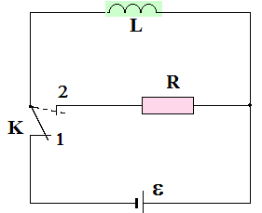

Fig.5.1

When the key is closed (position 1), a steady current ***I*** will flow in the solenoid, causing to a magnetic field coupled with the turns of the solenoid.

If you switch the key to position 2, then through the resistance ***R*** a gradually decreasing current flows, supported by self-induced EMF arising in the solenoid. The work done by this current in time ***dt*** is equal to



Integrating this expression over ***I***, from the initial value ***I*** to zero, we get the work done in the circuit for the entire time during which the magnetic field disappears:

$A=-\int_{I}^{0}{LIdI=\frac{LI^{2}}{2}}$ (5.1)

The work goes on the increment of the internal energy of resistance ***R***, the solenoid and connecting wires, that is, on their heating. The implementation of this work is accompanied by the disappearance of the magnetic field, which originally existed in space, surrounding the solenoid.

Since there are no other changes in the bodies surrounding the electrical circuit, we conclude that the magnetic field is a carrier of energy, due to which the work is carried out.

Thus, a conductor with inductance ***L***, through which current ***I*** flows, has energy

 (5.2)

Expression (5.1) can be interpreted as the work that needs to be done against self-induction EMF in the process of increasing current from ***0*** to ***I*** and which creates a magnetic field, having energy (5.2).

Express the energy of the magnetic field in terms of the quantities characterizing this field.

In the case of a very long solenoid, we have

$B=μμ_{0}nI=μμ_{0}\frac{N}{l}I$ $I=\frac{Bl}{μμ_{0}N}$*; $Ф=LI$;* .

Then formula (5.2) is converted to the form



Here n - is the number of solenoid turns per unit of its length

***V*** - the volume of the solenoid.

**The volume density of the magnetic field energy is the energy of this field, referred to its volume**



where - is the energy contained in a small volume ***dV*** of the field, provided that the field is homogeneous in this volume.

Knowing the density of the field energy at each point, one can find the field energy contained in any volume ***V***:



If a field is created by a system of connected circuits, then its energy is



## Chapter 3. MAGNETIC FIELD IN SUBSTANCE

## §1. Magnetic moments of electrons and atoms. Types of magnetics

Magnetics are called different environments that can magnetize under the action of a magnetic field, that is, acquire a magnetic moment.

The magnetic properties of matter are determined by the magnetic properties of atoms, which are a collection of microcurrents created by moving electrons.

Suppose for simplicity that an electron in an atom moves in a circular orbit. In accordance with the definition of magnetic moment value

 (1.1)

where S - is the area of the electron orbit,

*I* - is the current produced by the moving electron, called **the orbital magnetic moment of the electron (fig**.1.1).

The current is equal to

 (1.2)

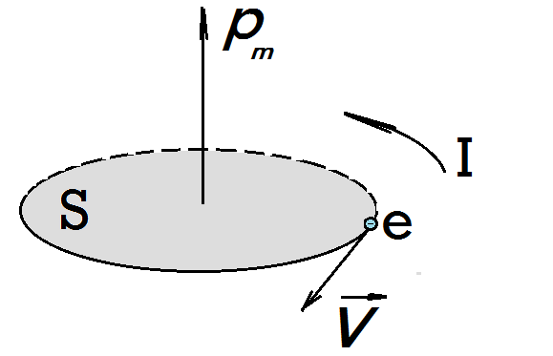

Fig.1.1

where n - is the number of revolutions of the electron in orbit during time t;

 - rotation period (time of one turn)

ν - is the number of turns per unit of time (frequency)

Because

,

then from formulas (1.1) and (1.2) for the orbital magnetic moment of the electron we have

.

The value - is vectorial and in relation to the circular current is oriented according to the rule of the right screw.

In addition to the orbital magnetic moment, an electron in an atom has its own magnetic moment, which is called the **spin magnetic moment**, because initially, the electron was considered as a charged ball rotating around its axis. Currently accepted, that the spin magnetic moment is the same inherent property of the electron as its mass and charge.

The spin magnetic moment of an electron is

,

where  - is Planck's constant.

The value of J / T is called the **Bohr magneton**. Consequently, the ***self magnetic moment of the electron is equal to one Bohr magneton***.

The total magnetic moment of an atom is equal to the geometric sum of the orbital and spin magnetic moments of all electrons:

All magnets are divided into three groups:

1) diamagnets; 2) paramagnets; 3) ferromagnets.

## §2. Micro and macro currents. Magnetization. Magnetic field strength

Currents due to the movement of electrons in an atom are called **microcurrents or molecular currents.**

**Macrocurrents are conduction currents.**

In the absence of an external magnetic field, all molecular currents are randomly oriented, therefore the resulting moment of the medium is zero. When an external field created by macrocurrents is applied, all microcurrents acquire a preferential orientation, and an additional field arises due to the magnetization of the substance.

Magnetisation of magnetic is characterized by a vector value - **magnetization $( \vec{J} ),$** equal to the ratio of the magnetic moment of a small volume of matter to the value of this volume:



where  - is the magnetic moment of the i-th atom (molecule);

- physically infinitely small volume, within which the magnetic field is uniform.

In other words, it is the magnetic moment of a unit volume of a substance.

In SI .

Let us determine the connection of magnetization with microcurrents. To do this, we consider a cylindrical magnet rod placed in a uniform magnetic field (fig.2.1).

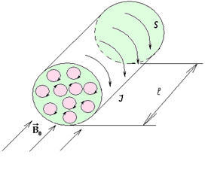

Fig.2.1

The planes of molecular currents are located perpendicular to the field. All internal molecular currents are mutually compensated. Molecular currents ***I***, flowing over the surface, only remain. They create a magnetic moment



where S - is the area of the rod;

n - is the number of currents per unit length.

Dividing both sides of the equality by the volume of the rod  , we get

.

The currents flowing along the side surface of the cylinder are similar to the current in a solenoid, creating inside it a magnetic field with induction



Consequently,

.

In the presence of an external field of macrocurrents , the resulting magnetic field is



Convert this expression to the next view



The vector thus defined is called **the magnetic field strength vector**.

In vacuum  (since molecular currents are absent), therefore



## §3. Magnetic susceptibility and magnetic permeability of the substance. The law of total current for a magnetic field in a substance

It is obvious that the induction of the internal field  in a substance arising under the action of an external field depends on it and can be represented as



The value  is called the magnetic susceptibility of a substance. Then the total field in the substance can be written as

.

where  is the magnetic permeability of the medium.

Consequently, .

Let us generalize the law of the total current for a magnetic field in a vacuum in the case of a magnetic field in a substance.

In vacuum



In substance, the ratio is fair



Then for the magnetic field in the substance we get



or



**The circulation of the magnetic induction vector along a closed contour is proportional to the algebraic sum of the conduction currents and the molecular currents covered by this contour.**

## §4. Diamagnets and paramagnets

**Diamagnetic materials are substances whose magnetic moments of atoms in the absence of an external magnetic field are zero.**

When a diamagnetic is introduced into a magnetic field, its atoms acquire induced magnetic moments that are opposite to the field, i.e. internal field will be directed in the opposite direction.

Therefore, for diamagnetic value  is negative, because



but  .

Diamagnetic include substances in the atoms and molecules of which there are only completely filled electron shells: inert gases, hydrogen, water (gold, silver, copper).

**Paramagnetic substances are substances whose atoms in the absence of an external magnetic field have a nonzero magnetic moment**. This moment is associated with both the orbital and spin magnetic moments of the electrons. Vectors coincide in direction with the vector ${\vec{B}}_{0}$, therefore the value  is positive, a > 1 

Alkali and alkaline-earth metals, oxygen, air, platinum belong to paramagnets. Diamagnets and paramagnets are weak magnetic media.

## §5. Ferromagnets. Magnetization curve. Magnetic hysteresis

Ferromagnetic substances are substances in which the own magnetic field caused by an external magnetic field can exceed it by hundreds and thousands of times.

These include: iron, cobalt, nickel and a number of alloys, and ferromagnetism is found only in the crystalline state of these substances and does not manifest itself for individual atoms.

In ferromagnets >> 1 and >> 1.

**Distinctive properties of ferromagnets:**

**1.** Nonlinear relationship between the induction of an external magnetic field and the magnetization of a ferromagnet in a medium (fig.5.1).

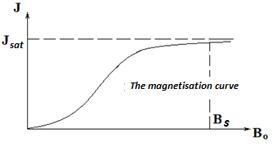

Fig.5.1

The magnetization curve of iron was first obtained and investigated by A.G. Stoletov.

In coordinates , this curve has the form shown in fig.5.2. Upon reaching saturation when  the value of continues to grow as it increases according to a linear law, since , where const.

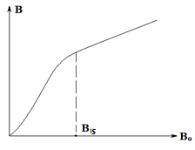

Fig.5.2

**2**. Dependence of relative magnetic permeability on the induction of an external magnetic field (fig.5.3).

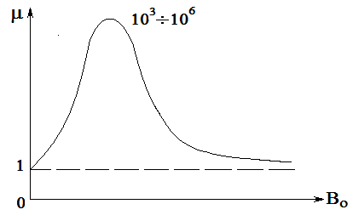

Fig.5.3

**3.** When magnetization reversal, magnetic hysteresis is detected, i.e. magnetization occurs with one dependence of *B* on , and demagnetization with another (fig.5.4).

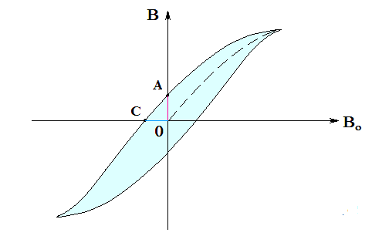

Fig.5.4

OA - residual magnetization, which turns the ferromagnet into a permanent magnet when it is removed from the magnetic field.

OB - coercive force, - magnetic field induction, at which the ferromagnet is fully demagnetized.

The loop area is numerically equal to the work that the external magnetic field expends for one cicle of magnetization reversal. This work is released in the form of heat. To reduce the magnetization reversal losses in transformers, “soft” ferromagnets are used, for which this work is small. Materials with a wide hysteresis loop are used to make permanent magnets.

4. When magnetizing and demagnetizing, the ferromagnets change their dimensions. This phenomenon **is called electrostriction**.

## §6. Spin nature of ferromagnetism. Domains. Curie point

The foundations of the theory of ferromagnetism were created by Y.I. Frenkel and V. Heisenberg in 1928.

From experiments, it follows that the spin magnetic moments of electrons are responsible for the magnetic properties of ferromagnets. The crystals have small regions of 1–10 µm in size — domains in which the magnetic moments of the electrons are parallel to each other. Within each domain, a ferromagnetic is magnetized to saturation and has a certain magnetic moment. In the absence of an external field, the directions of these moments are arbitrary.

The action of the external field is as follows:

**1.** In weak fields, there is a shift in the boundaries of the domains, accompanied by an increase in those domains whose moments make up a smaller angle  (dashed curves in fig.6.1).

**2.** An increase in  the absorption of domains 2 and 4 takes place.

**3.** There is a rotation of the magnetic moments of the domains in the direction of the field.

These processes are irreversible, which causes hysteresis.

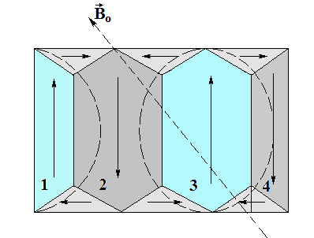

Fig.6.1

For each ferromagnetic there is a certain temperature, above which the areas of spontaneous magnetization decay and it turns into an ordinary paramagnet. This temperature is called the Curie point. For example, for iron  and for nickel 

# Part IV. FUNDAMENTALS OF THE THEORY OF MAXWELL FOR ELECTROMAGNETIC FIELD

## §1. Displacement current

Direct current is always closed. Consider the process of passing an alternating current through a circuit, containing a capacitor (fig.1.1).

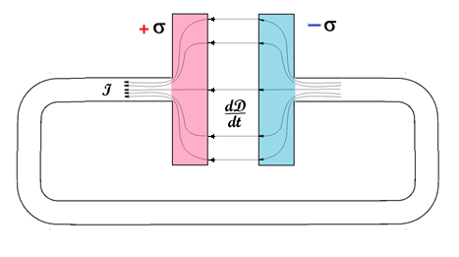

Fig.1.1

Charges of the plate are equal to ***±q*** and when the area of plates ***S*** they have a surface density ***±σ***. When connecting the capacitor plates with a conductor, a gradually decreasing current  flows through it, the density of which

,  (1.1)

As is known, the field strength inside a capacitor

, (1.2)

And the electrical bias is related to the voltage ratio

 (1.3)

Combining formulas (1.2) and (1.3), we get that

.

Since during the discharge of capacitor ***D*** and are changed over time, we find their derivatives



However, the value is the current density in the conductor at a given time. Therefore, at the suggestion of Maxwell, the current density due to the time variation of the electric field was called **the displacement current density**:



Thus, with any change in the electric field, a **displacement** current occurs that is proportional to the rate of change of the electric bias. **Therefore, the circuits of any non-constant currents are also closed due to the presence of displacement currents in those areas where there are no conductors.**

The direction of the vector coincides with the direction of the conduction current in the circuit in which the capacitor is connected (fig.1.2).

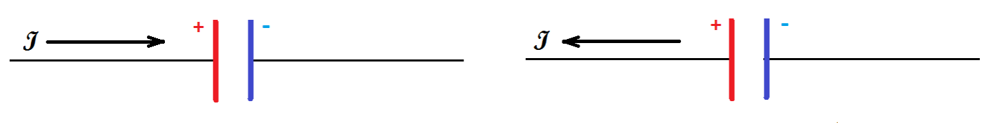

Capacitor charge Capacitor discharge

Fig.1.2

The bias current, like ordinary conduction currents, is the source of a vortex magnetic field (fig.1.3).

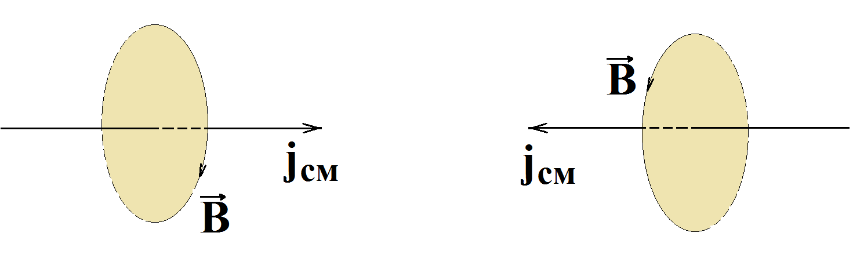

Fig.1.3

If there is a dielectric between the plates of the capacitor, then the electric displacement vector consists of two terms

,

where - is the polarization vector associated with the actual charge displacement when the dipoles rotate along the field and when induced dipole moments occur.

In this case, the bias current density in the dielectric is



Thus, the total bias current density is equal to the sum of the bias current density in a vacuum



and the current density of the polarization bias , which has the same nature as the conduction current, i.e. movement of electric charges, but not free, but related.

It follows from the above that a capacitor in an AC circuit does not break the circuit, since alternating conduction current going through the wires passes through the capacitor in the form of a bias current, i.e. in the form of changes in the electric field of the capacitor. Therefore, the total current in the circuit is



Thus, the introduction of a bias current means that an alternating electric field causes the appearance of an alternating magnetic field.

## §2. Maxwell's equations for the electromagnetic field in the integral form

Maxwell summarized the law of the total current in a substance by introducing a bias current into its right-hand side and writing it in the form:

 (2.1)

This equality expresses the law of total current and is **the first Maxwell equation**.

**The bias current through an arbitrary surface *S* is numerically equal to the flux of current density vector of the bias current through this surface**

 (2.2)

In view of (2.1), the first Maxwell equation will be

 (2.3)

The circulation of the voltage vector along a closed loop is equal to the sum of the conduction currents covered by the loop and the rate of change of the flux of electrical induction through the surface bounded by the loop.

In accordance with the law of electromagnetic induction, the EMF of induction in a closed circuit, placed in an alternating magnetic field, is defined as



The appearance of the EMF cannot be explained by the Lorentz force, since it does not act on immobile charges. The only explanation is that an alternating magnetic field causes the appearance of a vortex electric field, the circulation of the intensity of which  along a closed circuit is equal to the induced EMF, i.e.



It follows that

 (2.4)

This expression is **the second Maxwell equation** and is valid not only for the conducting circuit, but also for any closed circuit, mentally allocated in an alternating magnetic field.

It follows from it that an alternating magnetic field at any point in space creates a vortex electric field, regardless of whether the conductor is at this point or not.

In the absence of conduction currents and all EMF except for EMF induction, both Maxwell equations have a symmetric form





From the comparison of two Maxwell equations, we can conclude:

***1. The change in time of the electric field causes the appearance of a magnetic field, and the alternating magnetic field is the source of the vortex electric field, resulting in a single electromagnetic field.***

***2. The difference in signs at the rates of change in the fluxes of magnetic and electric induction is due to the fact that the directions of the vectors*** ***and***  ***form the "right-handed" system, and the directions of the vectors***  ***and***  ***form the "left-handed" system.***

The difference in signs is a necessary condition for the existence of a stable electromagnetic field. If the signs were the same, then an infinitesimal increase in one of the fields would cause an unlimited increase in both fields, and an infinitesimal decrease in one of the fields would lead to the complete disappearance of the fields.

As the third Maxwell equation, the Ostrogradski-Gauss theorem is used for the field in a dielectric

 (2.5)

Maxwell generalized it for an alternating electric field. This expression allows to calculate the electric field if the charge distribution is known, i.e. the presence of electric charges causes the appearance of an electric field.

Maxwell also suggested that the Ostrogradski-Gauss theorem for a magnetic field is also valid in the case of an alternating field. Therefore, the fourth Maxwell equation has the form

 (2.6)

Its meaning is that there are no magnetic charges. Magnetic force lines have no where to start and end - they are always closed.

The system of four Maxwell equations must be supplemented with the so-called material equations characterizing the electrical and magnetic properties of the medium:







The physical essence of Maxwell's equations is that the electromagnetic field can be divided into electric and magnetic only relatively. Only if the electric and magnetic fields are stationary, that is , only in that case they can exist independently of each other.

The electric field is described by two equations of electrostatics:





Accordingly, the magnetic field is described by two magnetostatic equations:



